**How to create sections on the website**

**following the steps below.**

**Banner Section**

How to add a banner section.

There are two types of layouts to create a banner on a page.

**a) Banner with slider**

**b) Banner without slider**

## **Banner with slider**

**How to create a banner with a slider.**

**Preview (Banner with slider)**

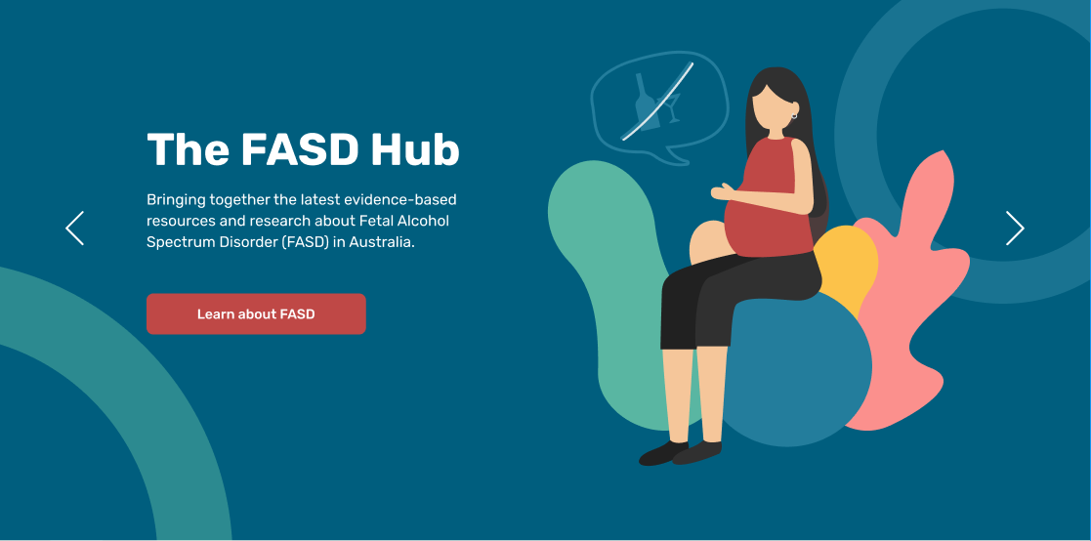

**Steps below:**

First, click on **'Add row**,' then select **'Banner section'** from the dropdown menu, as shown in the screenshot below.

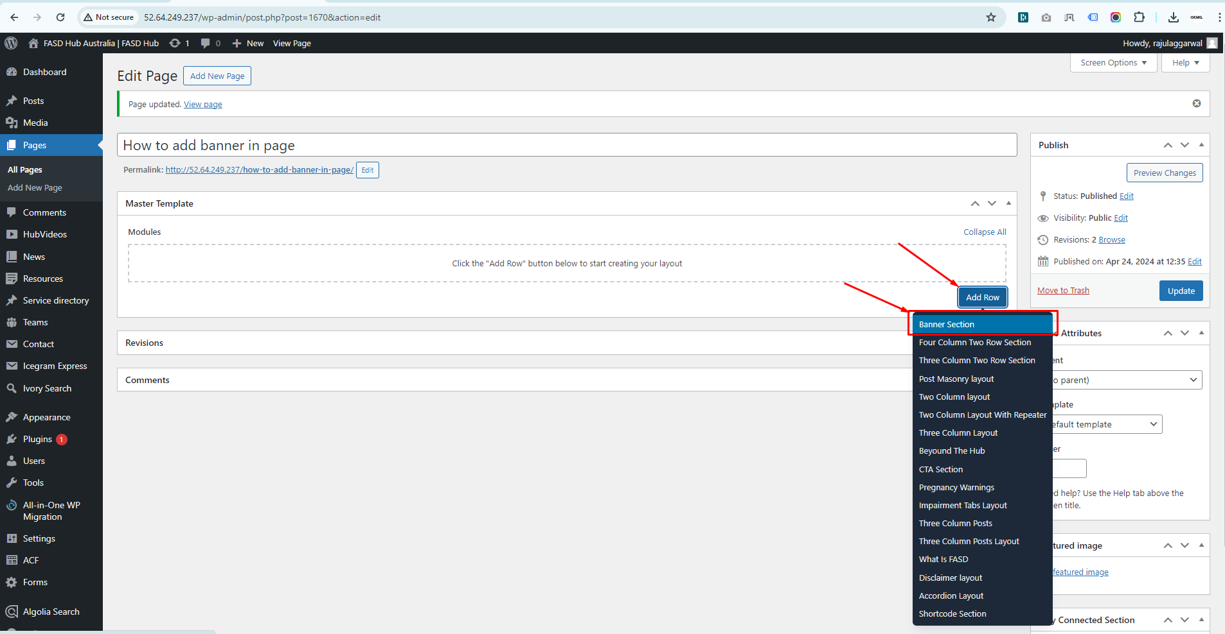

After that, the module related to the banner section will be added, and you will find options related to the banner, as shown in the screenshot below.

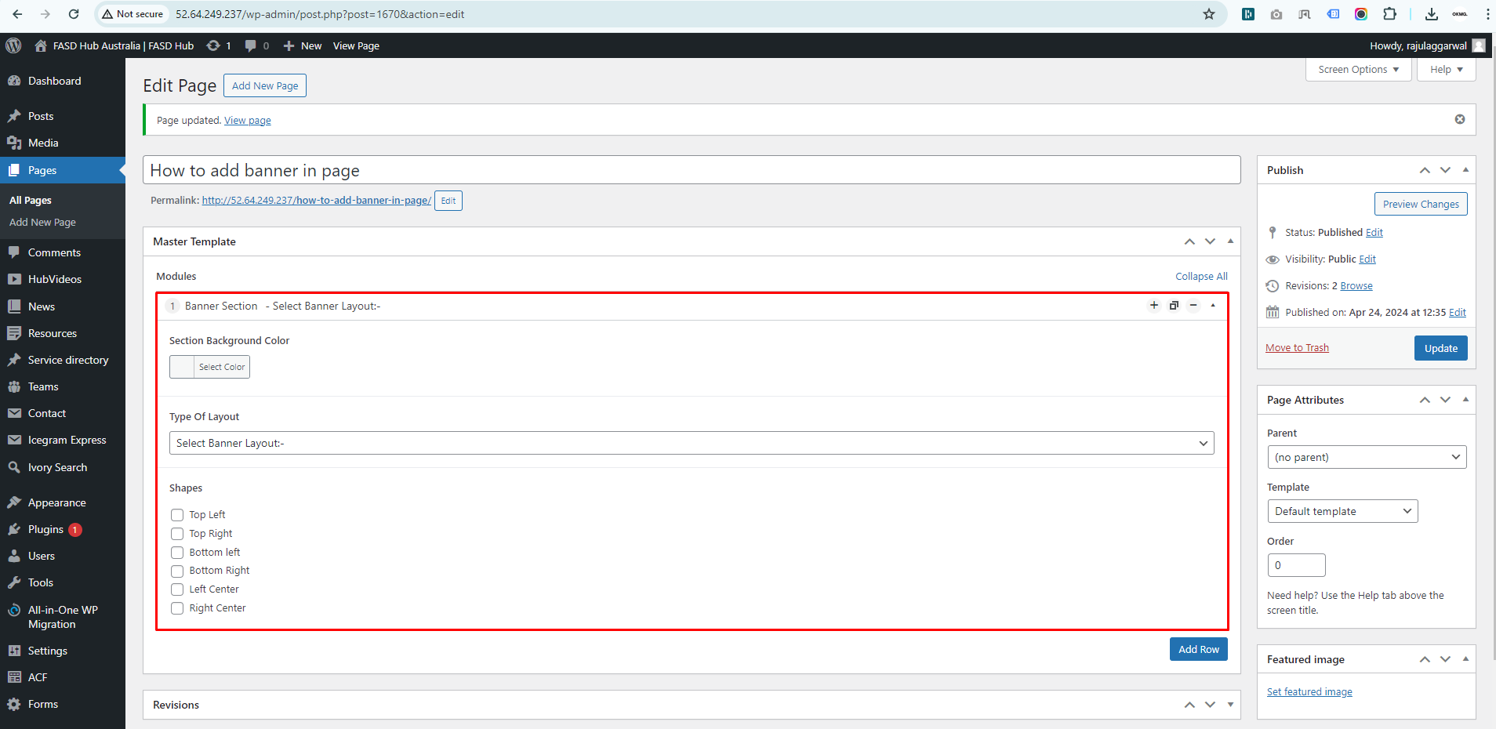

Now you will see the option for Section Background Color. From here, you can change the background color of the section, as shown in the screenshot below

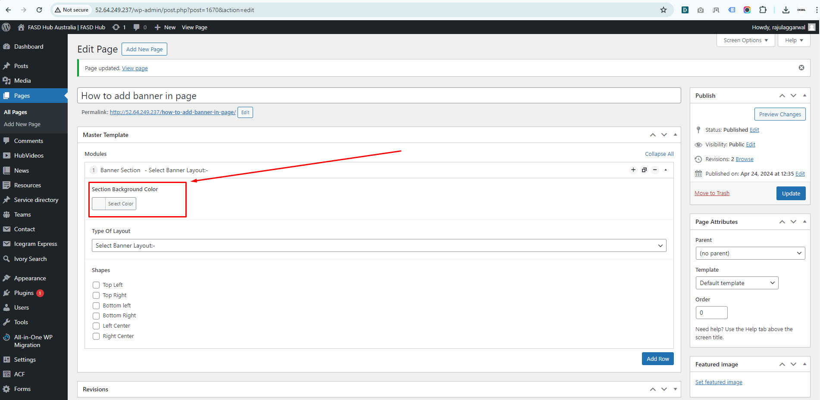

Now you will see the option for Type Of Layout. From here, Select the **'Banner with Slider'** option from the layout, as shown in the screenshot below.

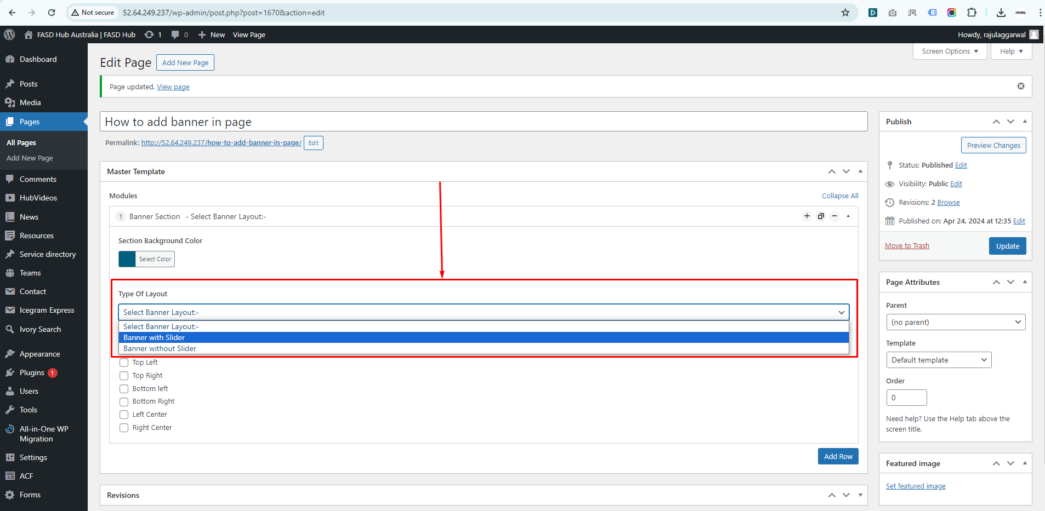

We have selected the Banner with Slider type layout, in which we need to insert content according to the slides, as shown in the screenshot below.

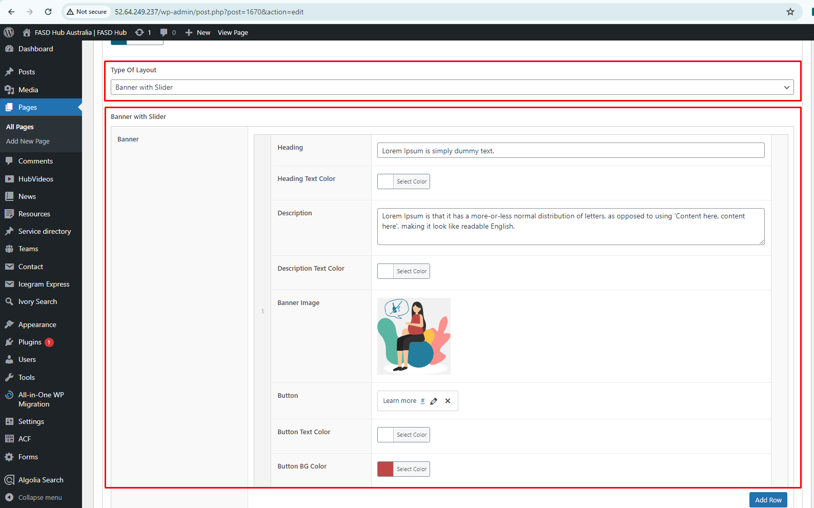

Finally, we have achieved the output of the **banner with a slider** on the front end, as shown in the screenshot below.

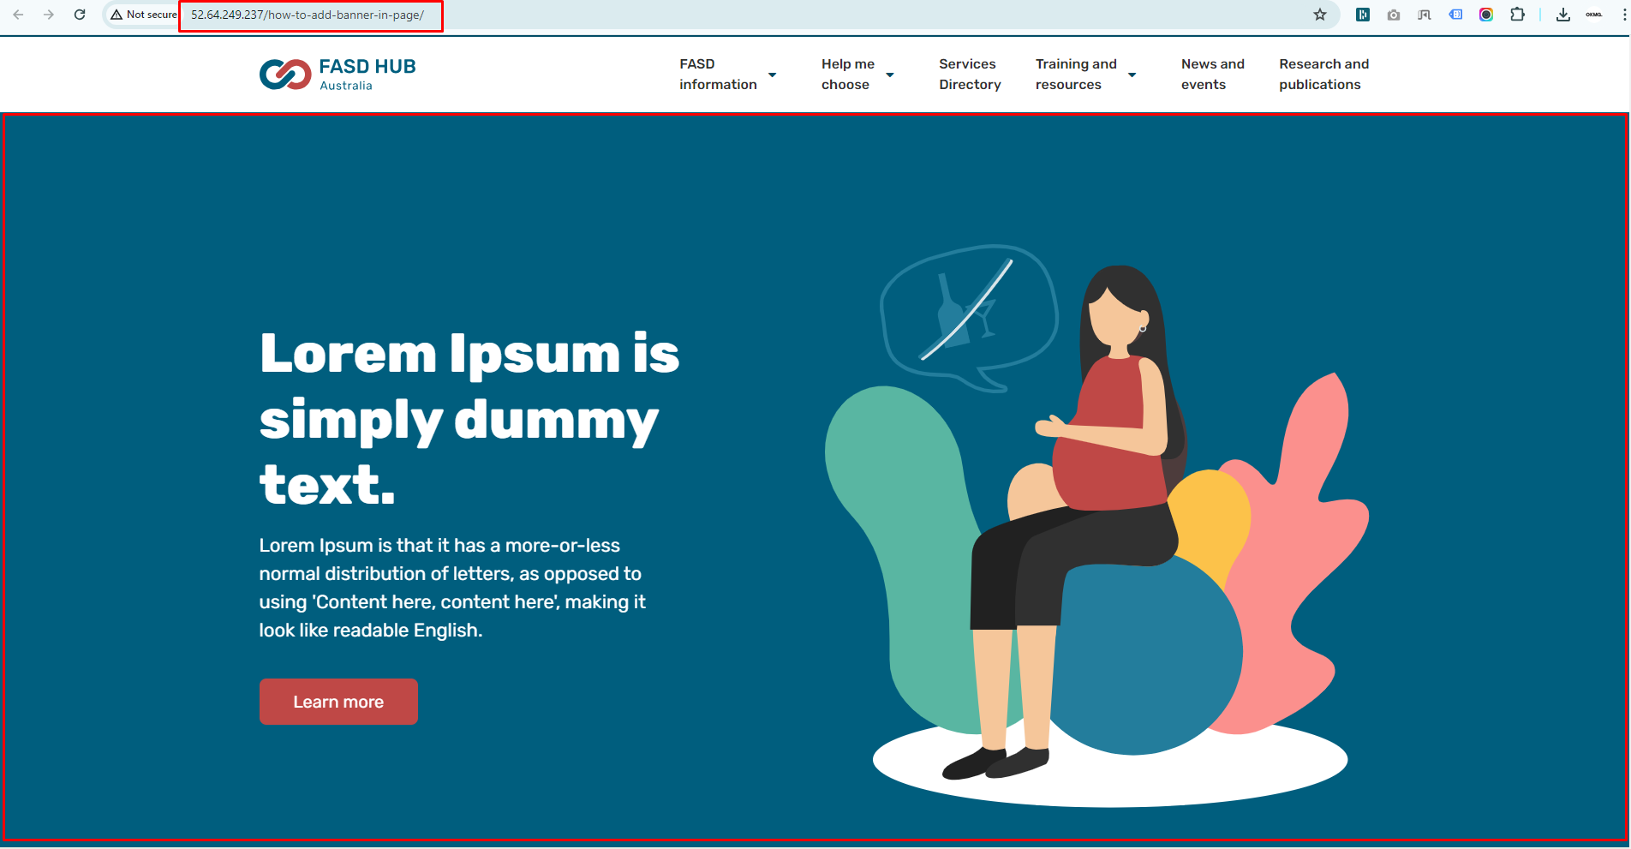

If you want to add more slides, click on the '**Add Row**' button as shown in the screenshot below.

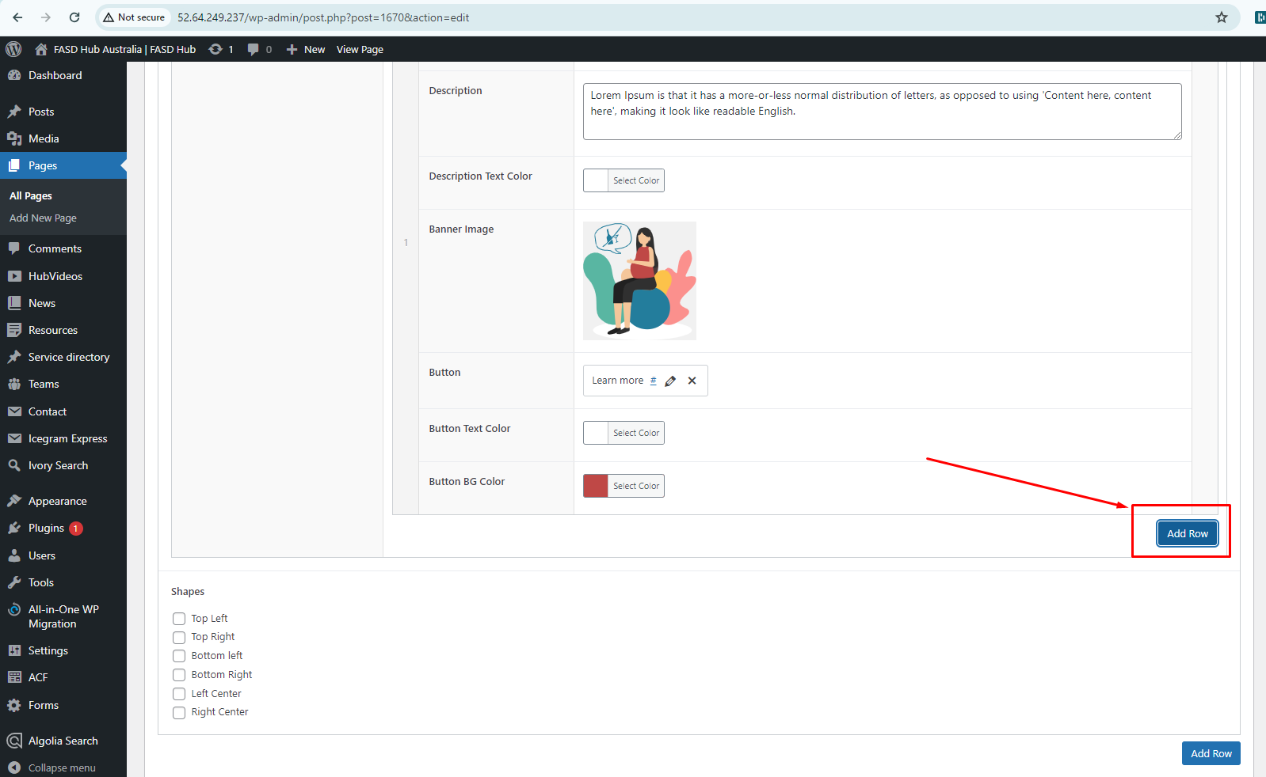

Now add content for slide 2, and if you want to add more slides, you can click on the '**Add Row**' button to add additional slides, as shown in the screenshot below.

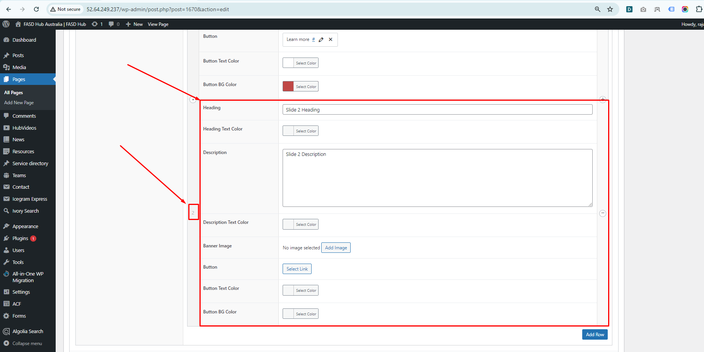

Now our slider is ready, as you can see in the screenshot, slider arrows have also appeared. Slider arrows will only show up when you add more than one slide, as shown in the screenshot below.

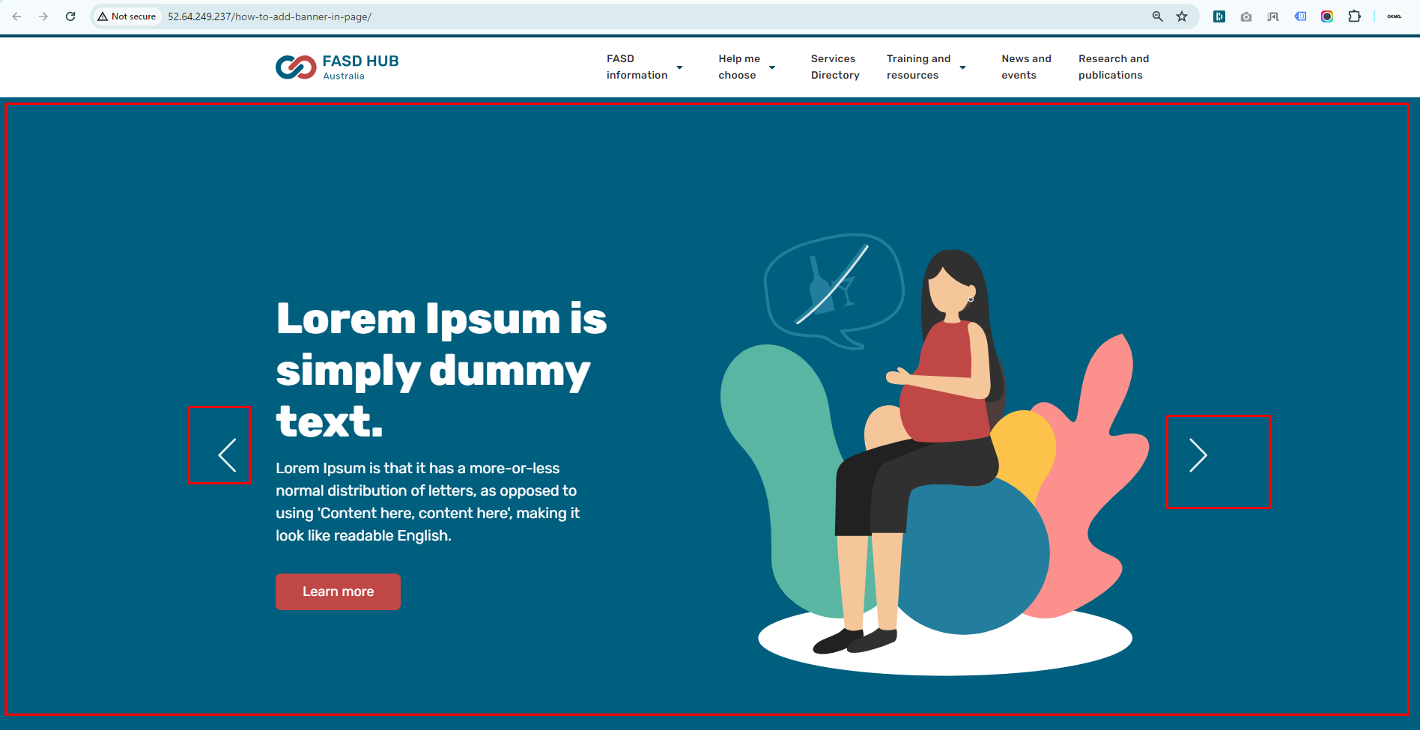

## **Banner without slider**

**How to create a banner without a slider**

**Preview (Banner without slider)**

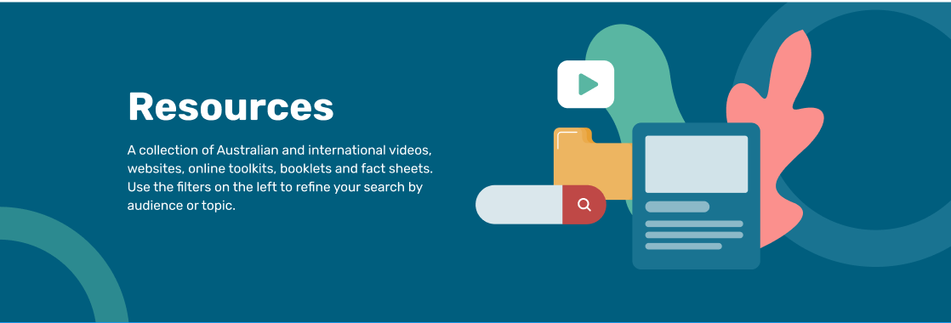

**Steps below:**

First, click on **'Add row**,' then select **'Banner section'** from the dropdown menu, as shown in the screenshot below.



After that, the module related to the banner section will be added, and you will find options related to the banner, as shown in the screenshot below.



Now, select the **'Banner without slider'** option from the **Type Of Layout** menu, as shown in the screenshot below.

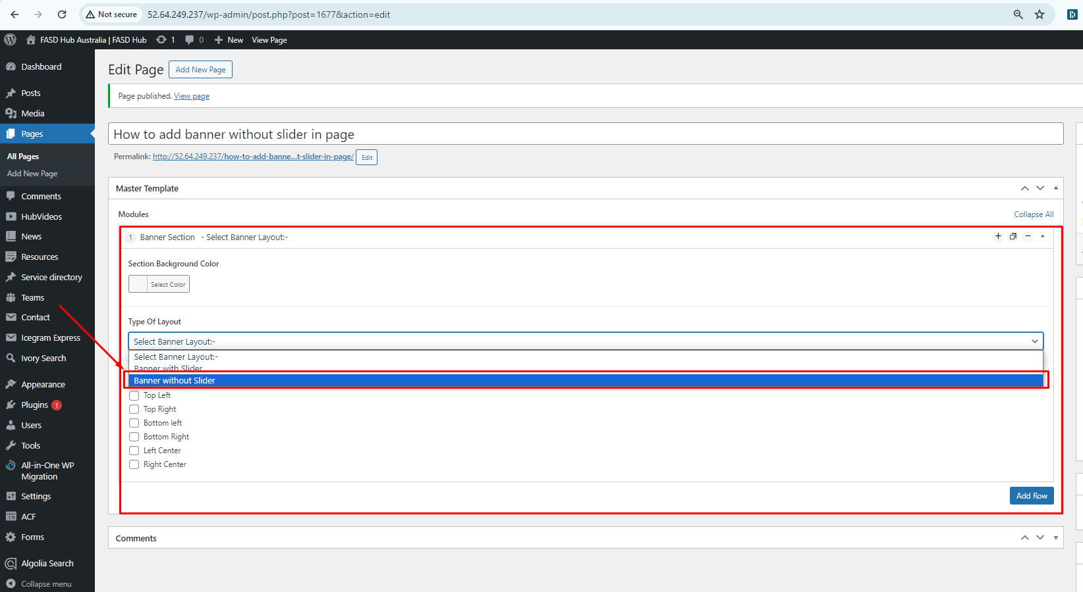

Now you need to add content, as shown in the screenshot below.

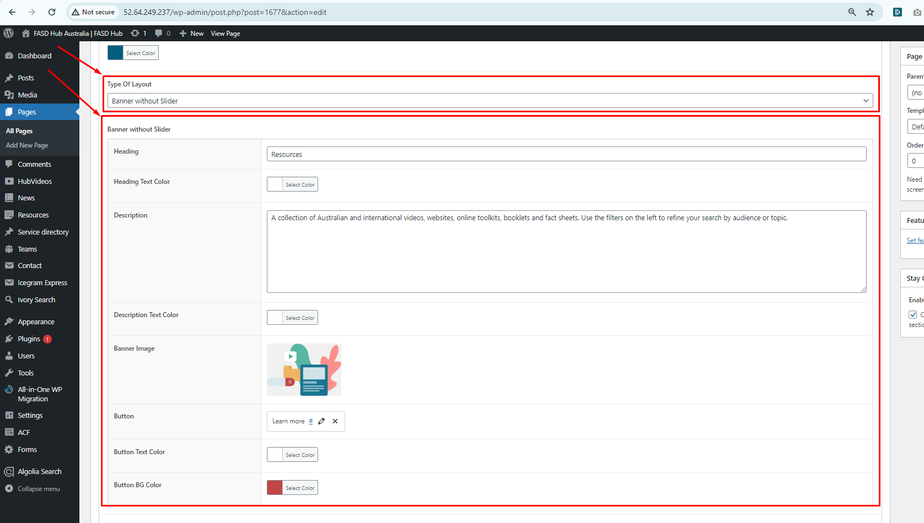

Finally, we have achieved the output of the **banner without a slider** on the front end, as shown in the screenshot below.

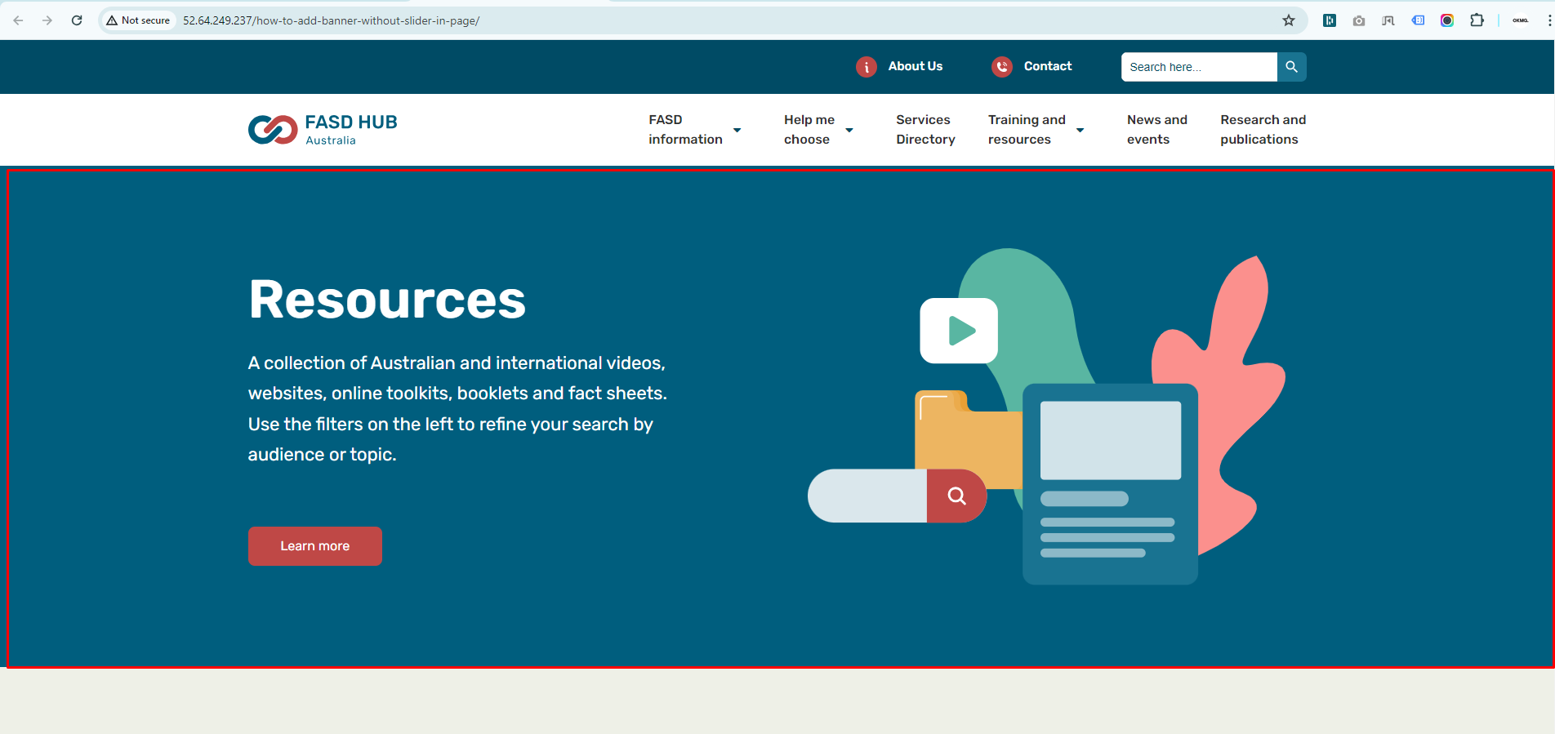

**How to add shapes in a section, follow these steps:**

To add shapes to any section, you first need to add the section. Then, you will see the option to add shapes, where you can add images of shapes in six different positions as you desire, as shown in the screenshot below.

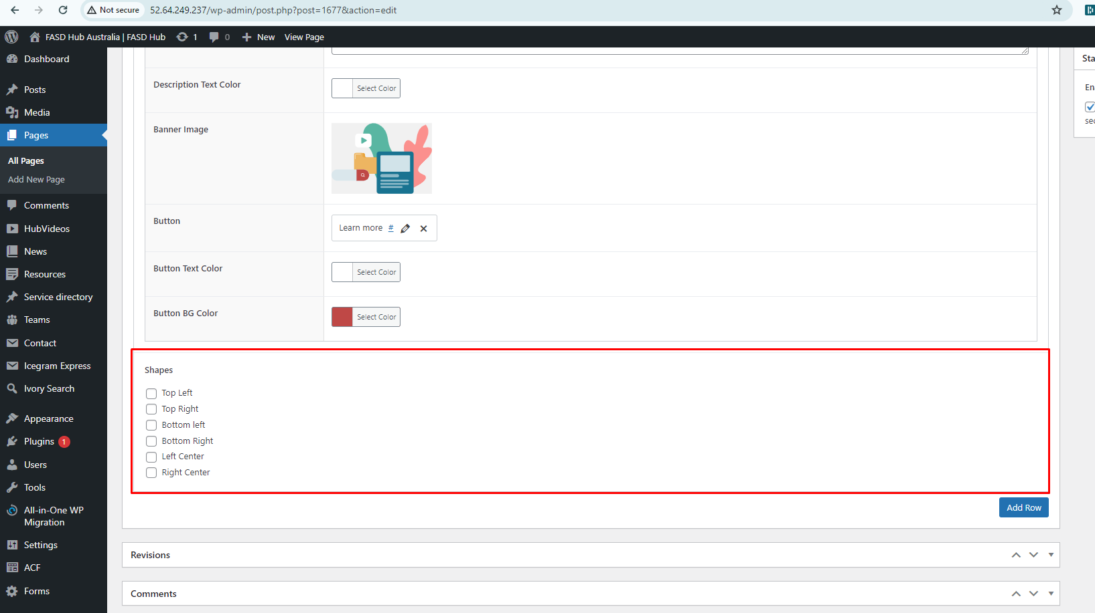

You need to select the checkbox according to the position where you want to add the image, then you will see the option to add the image, as shown in the screenshot below.

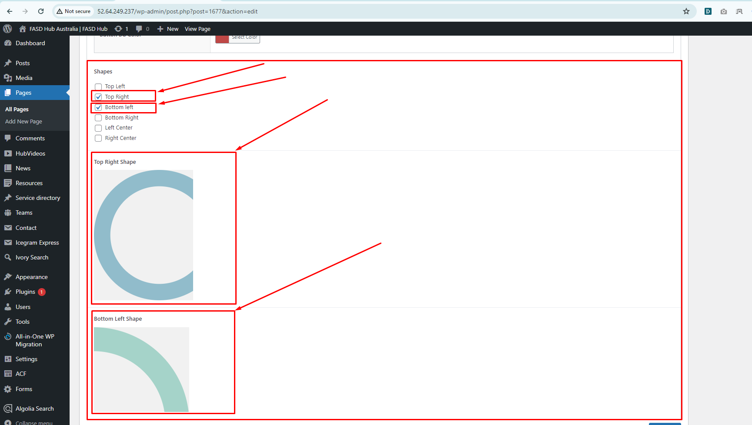

Finally, we have achieved the output of the shapes on the front end, as shown in the screenshot below.

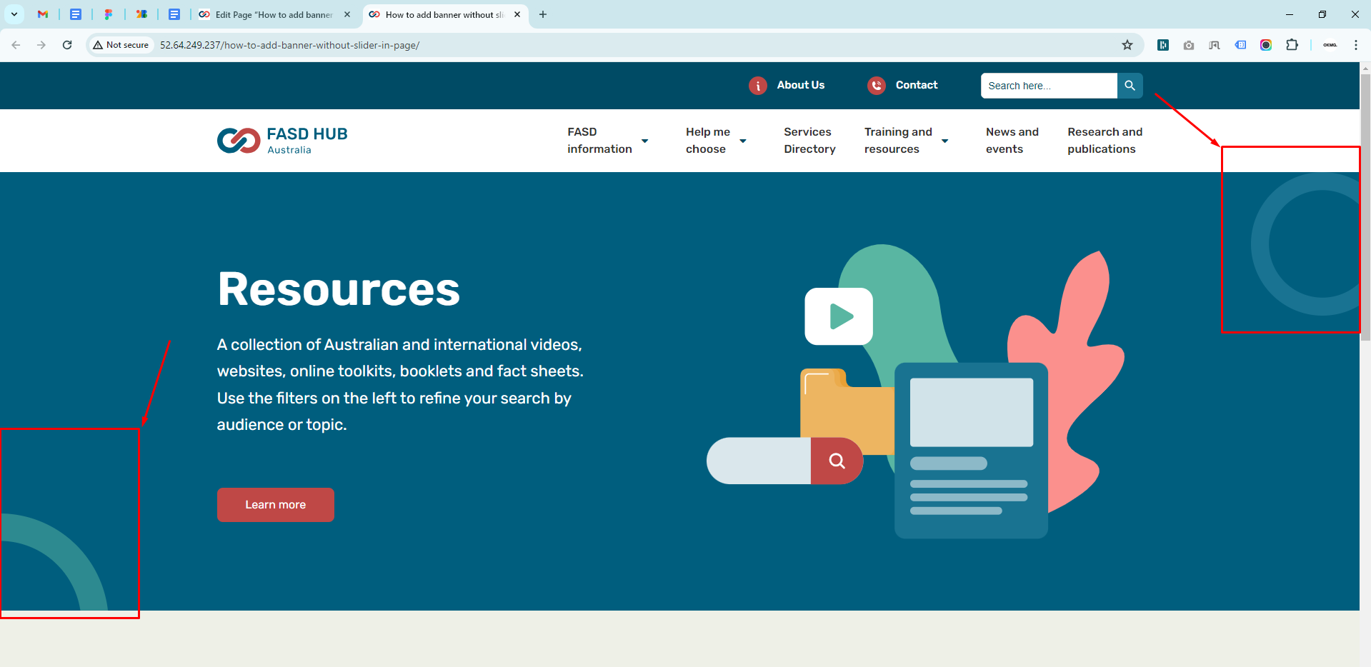

**Four Column Two Row Section**

**How to create a Four Column Two Row Section**

**Preview (Four Column Two Row Section)**

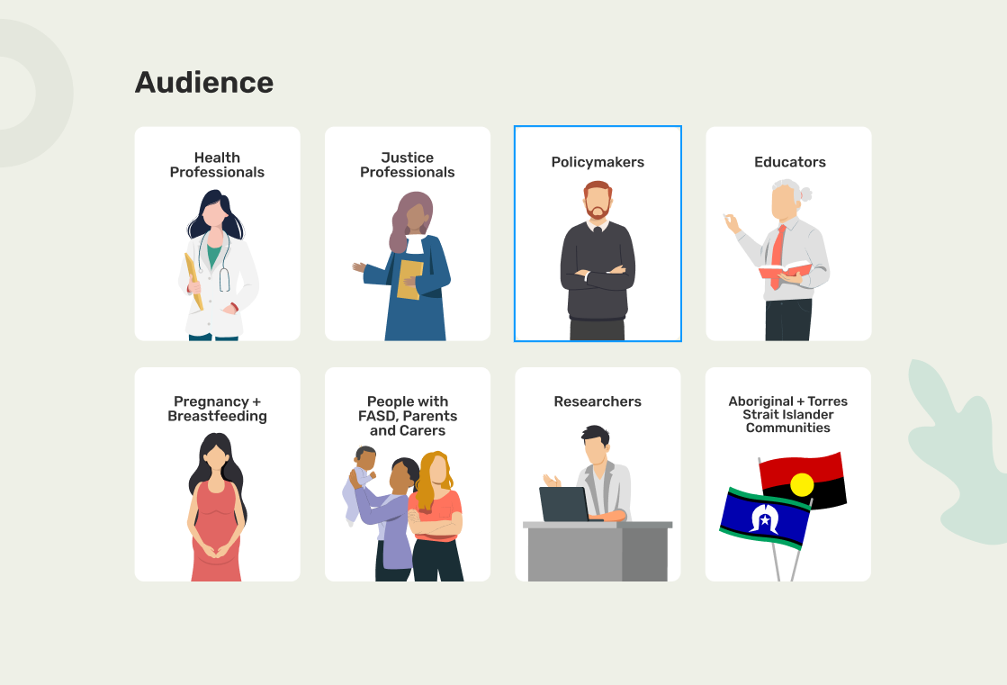

**Steps below:**

First, click on **'Add row**,' then select **'Four Column Two Row Section'** from the dropdown menu, as shown in the screenshot below.

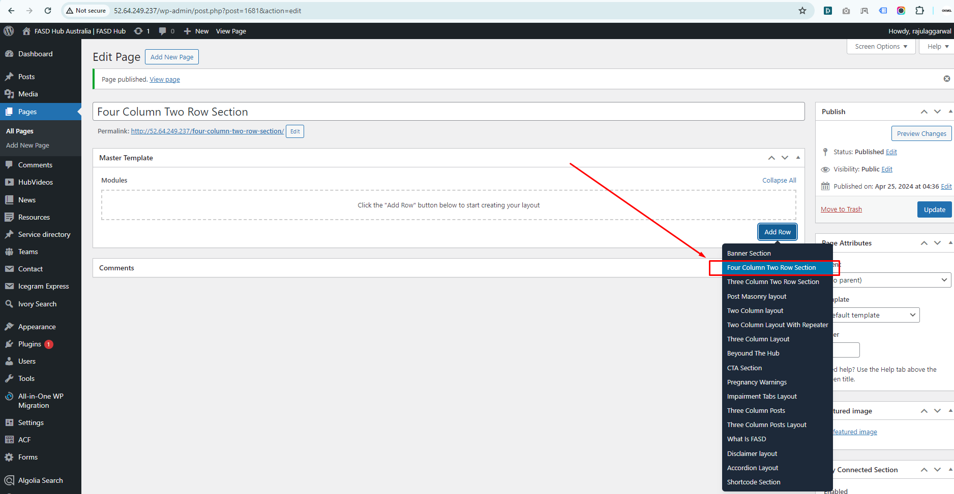

Now you need to add content according to the section's field, as shown in the screenshot below.

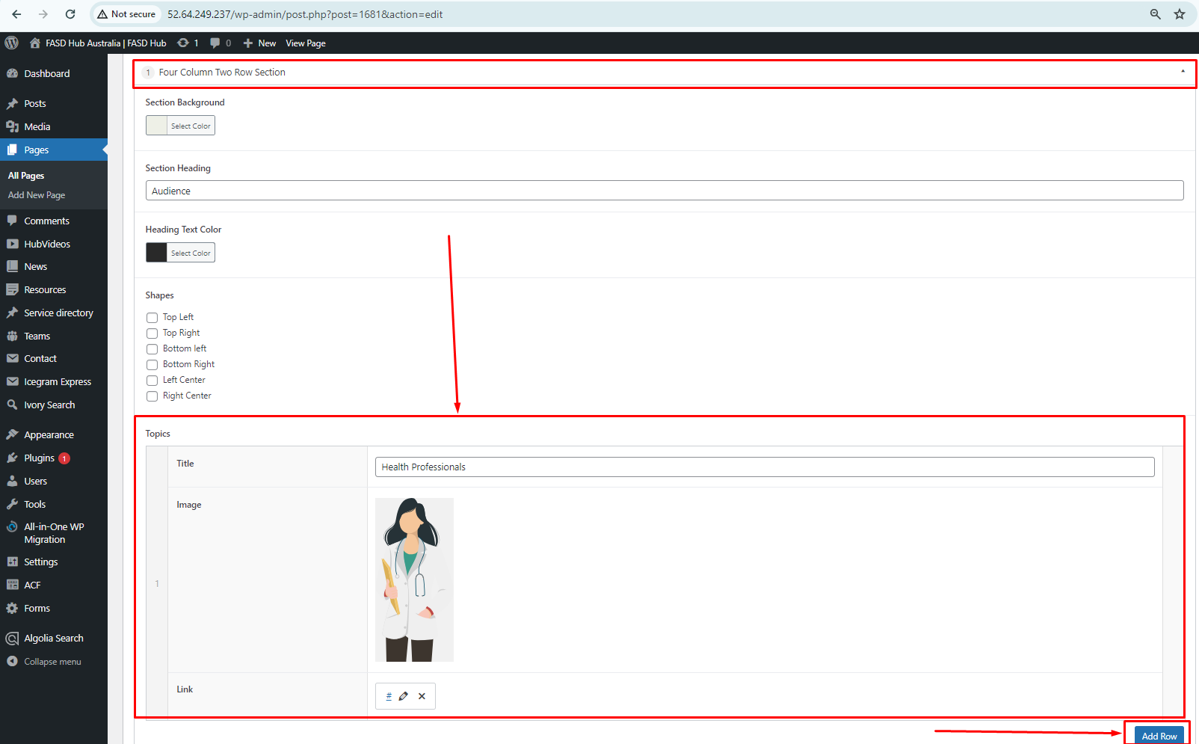

If you want to add more topics, click on the **'Add Row'** button, and a new field box will be added. Then, you can add content to the newly added box, as shown in the screenshot below.

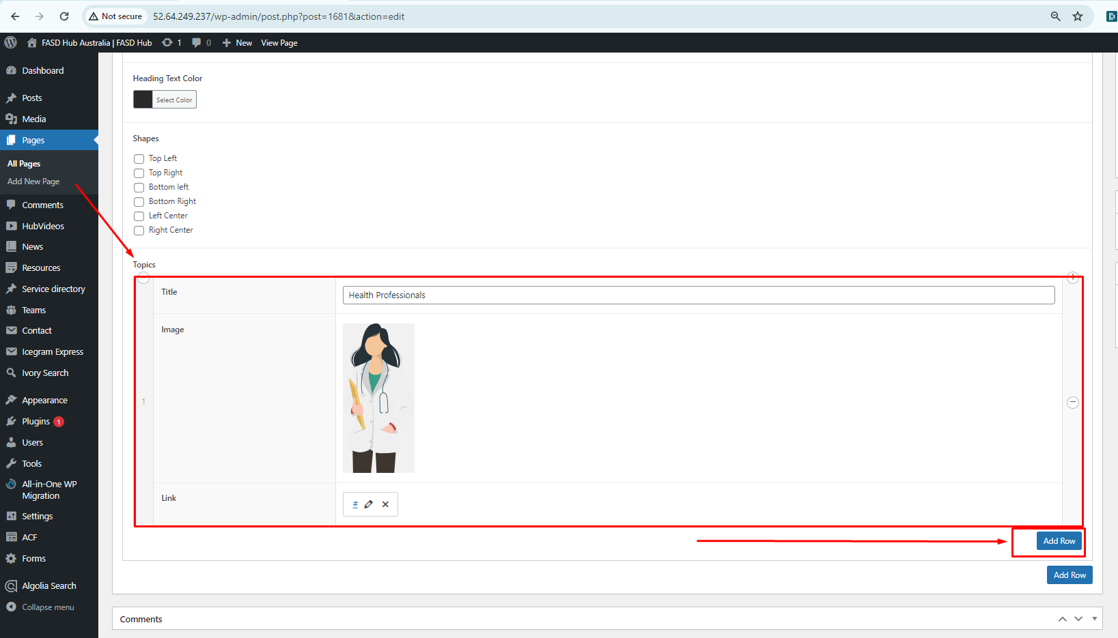

Finally, we have achieved the output of the **'Four Column Two Row Section'** on the front end, as shown in the screenshot below.

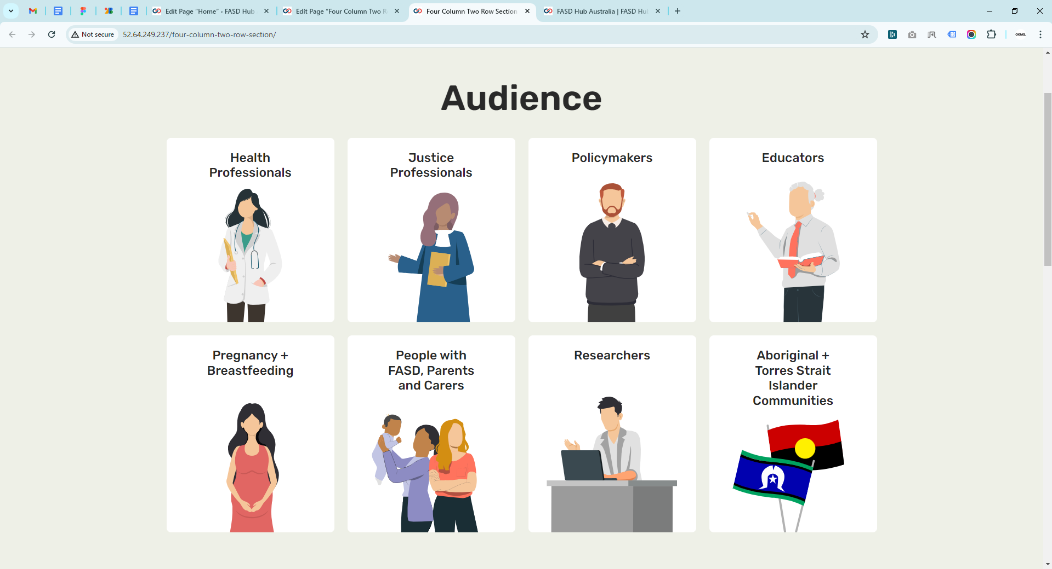

**Three Column Two Row Section**

**How to create a Three Column Two Row Section**

**Preview (Three Column Two Row Section)**

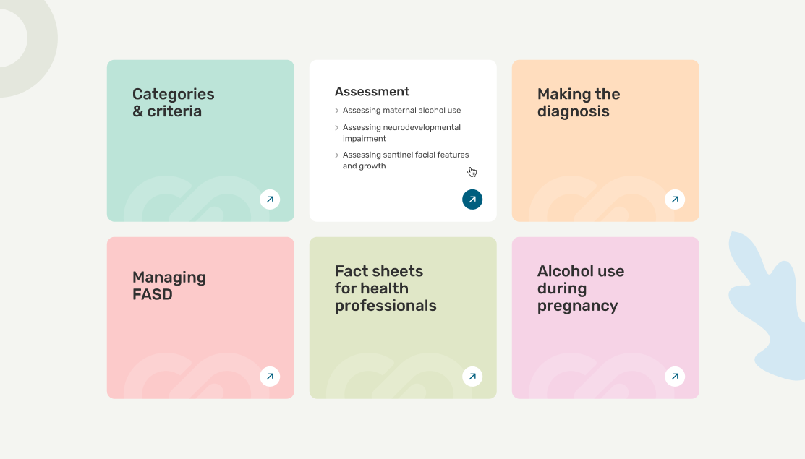

**Steps below:**

First, click on **'Add row**,' then select **'Three Column Two Row Section'** from the dropdown menu, as shown in the screenshot below.

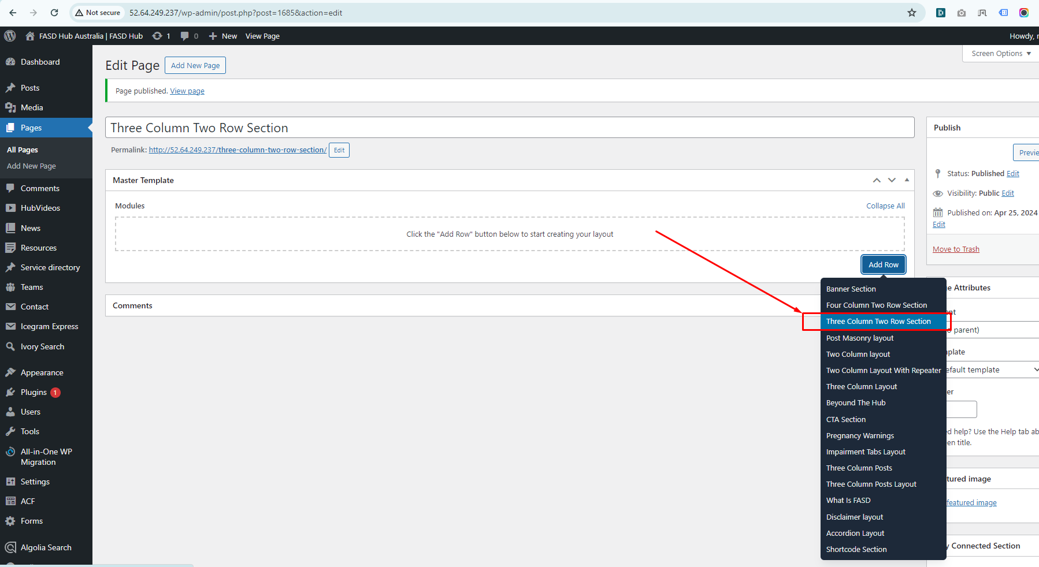

Now that the **'Three Column Two Row Section'** has been added, you need to click on the **'Add Row'** button to add topics, as shown in the screenshot below.

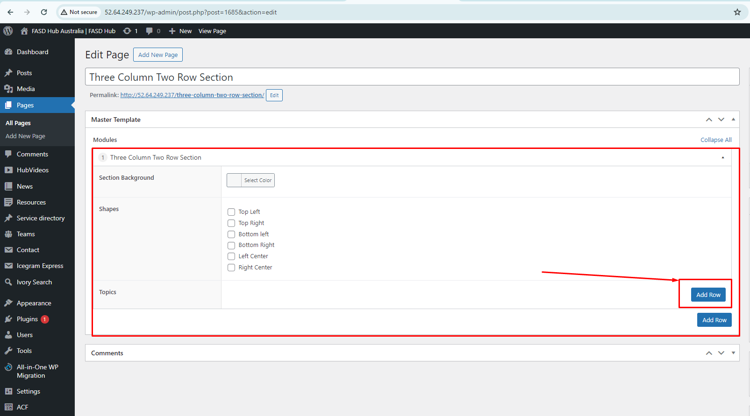

Now that the field box for adding topics has appeared, you need to add content to the field box. If you want to add more topics, click on the **'Add Row'** button, as shown in the screenshot below.

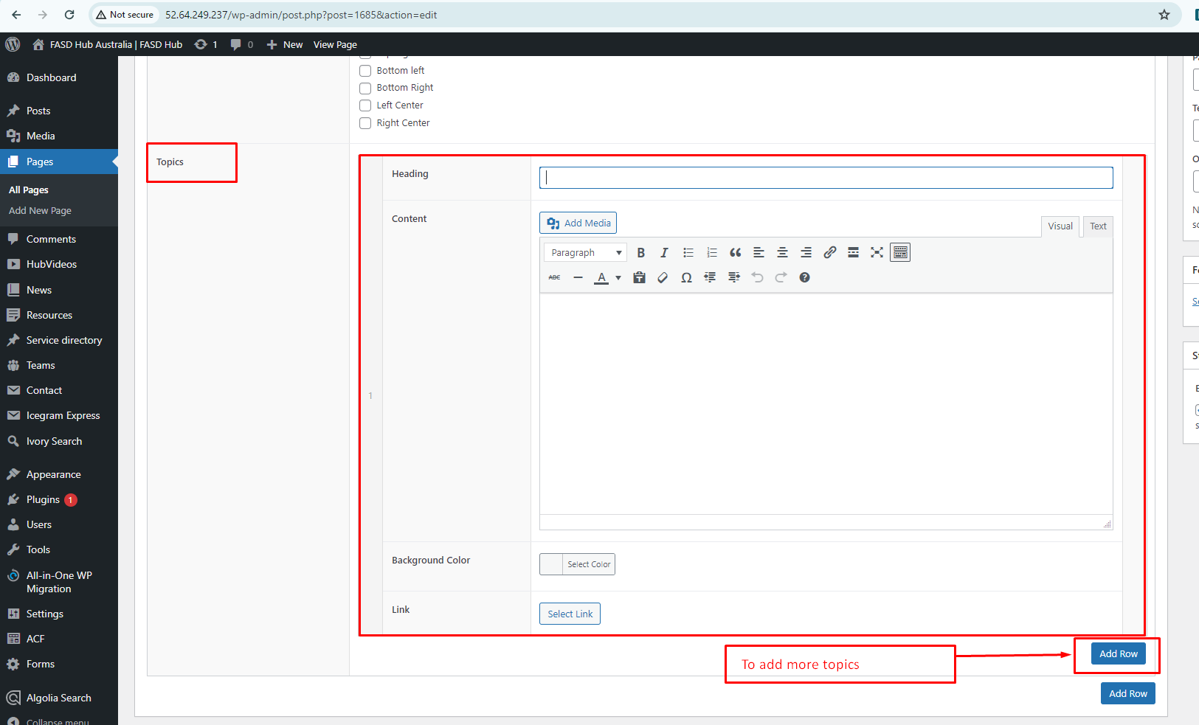

After adding content to these field boxes, save your changes and check your page, as shown in the screenshot below.

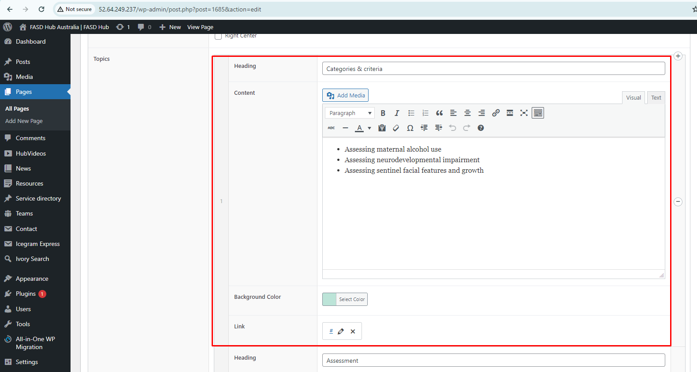

Finally, we have achieved the output of the **Three Column Two Row Section** on the front end, as shown in the screenshot below.

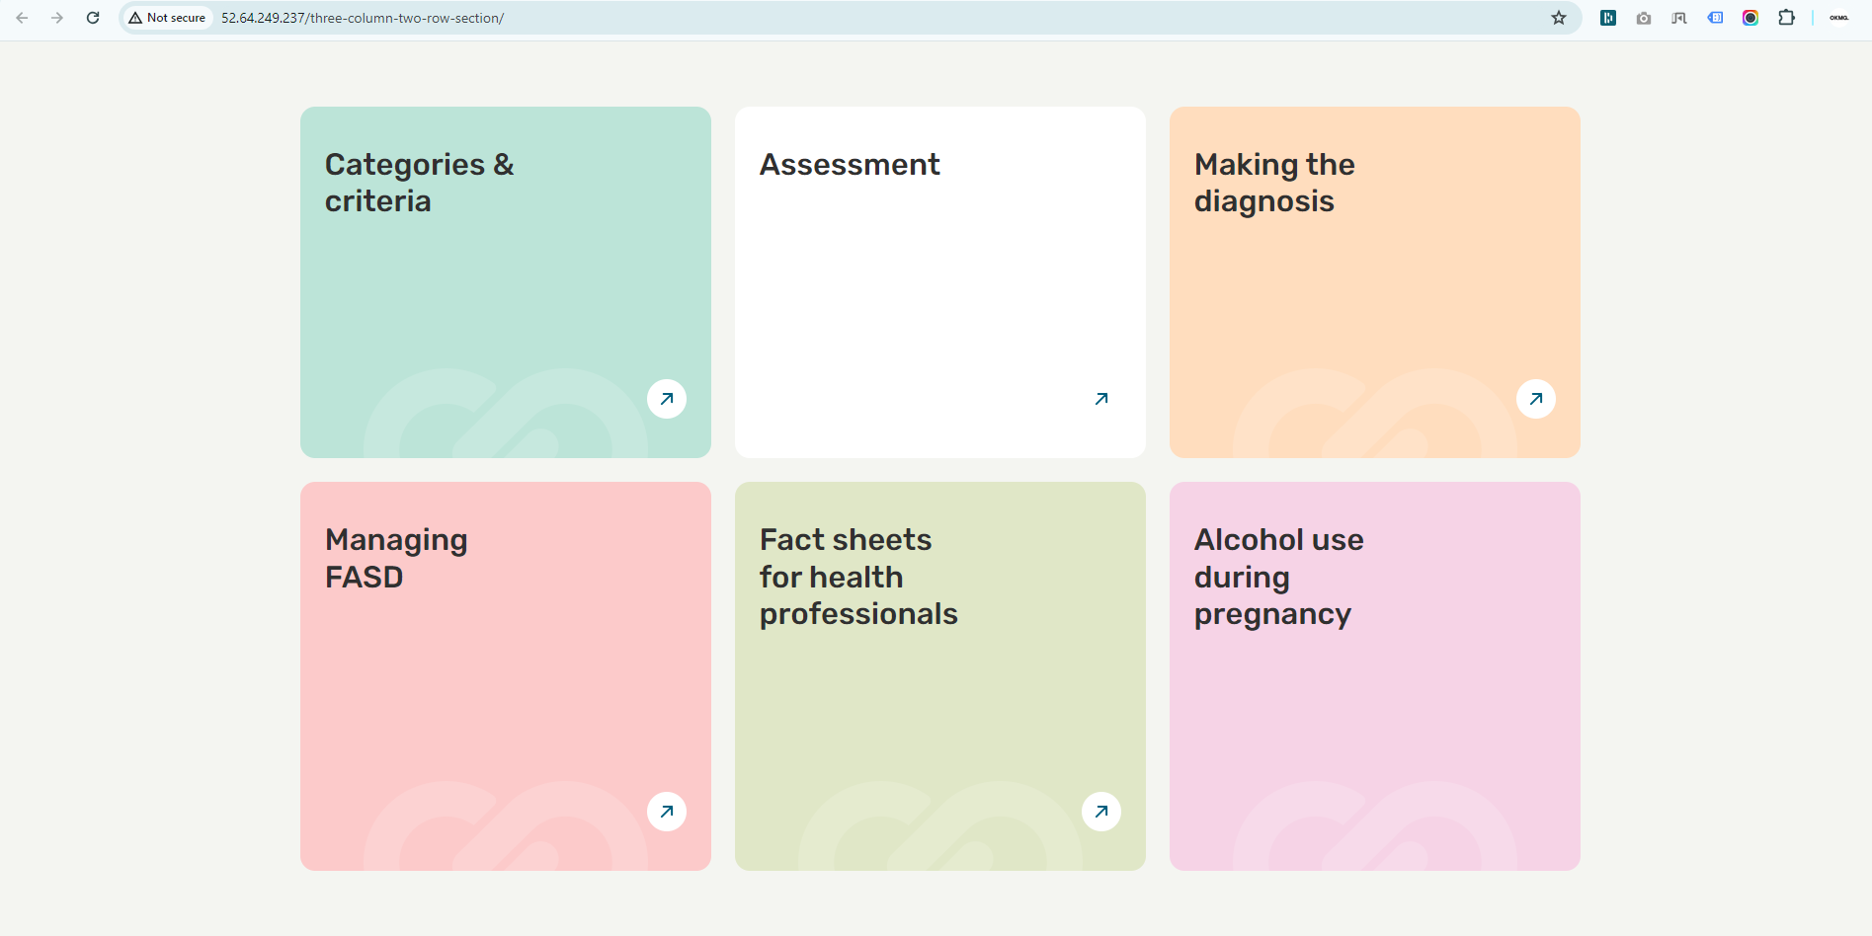

**Post Masonry Layout**

**How to create a Post Masonry Layout section**

**Preview (Post Masonry Layout section)**



**Steps below:**

First, click on **'Add row**,' then select **Post Masonry Layout** from the dropdown menu, as shown in the screenshot below.

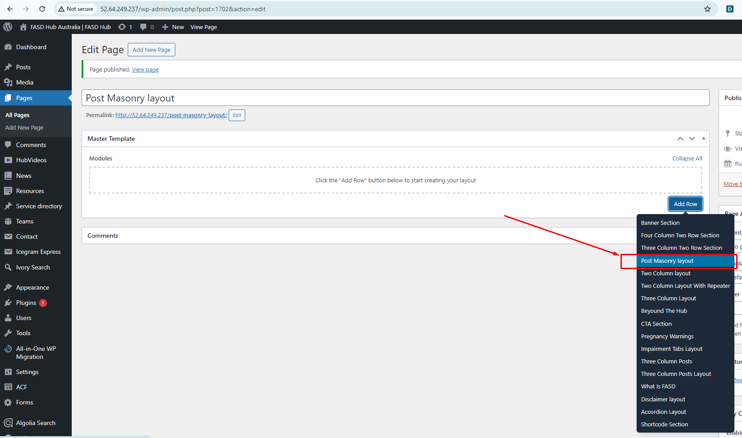

You will now see the field boxes for creating a post-masonry layout, as shown in the screenshot below.

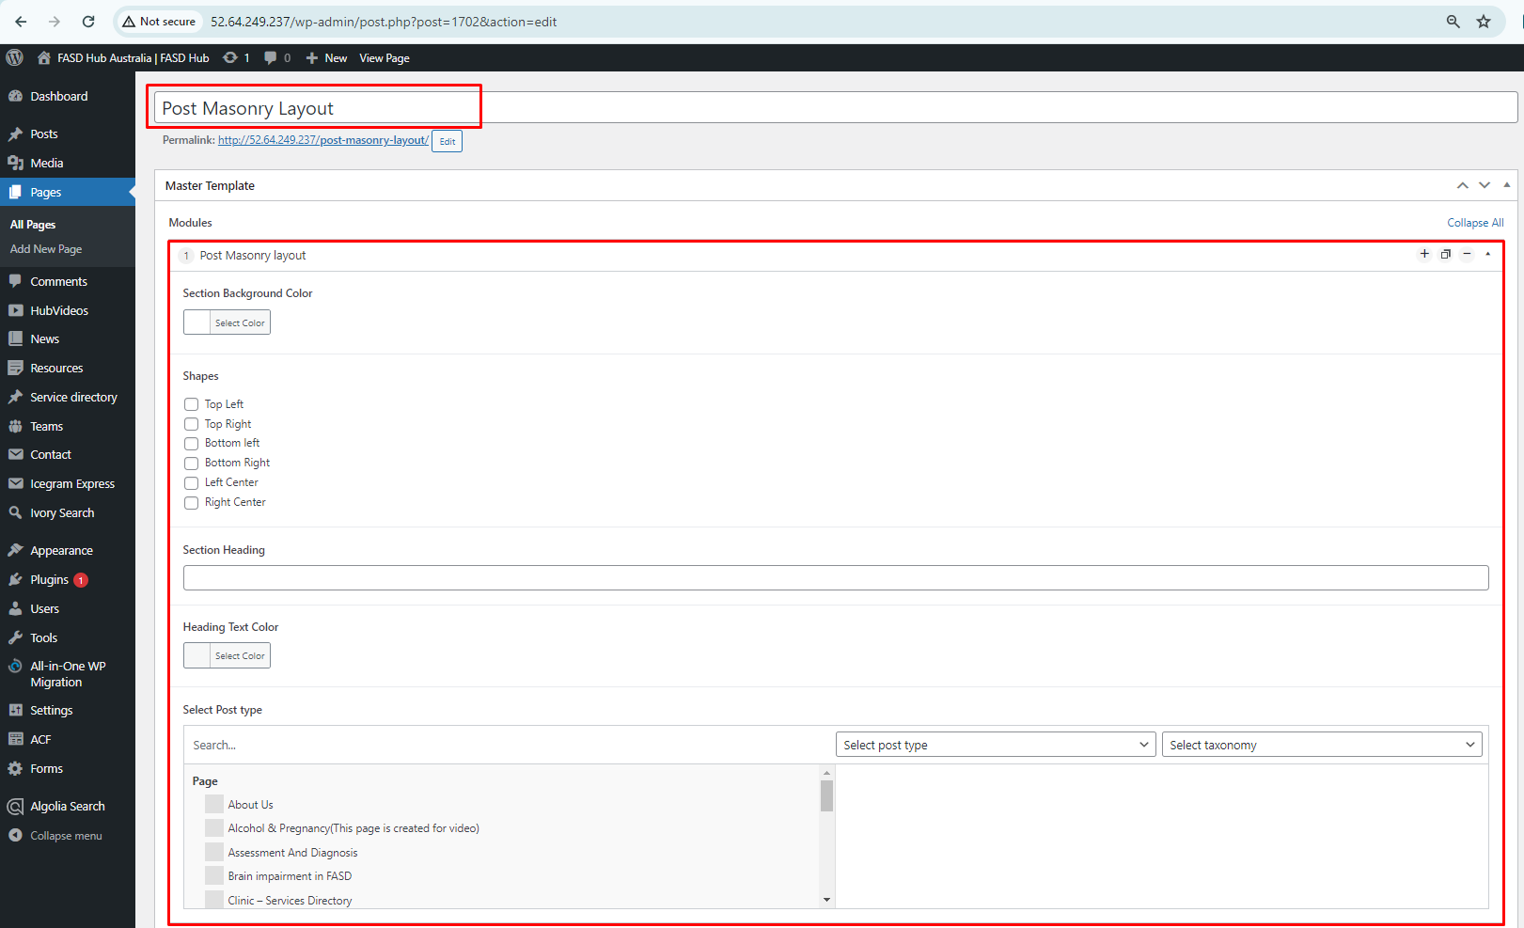

First, select the **post type** for which you want to create the masonry layout, such as '**Resources**' from the dropdown menu. The posts belonging to that post type will be displayed on the left side. Then, you need to select the posts you want to include, and they will move to the right side, as shown in the screenshot below.

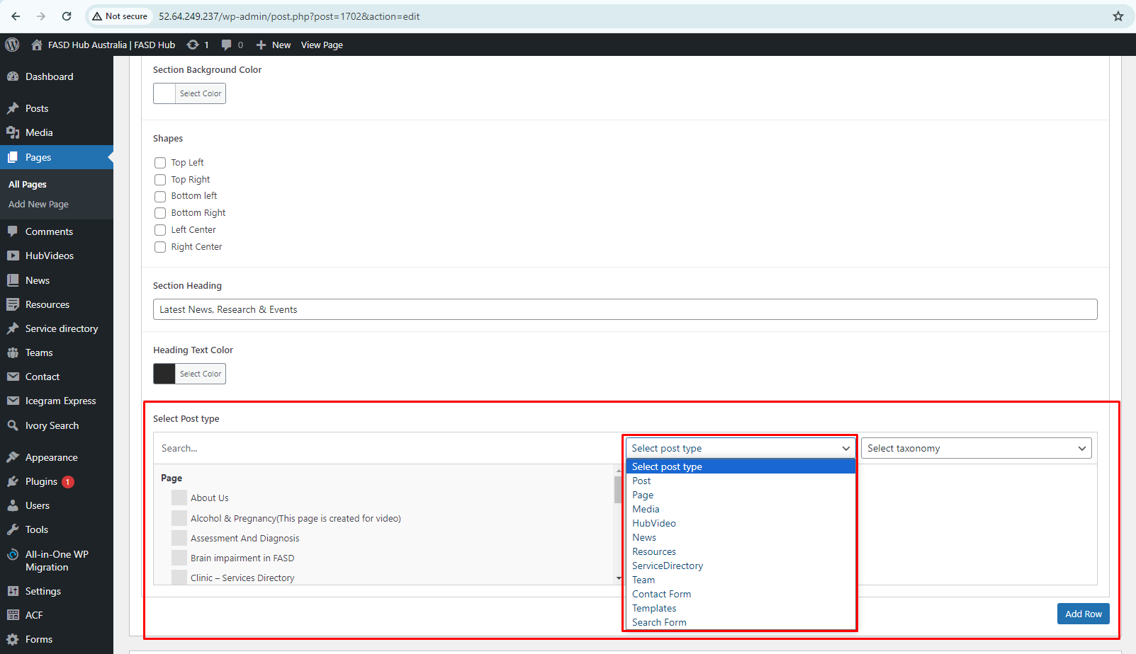

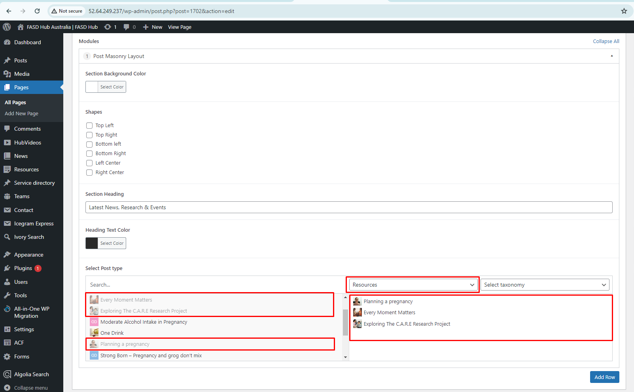

You can also filter and add posts according to taxonomy along with the **'Resource'** post type, as shown in the screenshot below.

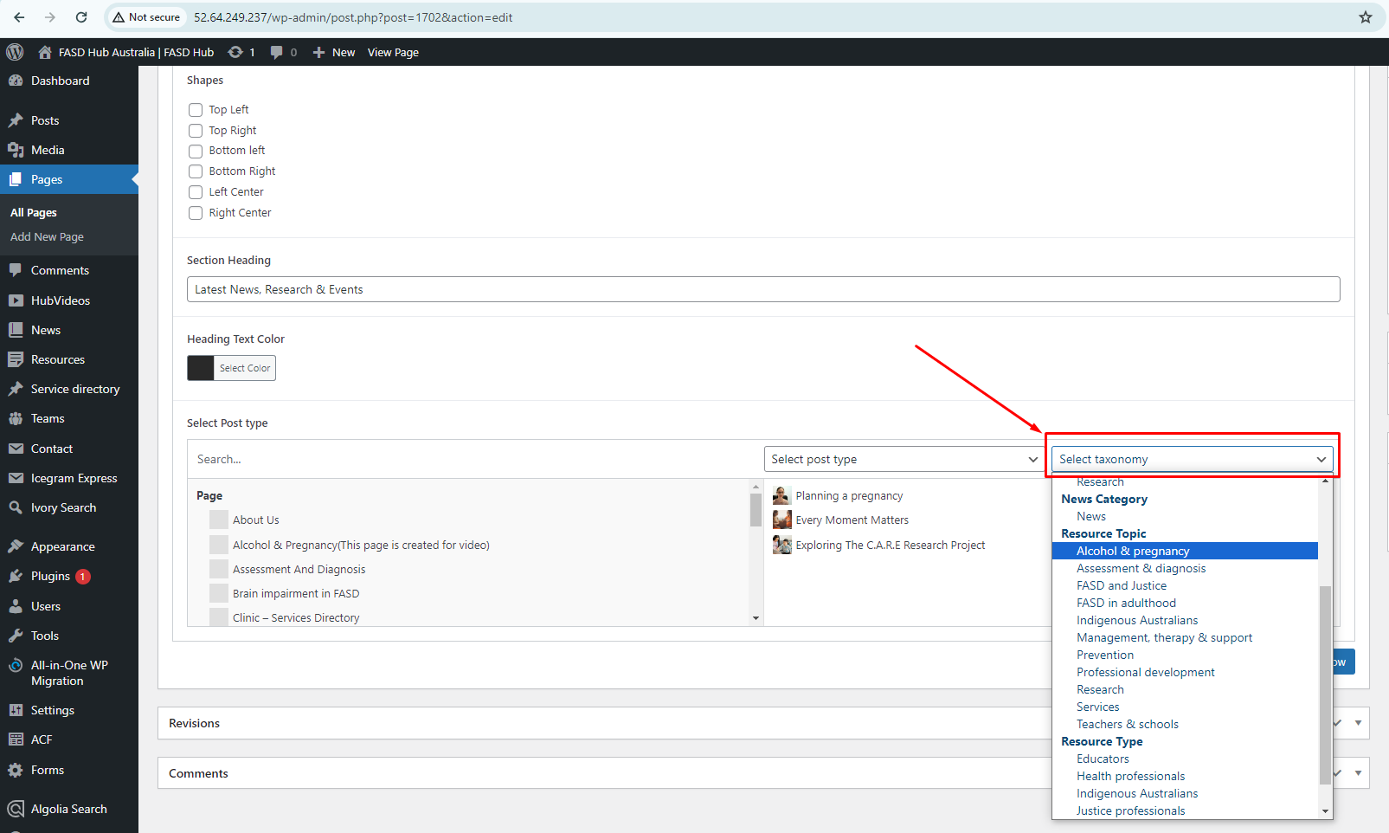

After adding content to these field boxes, save your changes and check your page. Finally, we have achieved the output of the **Post Masonry Layout section** with the selected posts from the backend on the front end, as shown in the screenshot below

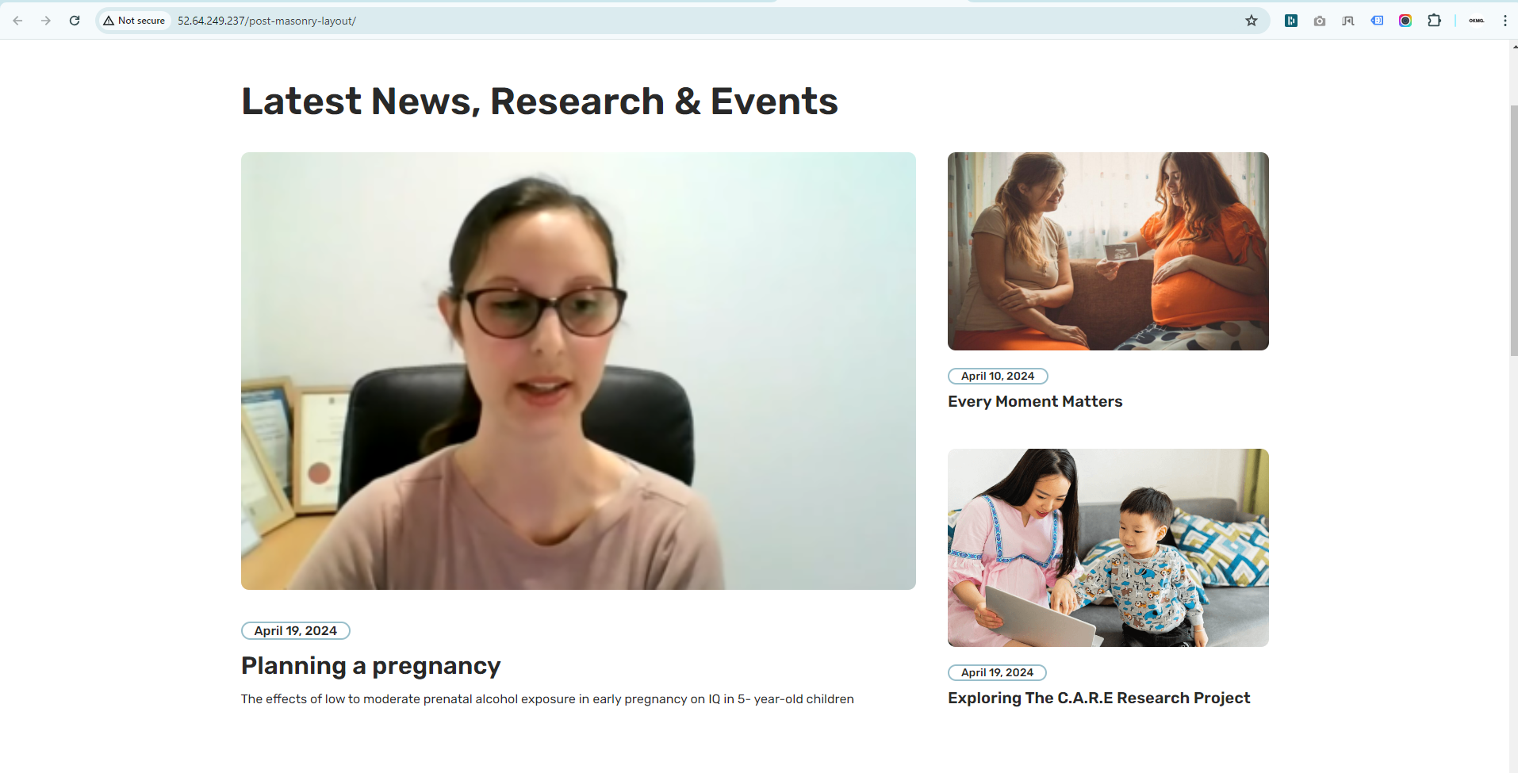

**Two Column Layout**

**How to create a Two Column Layout section**

There are six types of layouts to create a Two Column Layout section on a page.

**a) Text & Visual Duo**

**b) Visual Duo & Text Editor**

**c) Visual & Multiple Text Editor**

**d) Both Side Text**

**e) Both Side Visual**

**f) Both Side Text & Image**

## **'Text & Visual Duo'**

**How to create a Two Column Layout section with the layout option 'Text & Visual Duo'.**

**Preview (Two Column Layout section - Text & Visual Duo)**



**Steps below:**

First, click on **'Add row**,' then select **Two Column Layout** from the dropdown menu, as shown in the screenshot below.

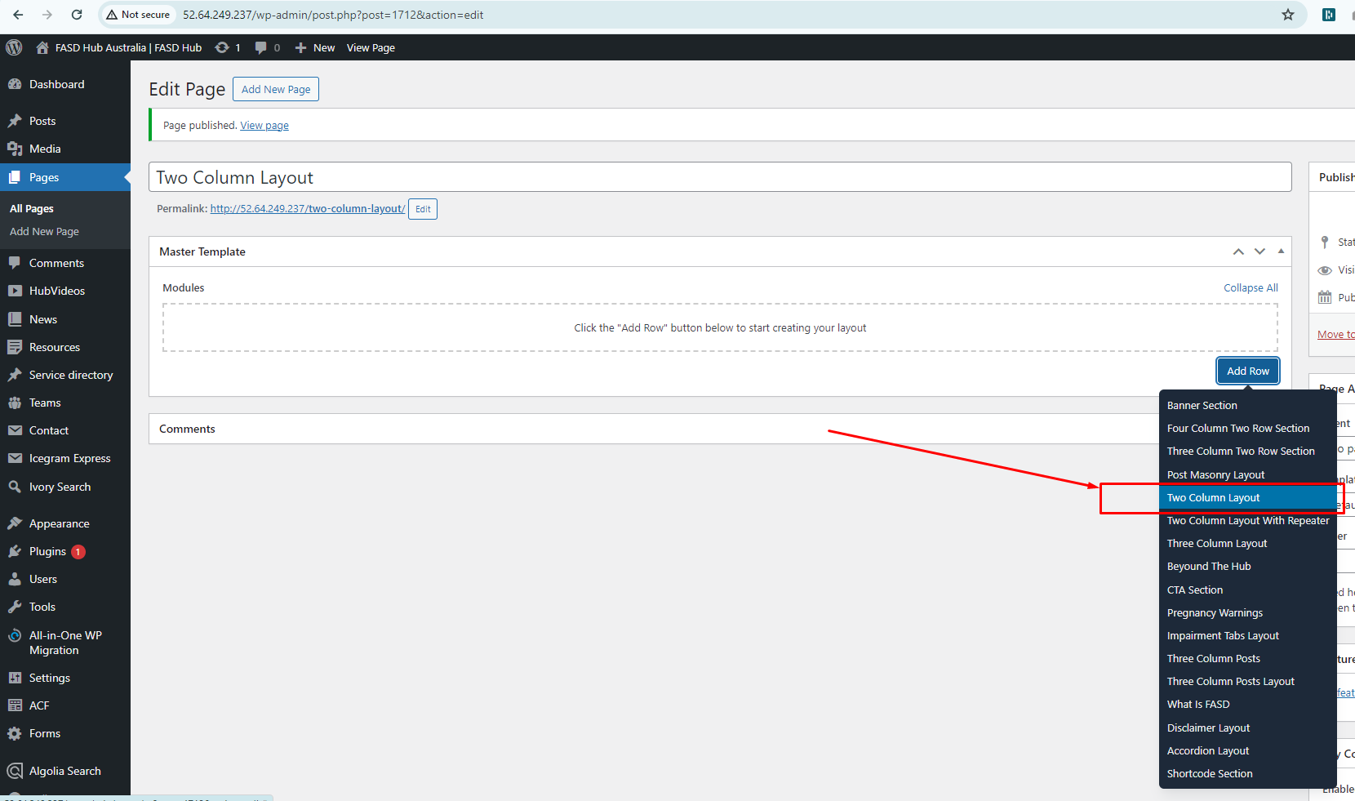

After this, you should select the '**Text & Visual**' option from the Type of Layout, as shown in the screenshot below.

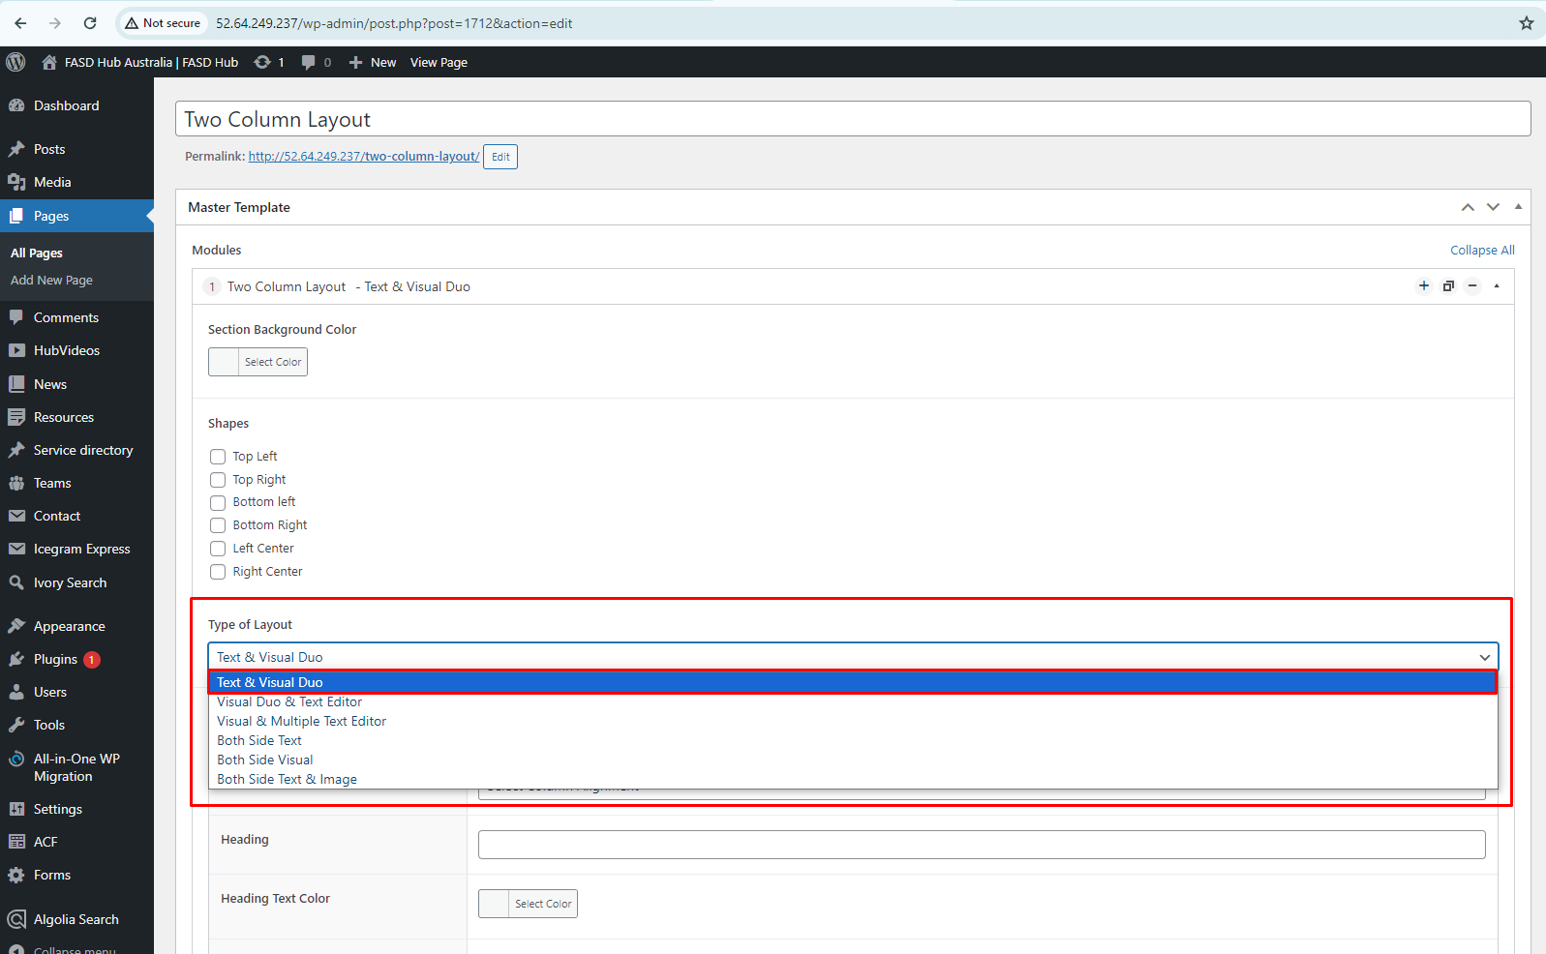

You will now see field boxes in the **Two Column Layout** for the **Text & Visual layout** option. You need to input data such as background images, shapes, and content according to the fields, as shown in the screenshot below.

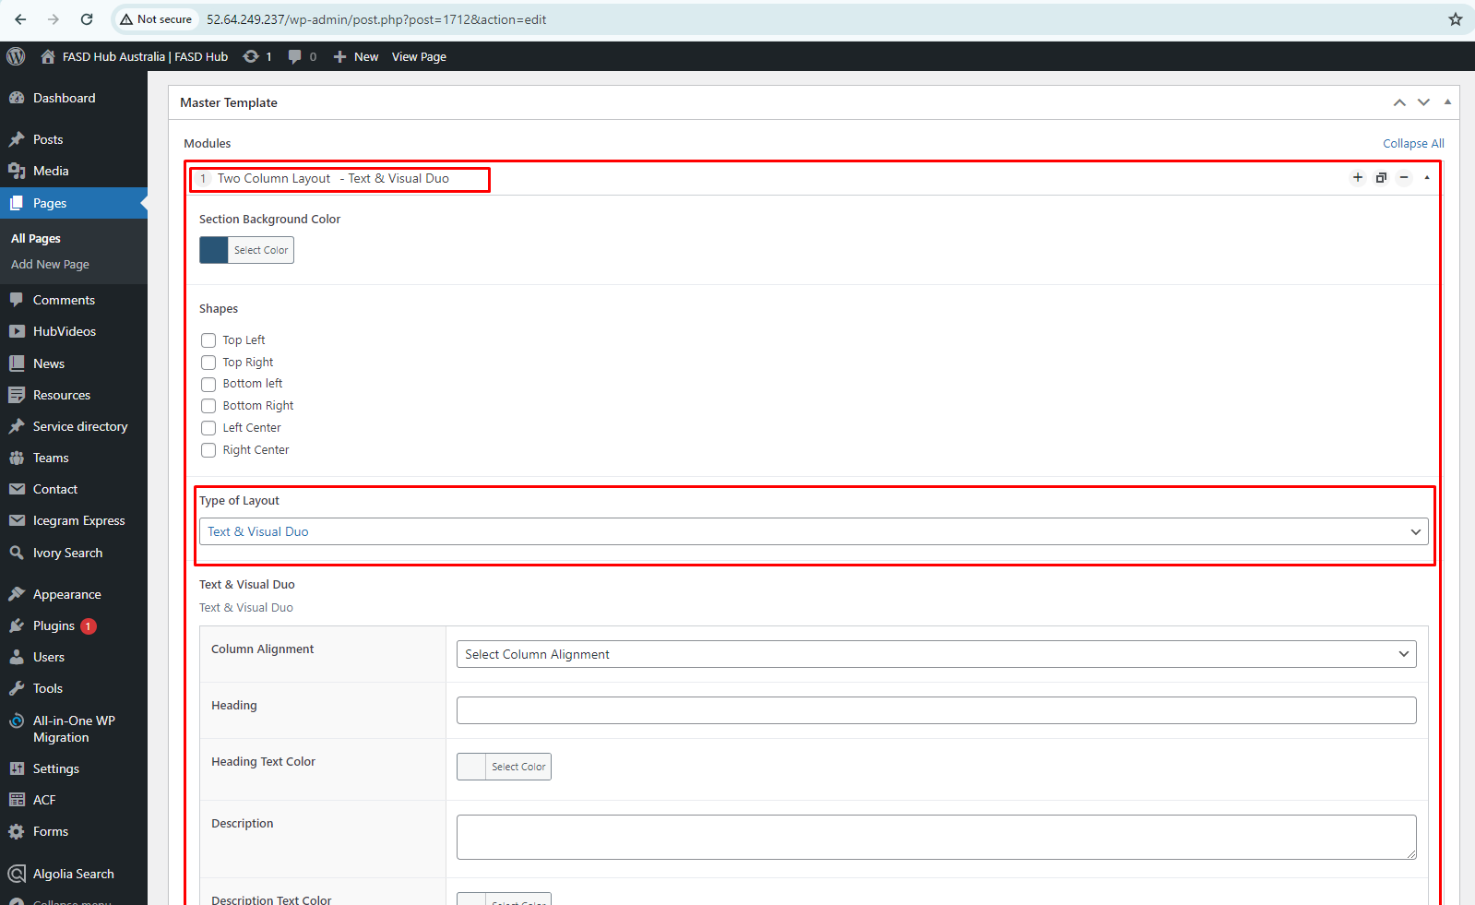

While adding content, you can also set the **Column Alignment**. We have set the option **'Image on the right side**' and saved the page, as shown in the screenshot below.

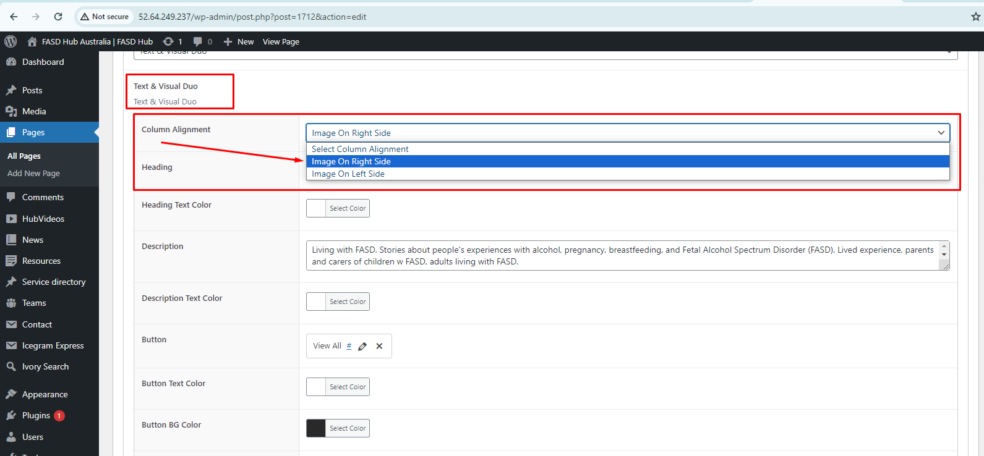

Finally, we have achieved the output of the **Two Column Layout** for the **Text & Visual layout** section on the front end, as shown in the screenshot below.

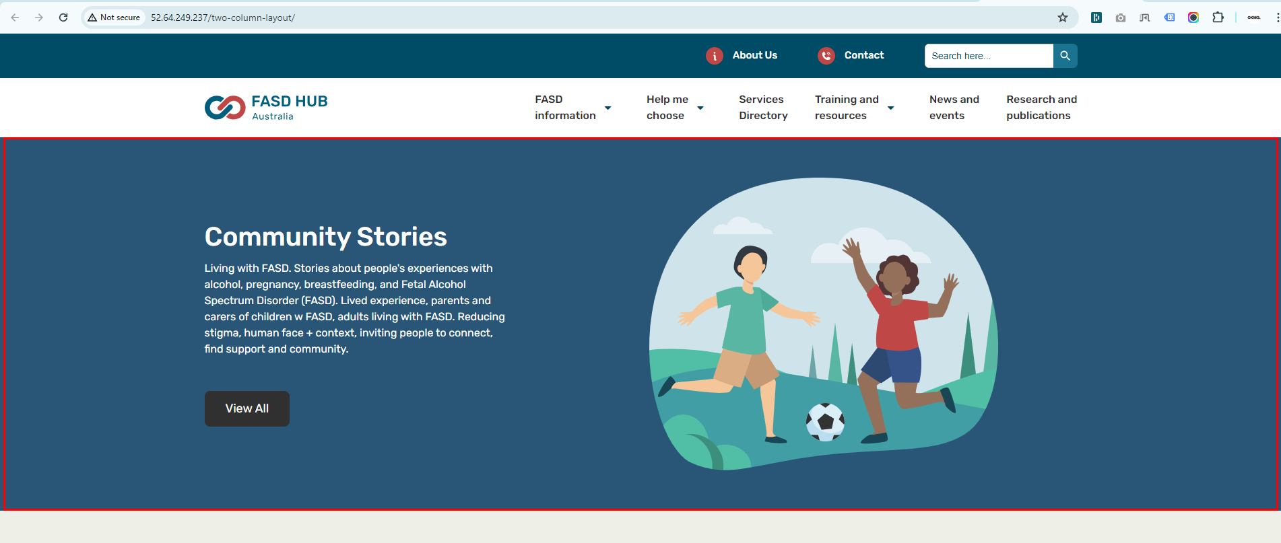

We have set the option **'Image on the left side'** to **Column Alignment**. and saved the page, as shown in the screenshot below.

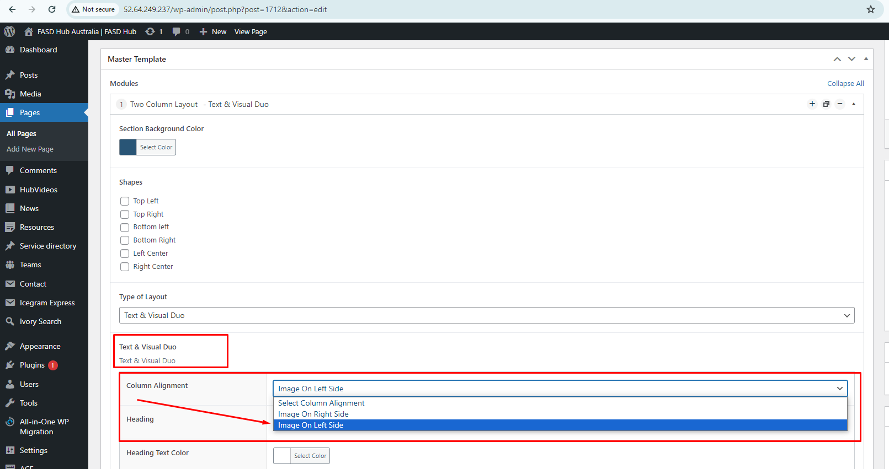

Finally, we have achieved the output of the **Two Column Layout** for the **Text & Visual layout** section on the front end with the image on the left side, as shown in the screenshot below.

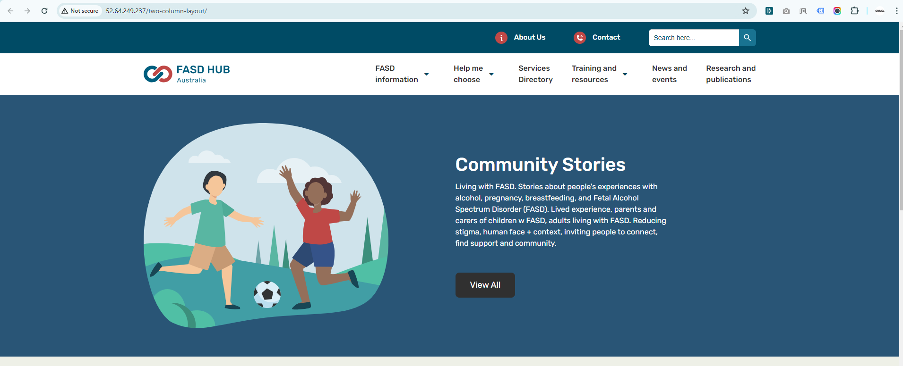

## **'Visual Duo & Text Editor'**

**How to create a Two Column Layout section with the layout option 'Visual Duo & Text Editor'.**

**Preview (Two Column Layout section - Visual Duo & Text Editor)**

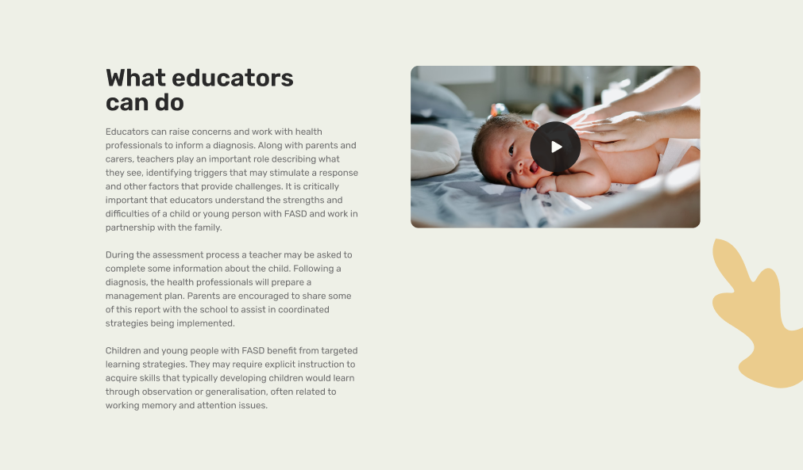

**Steps below:**

First, click on **'Add row**,' then select **Two Column Layout** from the dropdown menu, as shown in the screenshot below.

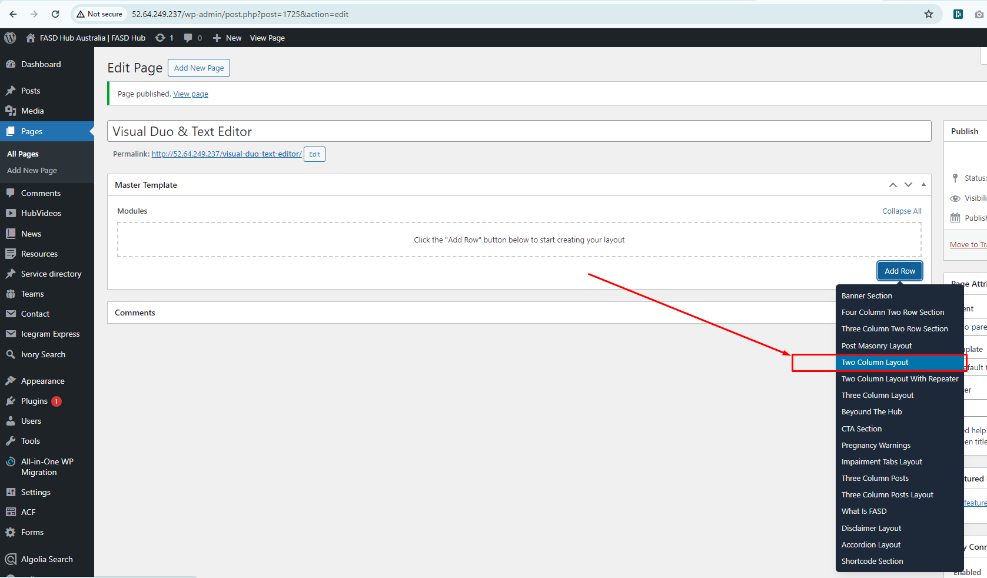

After this, you should select the '**Visual Duo & Text Editor**' option from the Type of Layout, as shown in the screenshot below.

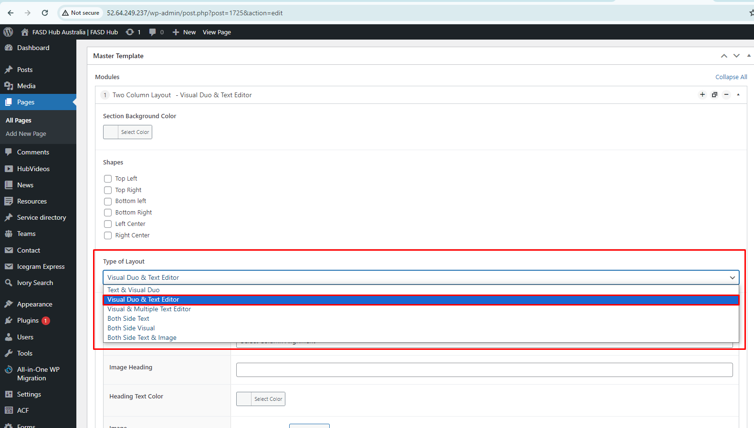

You will now see field boxes in the **Two Column Layout** for the **Visual Duo & Text Editor** option. You need to input data such as background images, shapes, and content according to the fields, as shown in the screenshot below.

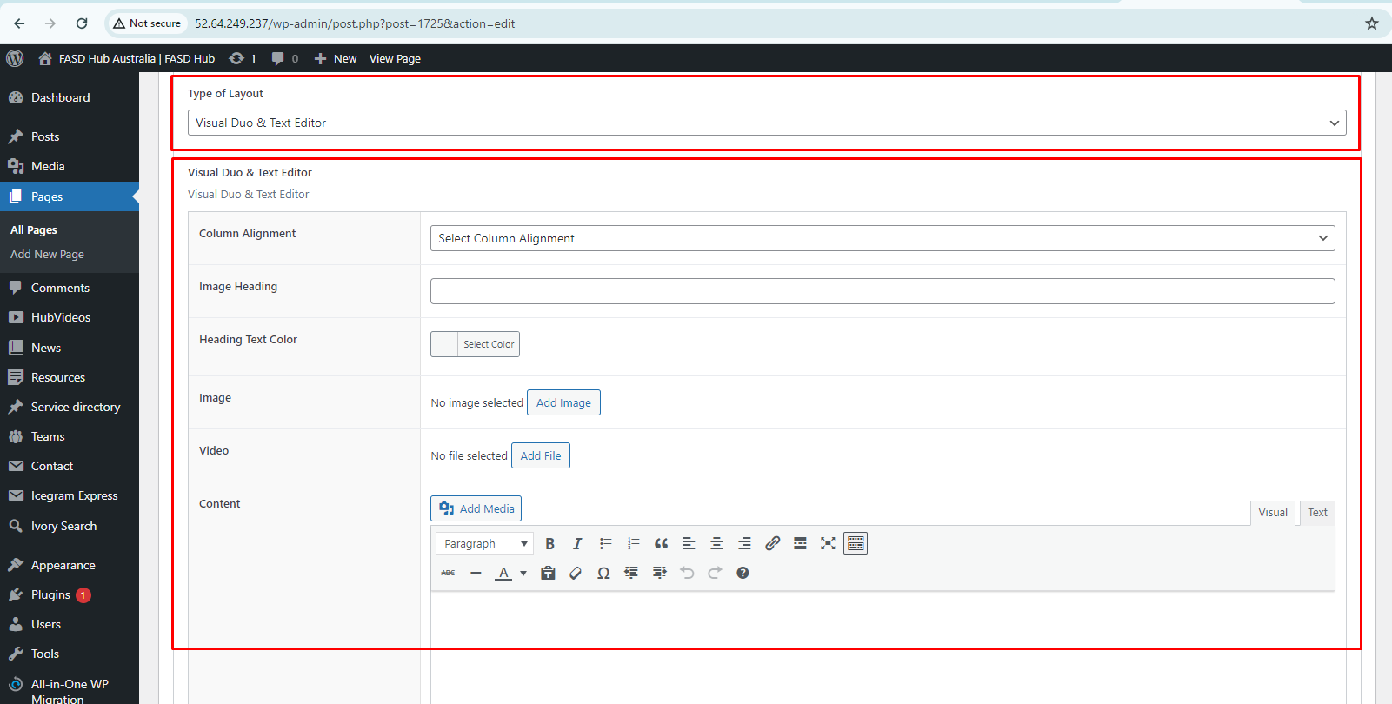

Here, you will have two options: one for **video** and the other for **image**. You can create two types of layouts using these options: '**Image with Text**' and **'Video with Text**'. If you choose to add a **video**, you will see the option for the **featured image**, where you need to set the **thumbnail**, as shown in the screenshot below.

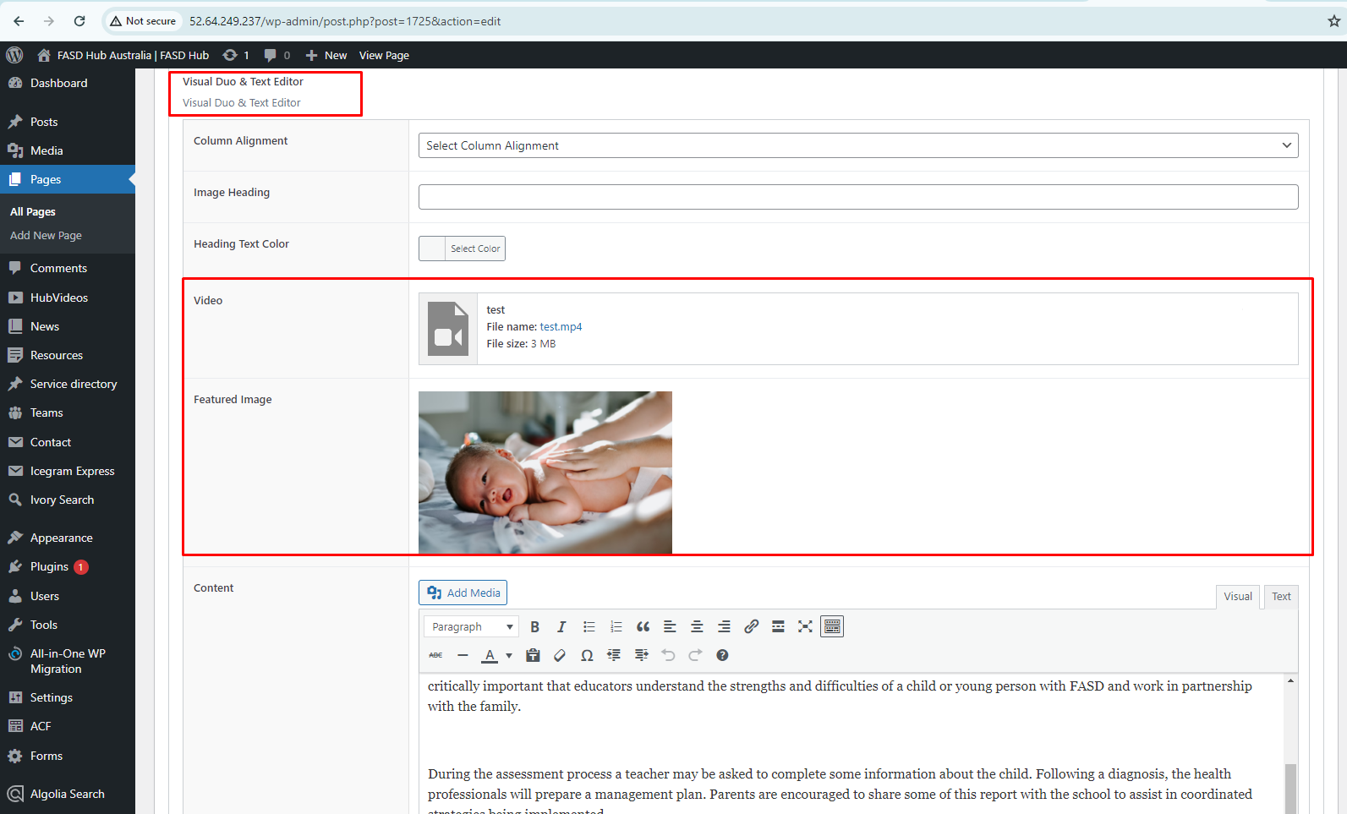

After adding content to these field boxes, save your changes and check your page, as shown in the screenshot below.

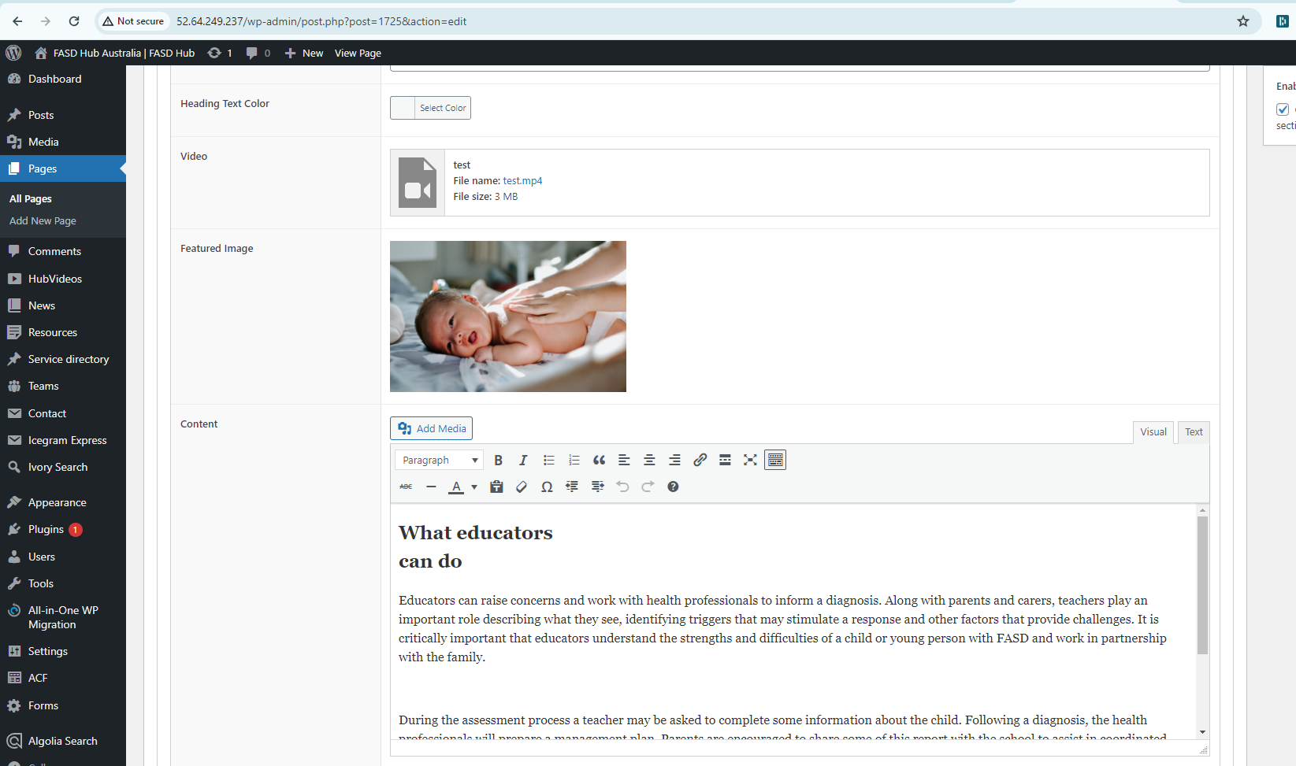

Finally, we have achieved the output of the **Two Column Layout** for the **Visual Duo & Text Editor** section on the front end with the **video** on the right side, as shown in the screenshot below.

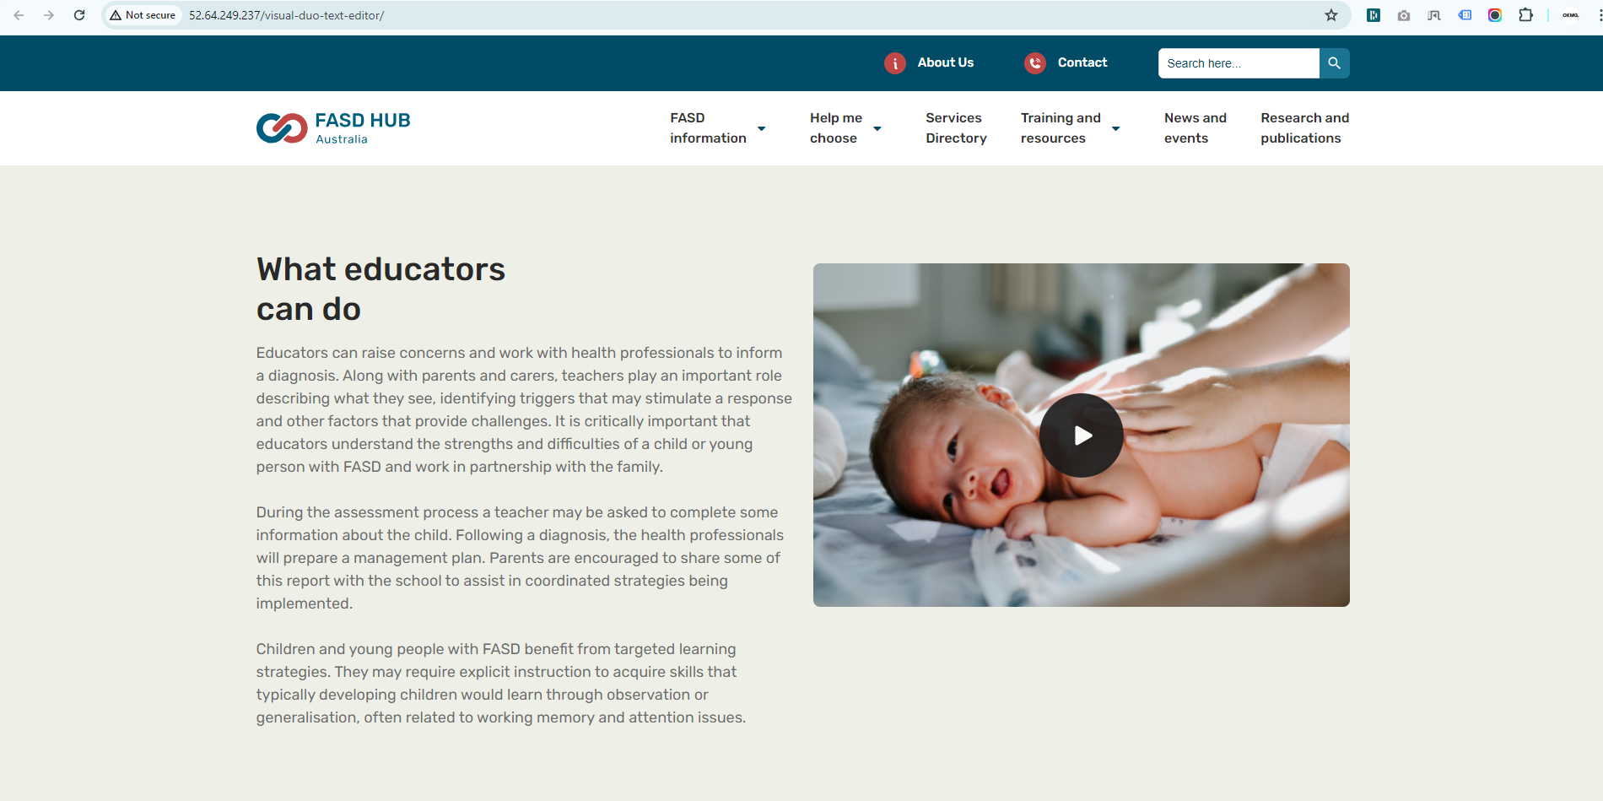

## **‘Visual & Multiple Text Editor'**

**How to create a Two Column Layout section with the layout option 'Visual & Multiple Text Editor'.**

**Preview (Two Column Layout section - Visual & Multiple Text Editor)**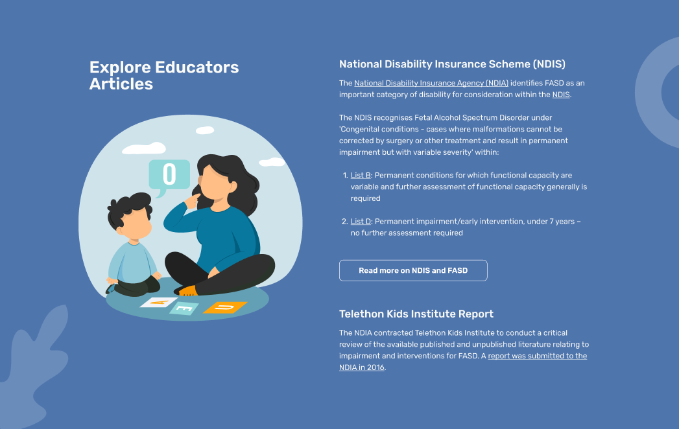

**Steps below:**

First, click on **'Add row**,' then select **Two Column Layout** from the dropdown menu, as shown in the screenshot below.

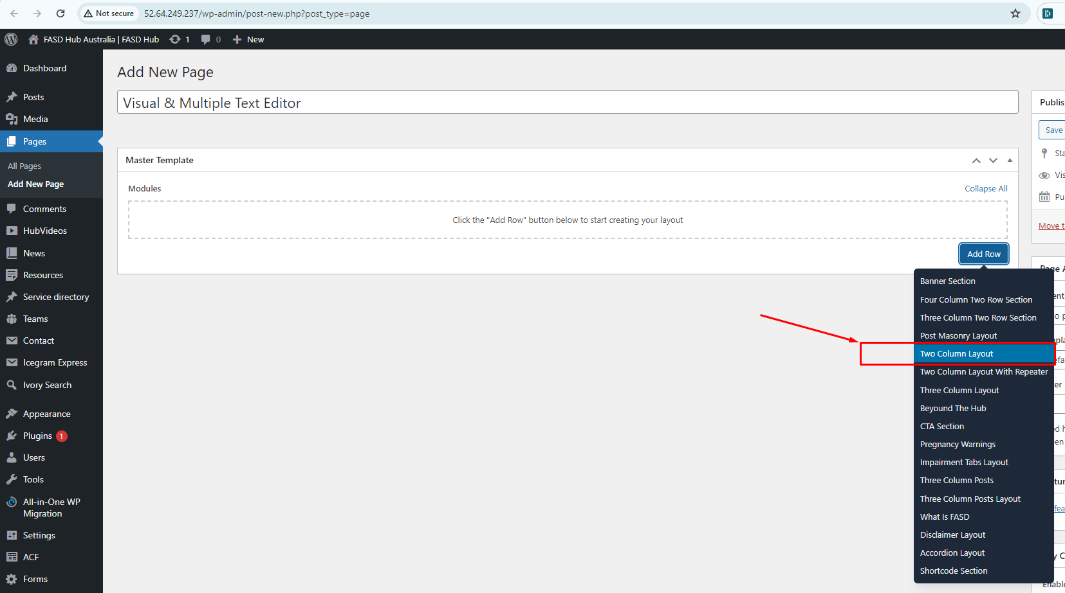

After this, you should select the '**Visual & Multiple Text Editor**' option from the Type of Layout, as shown in the screenshot below.

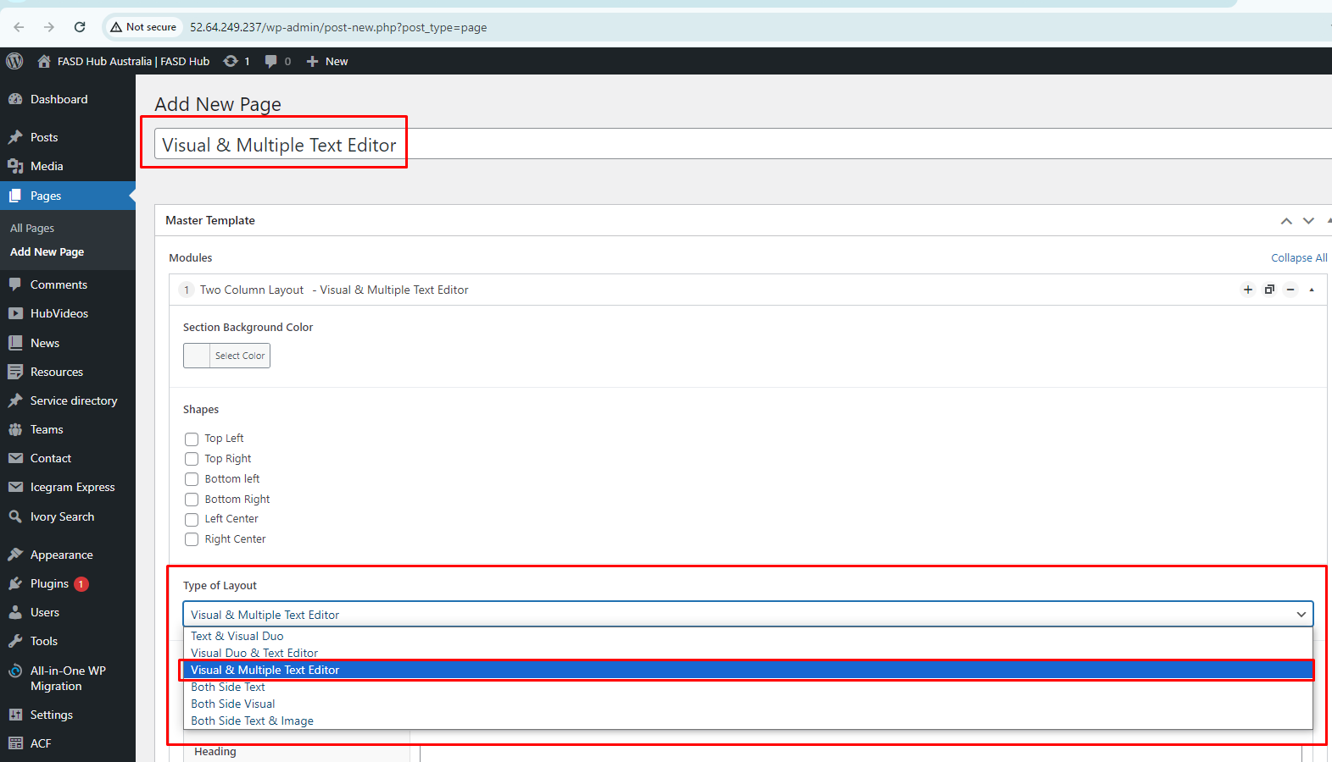

Here, you will have two options: one for **video** and the other for **image**. You can create two types of layouts using these options: '**Image with Text**' and **'Video with Text**'. If you choose to add a **video**, you will see the option for the **featured image**, where you need to set the **thumbnail**, as shown in the screenshot below.

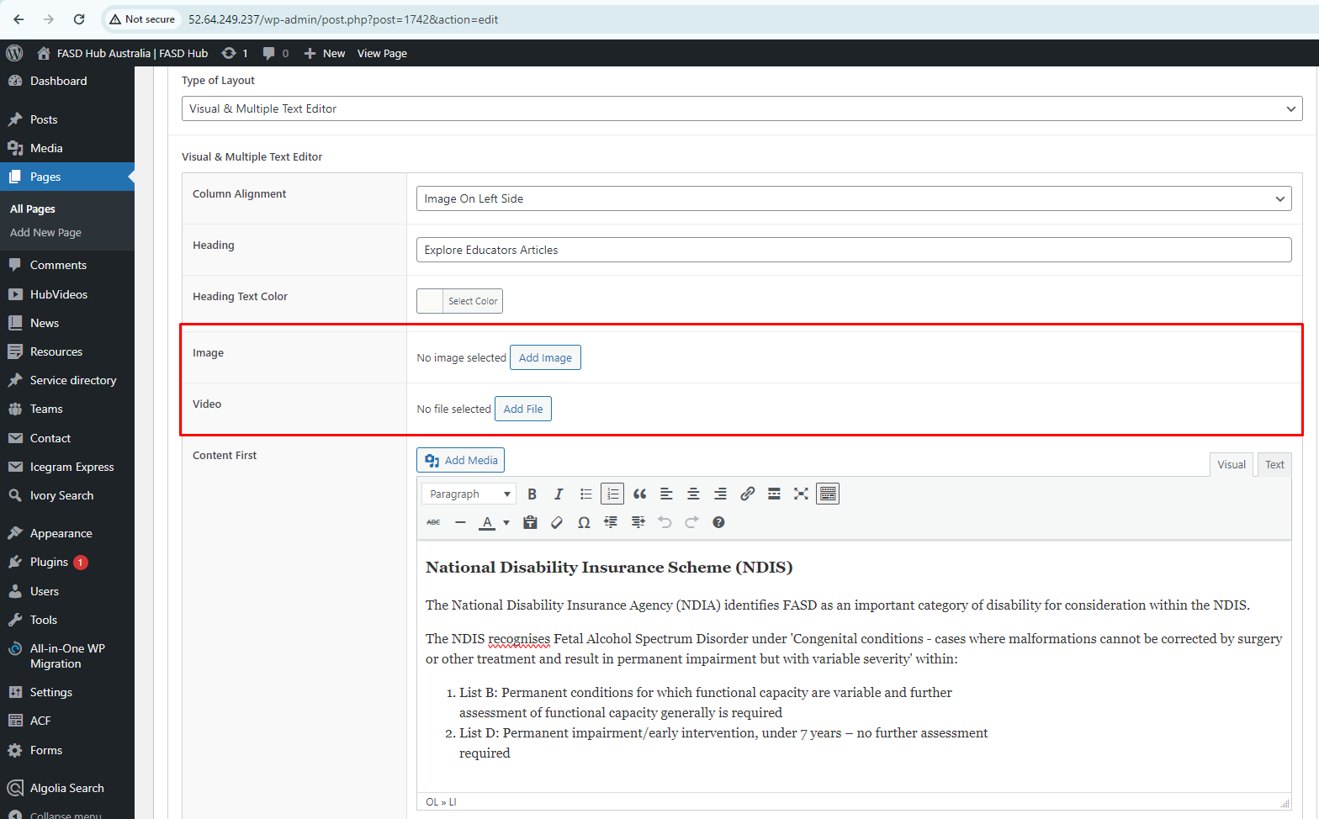

After adding content to these field boxes, save your changes and check your page, as shown in the screenshot below.

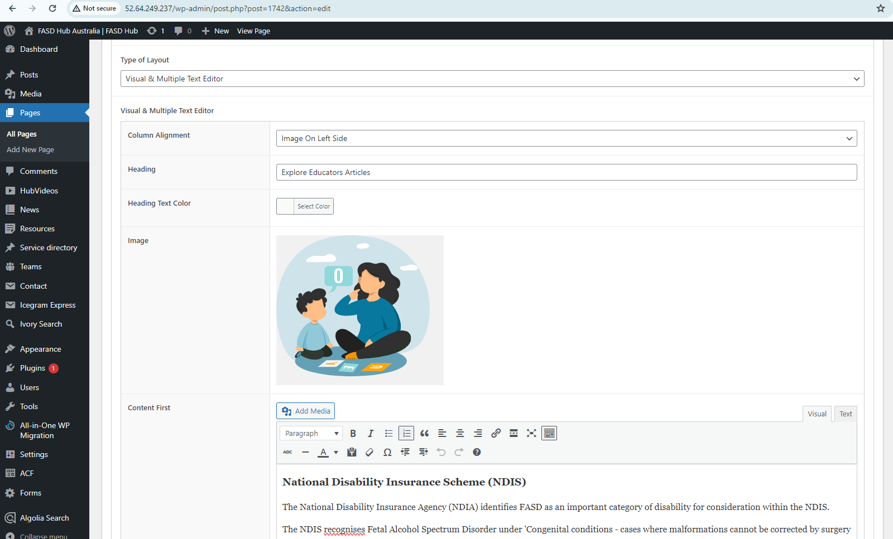

Finally, we have achieved the output of the **Two Column Layout** for the **Visual & Multiple Text Editor** section on the front end with the **image** on the left side, as shown in the screenshot below.

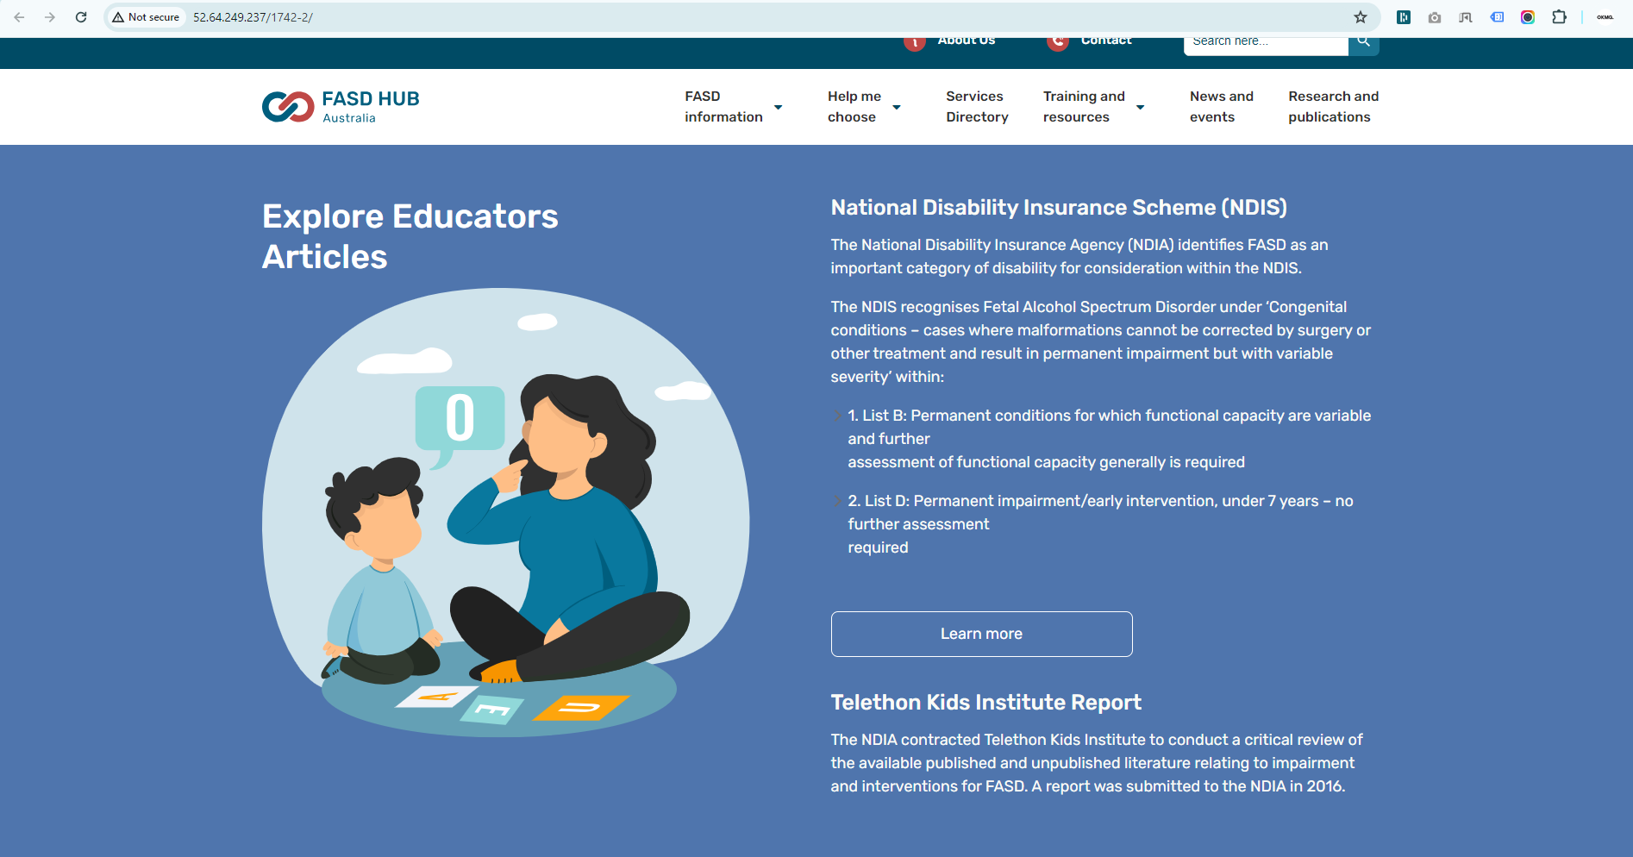

## **‘Both Side Text'**

**How to create a Two Column Layout section with the layout option 'Both Side Text'.**

**Preview (Two Column Layout section - Both Side Text)**

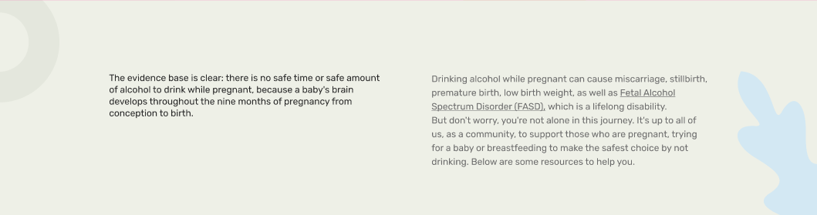

**Steps below:**

First, click on **'Add row**,' then select **Two Column Layout** from the dropdown menu, as shown in the screenshot below.

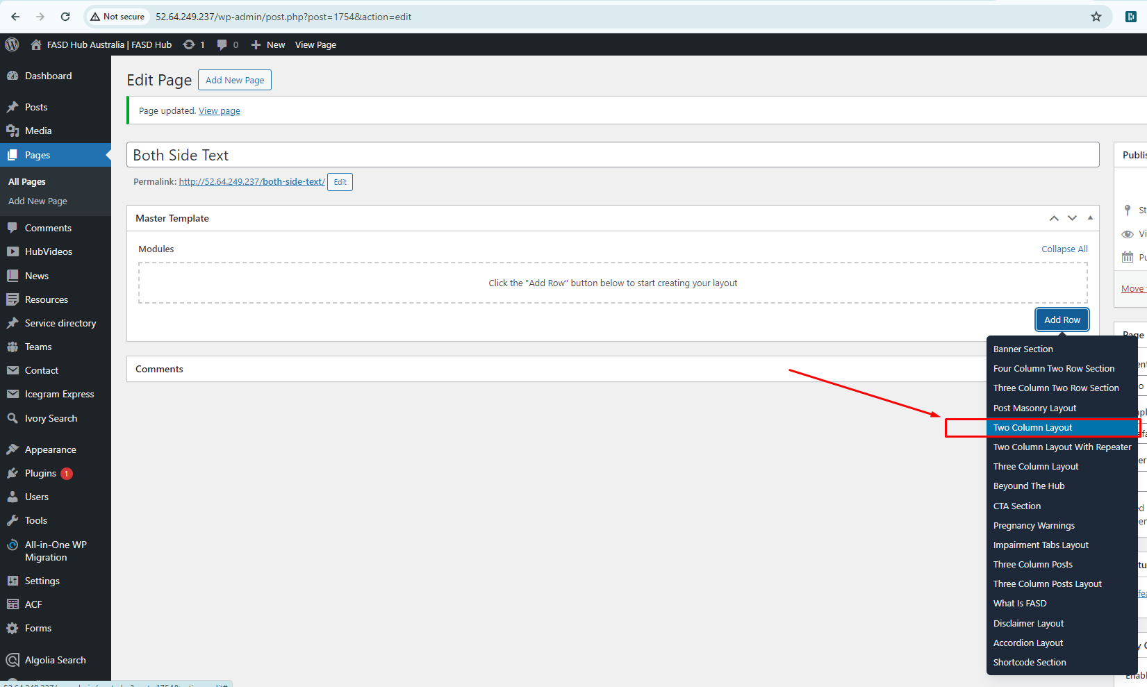

After this, you should select the ‘**Both Side Text**' option from the **Type of Layout**, as shown in the screenshot below.

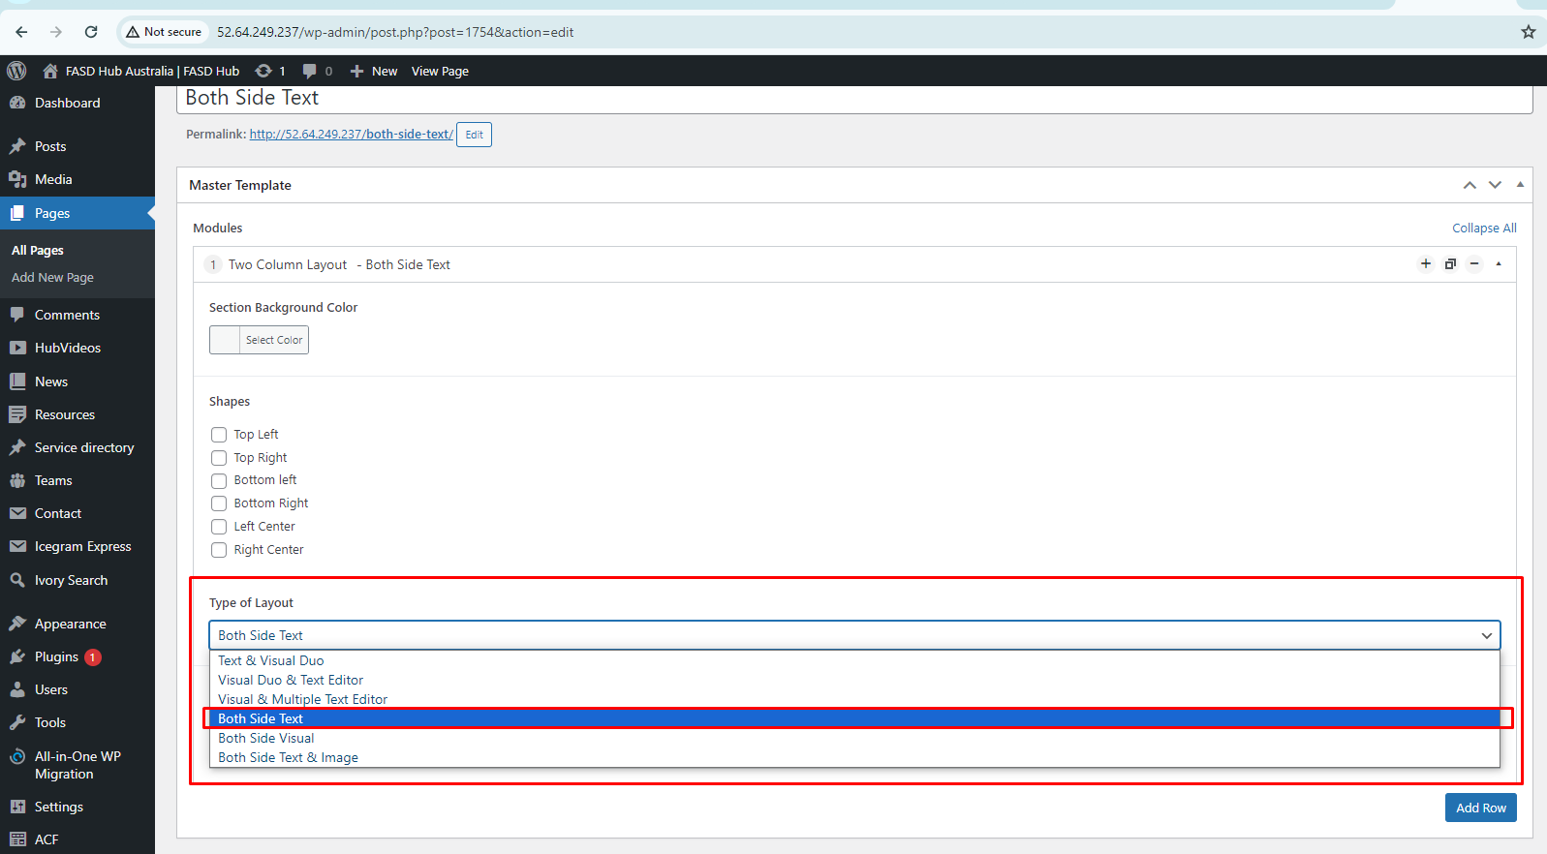

You will now see field boxes in the **two-column layout** for the **Both Side Text** layout option. You need to input data such as background images, shapes, and content according to the fields, as shown in the screenshot below.

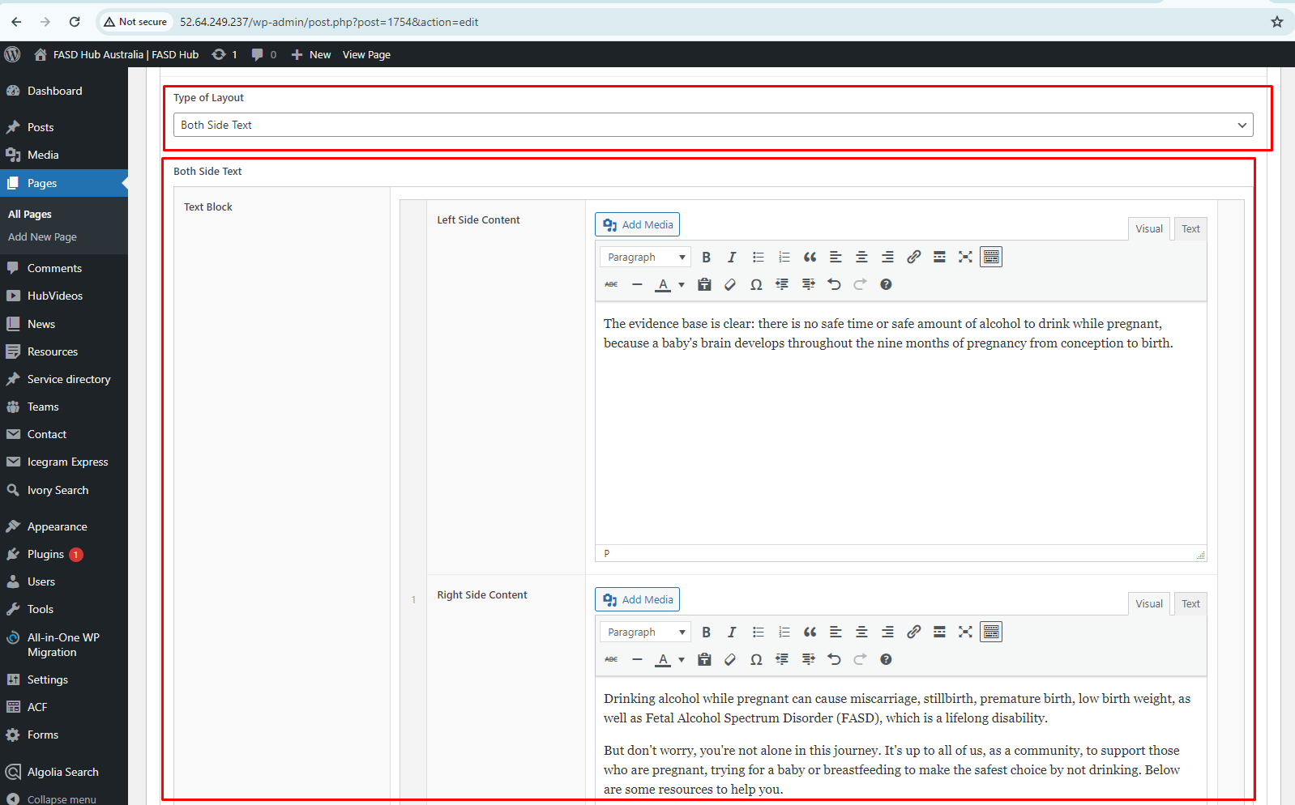

If you want to add more content boxes, click on the **'Add row**' button, and these blocks **'Left Side Content'** & **'Right Side Content'** will be repeated.

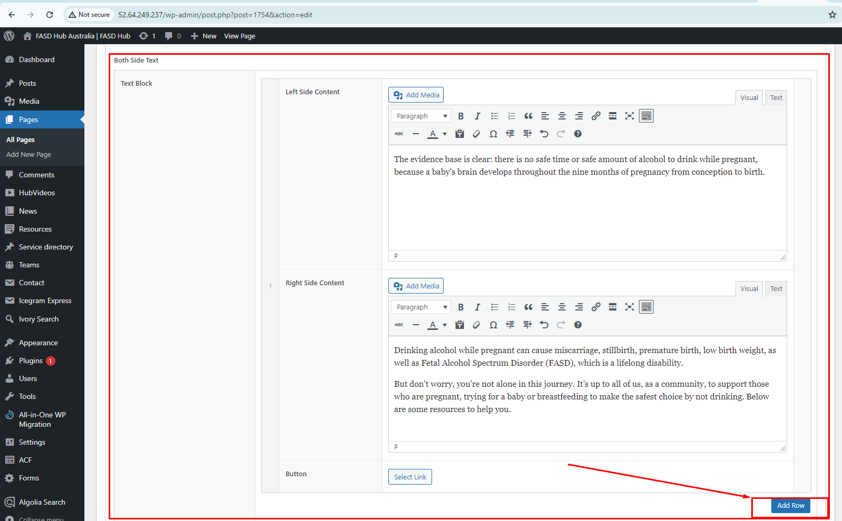

After adding content to these field boxes, save your changes and check your page, as shown in the screenshot below.

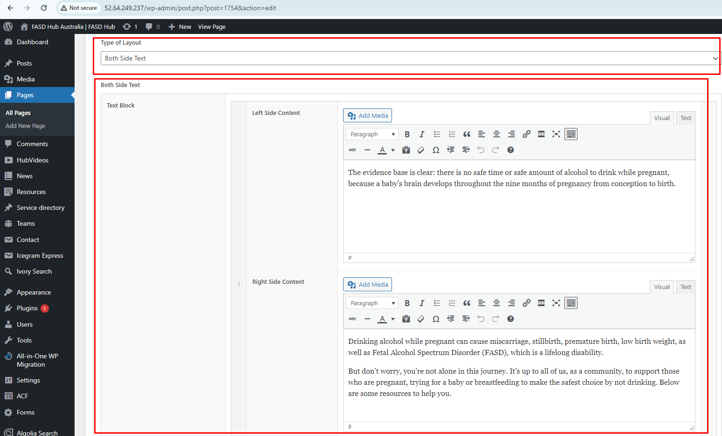

Finally, we have achieved the output of the **two-column layout** for the **Both Side Text** section on the front end, as shown in the screenshot below.

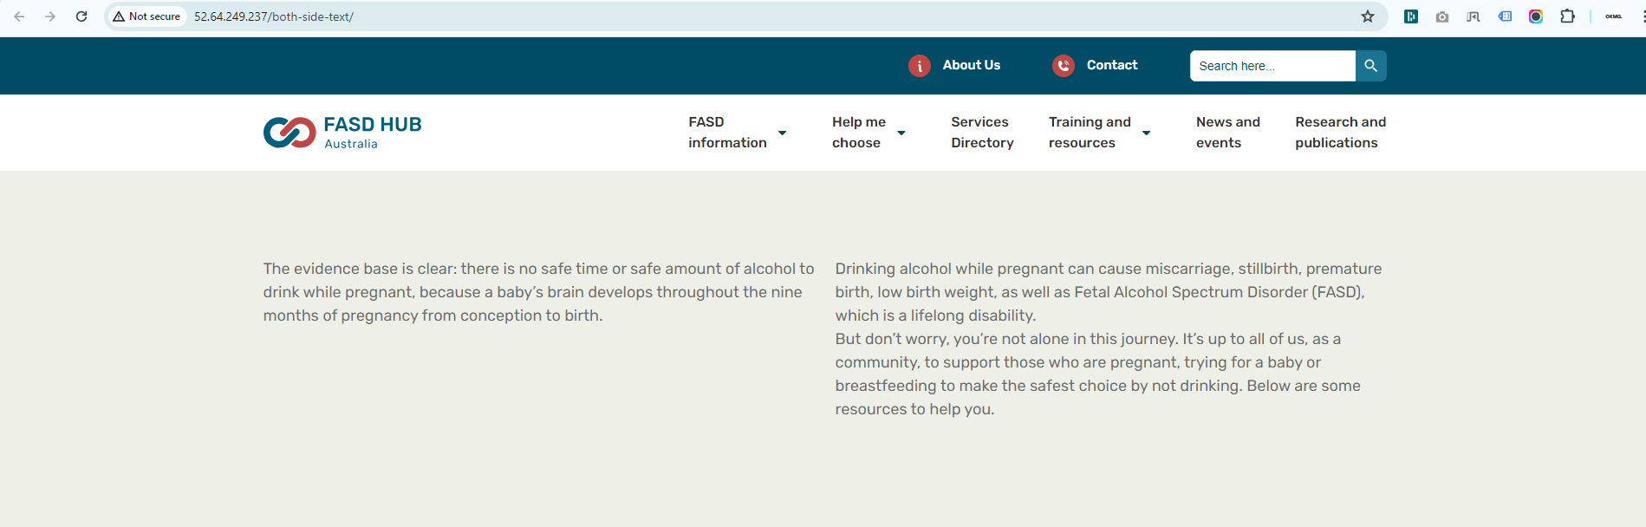

## **‘Both Side Visual'**

**How to create a Two Column Layout section with the layout option 'Both Side Visual'.**

**Preview (Two Column Layout section - Both Side Visual)**

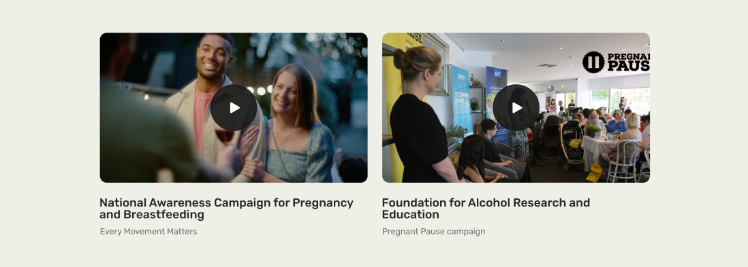

**Steps below:**

First, click on **'Add row**,' then select **Two Column Layout** from the dropdown menu, as shown in the screenshot below.

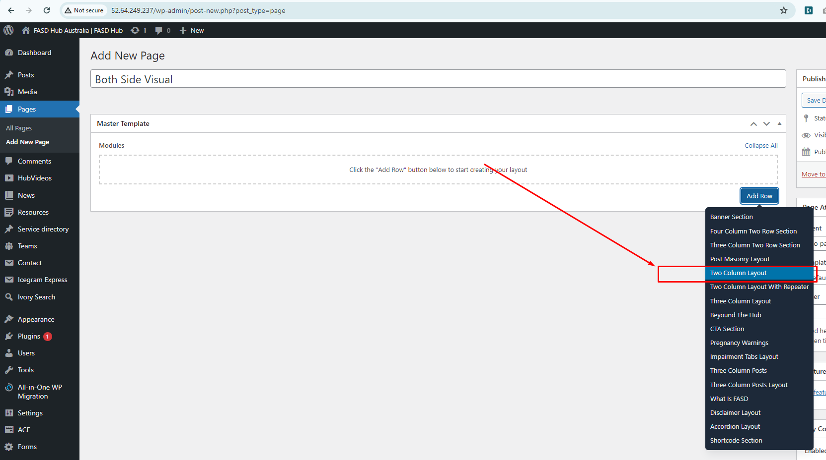

After this, you should select the ‘**Both Side Visual’** option from the **Type of Layout**, as shown in the screenshot below.

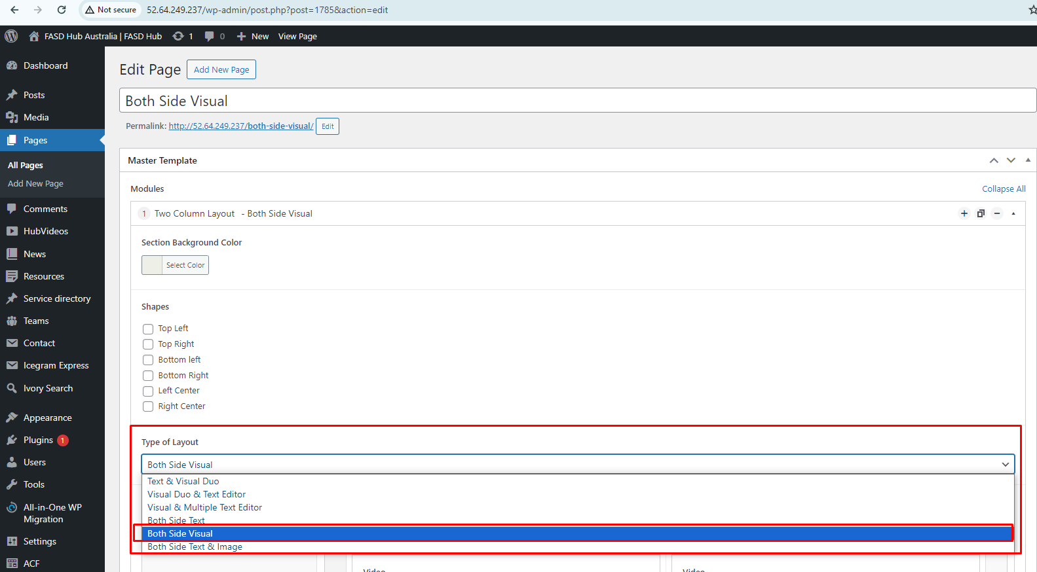

After that, click on the **'Add row'** button and add visual blocks for adding content, as shown in the screenshot below.

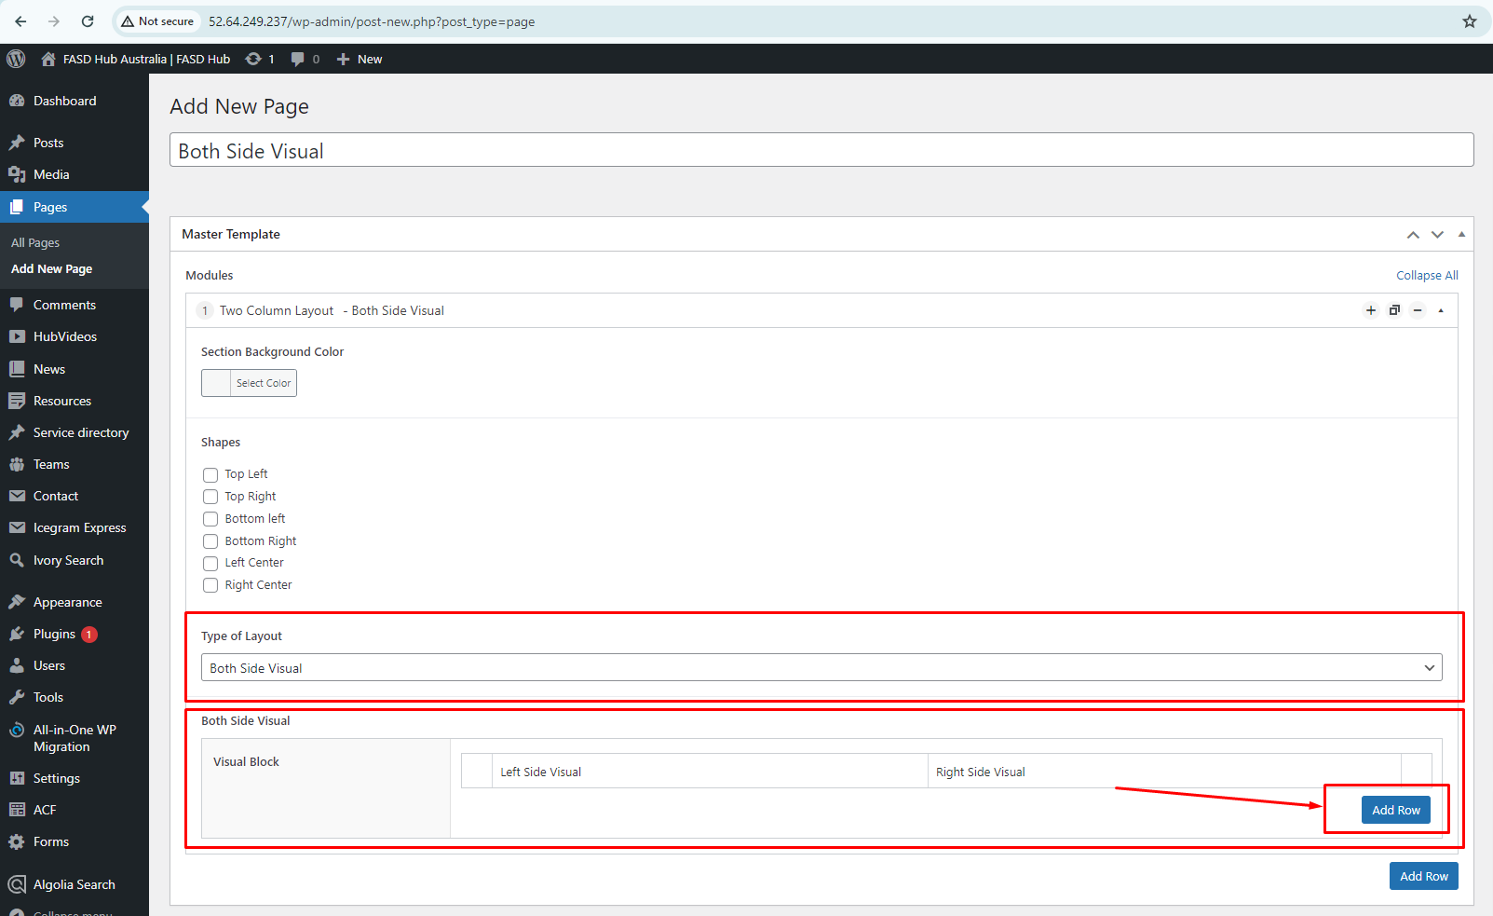

Here, you will have two options: one for **video** and the other for **image**. You can create two types of layouts using these options: '**Image with Text**' and **'Video with Text**'. If you choose to add a **video**, you will see the option for the **featured image**, where you need to set the **thumbnail**, as shown in the screenshot below.

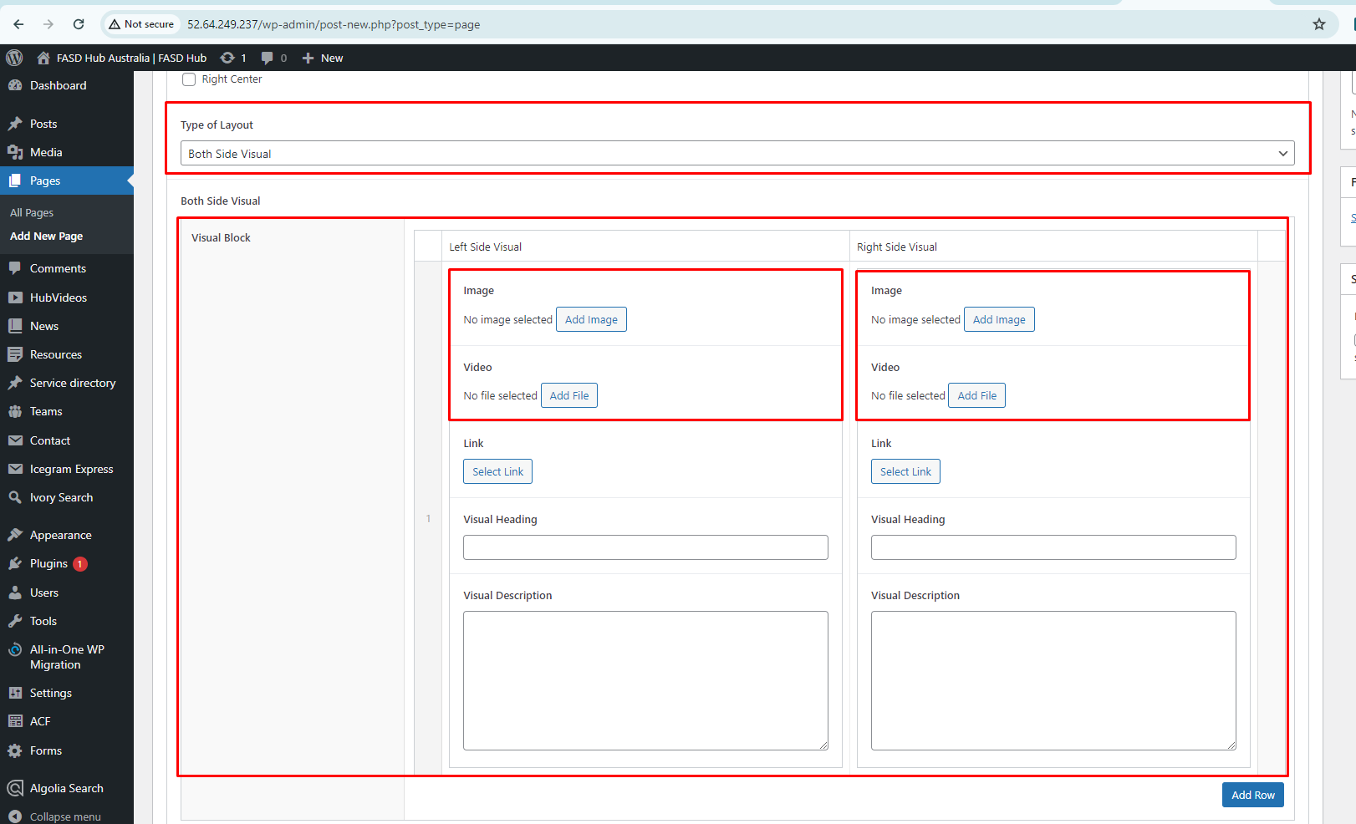

After adding content to these field boxes, save your changes and check your page, as shown in the screenshot below.

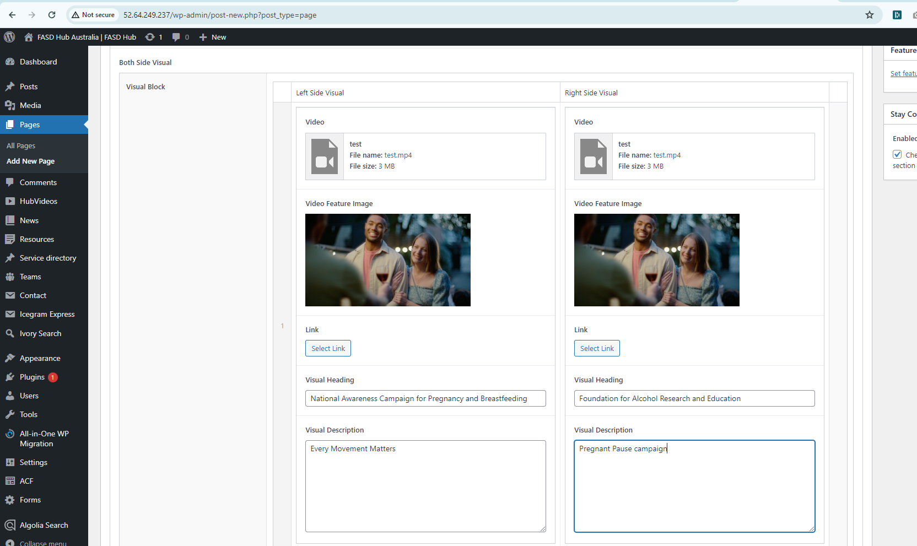

Finally, we have achieved the output of the **Two Column Layout** for the **Both Side Visual** section on the front end, as shown in the screenshot below.

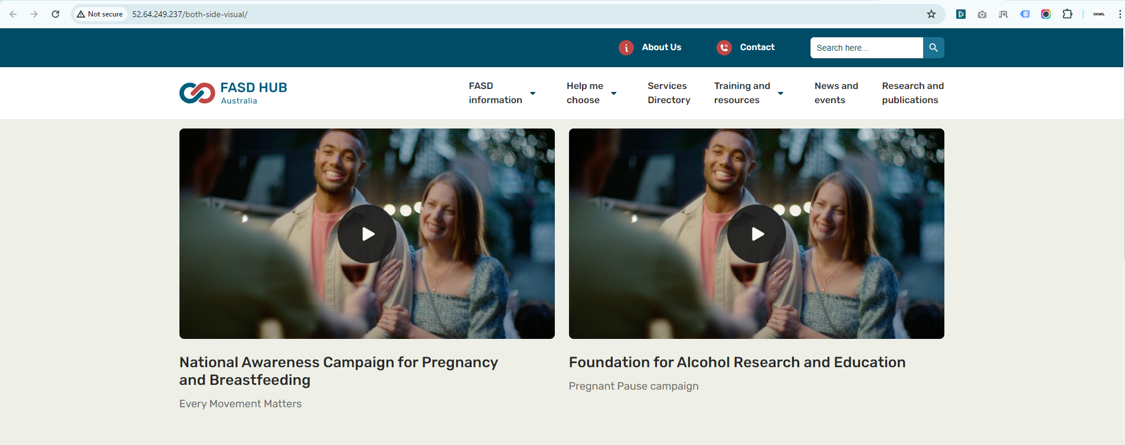.

## **‘Both Side Text & Image'**

**How to create a Two Column Layout section with the layout option 'Both Side Text & Image'.**

**Preview (Two Column Layout section - Both Side Text & Image)**

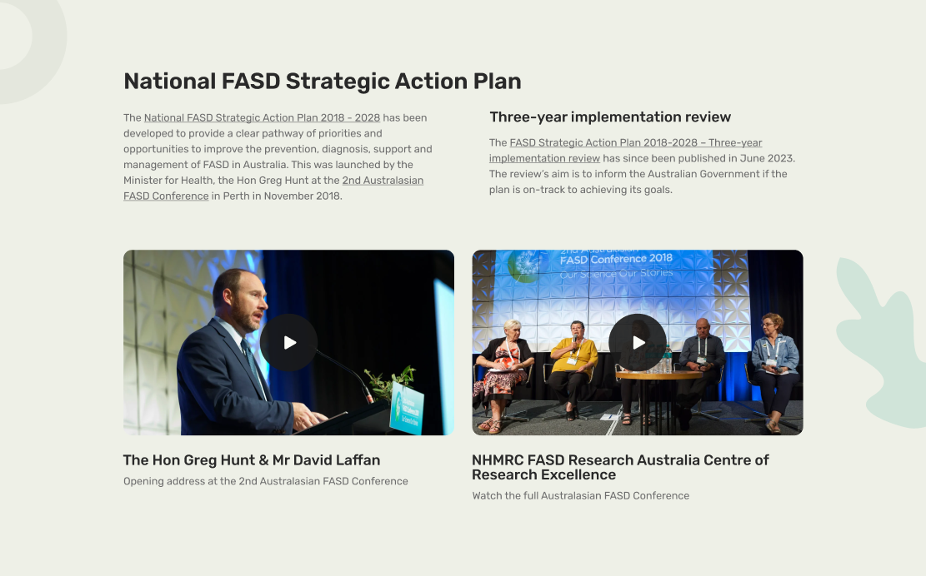

**Steps below:**

First, click on **'Add row**,' then select **Two Column Layout** from the dropdown menu, as shown in the screenshot below.

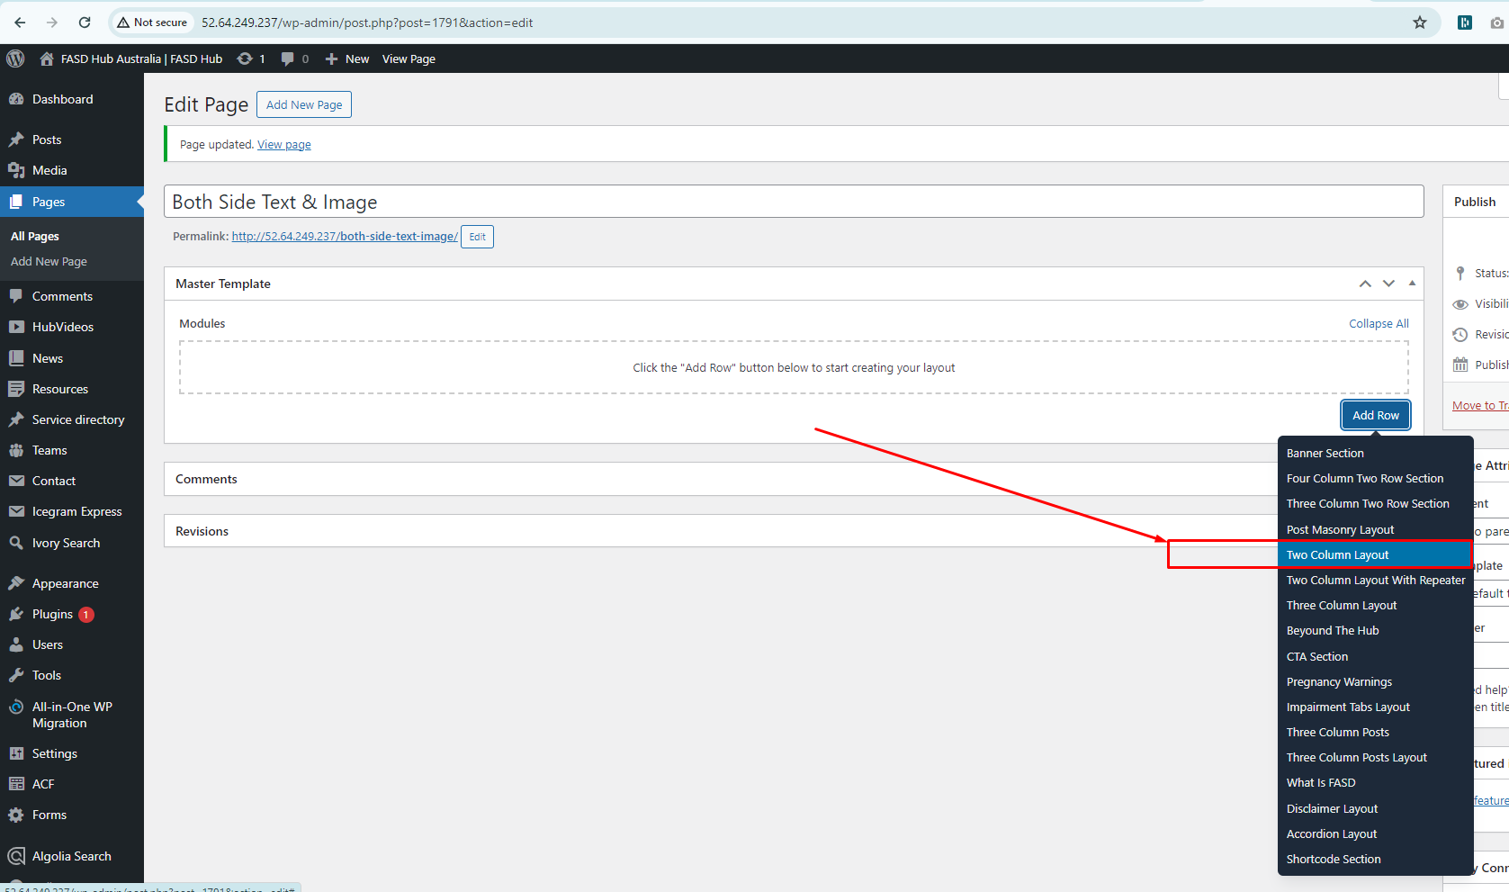

After this, you should select the ‘**Both Side Text & Image’** option from the **Type of Layout**, as shown in the screenshot below.

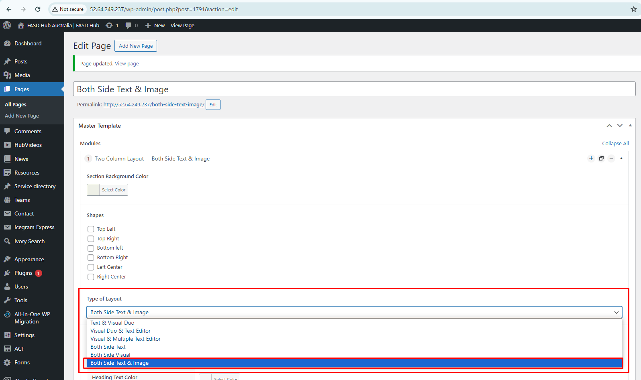

Here, you will have two options: one for **video** and the other for **image**. You can create two types of layouts using these options: '**Image with Text**' and **'Video with Text**'. If you choose to add a **video**, you will see the option for the **featured image**, where you need to set the **thumbnail**, as shown in the screenshot below.

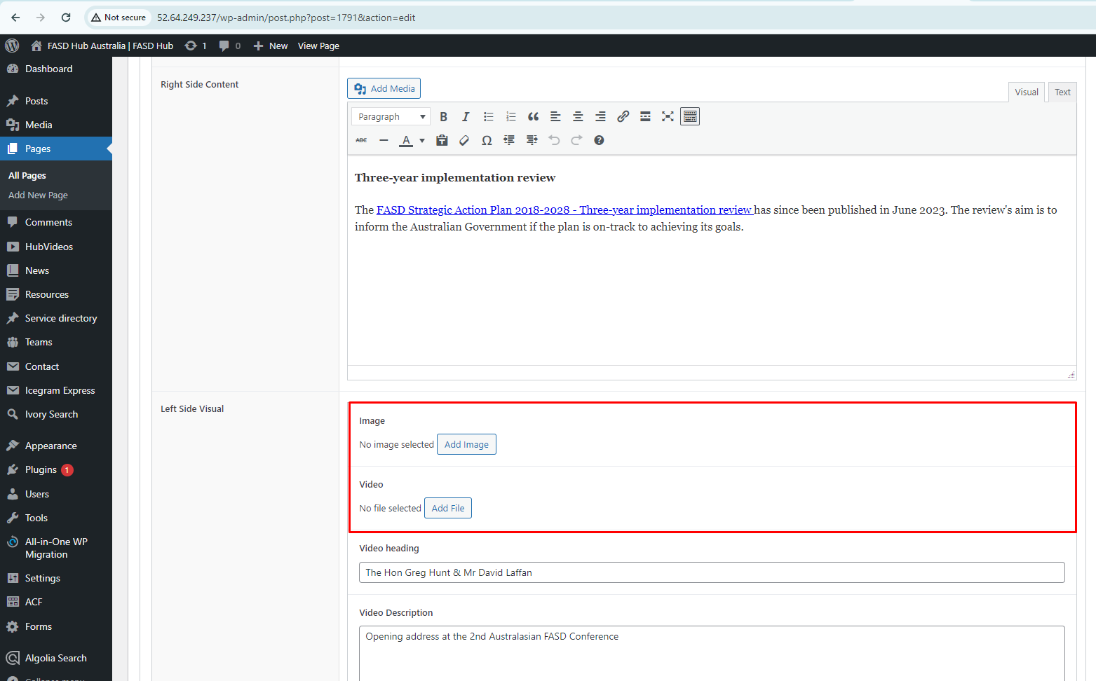

After adding content to these field boxes, save your changes and check your page, as shown in the screenshot below.

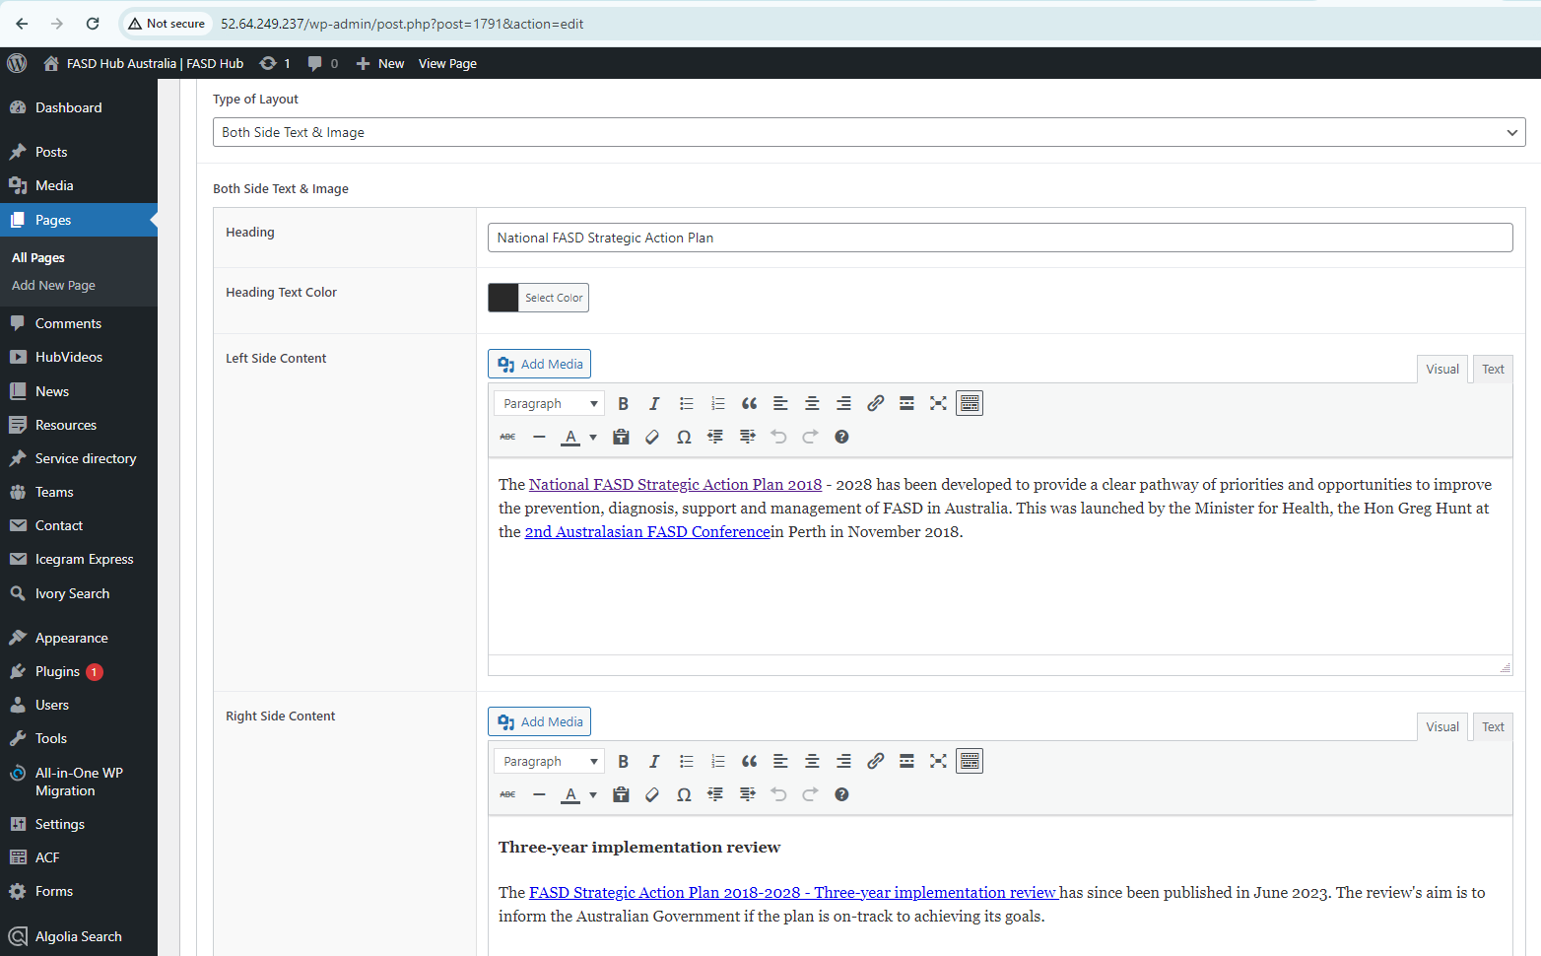

Finally, we have achieved the output of the **Two Column Layout** for the **Both Side Text & Image** section on the front end, as shown in the screenshot below.

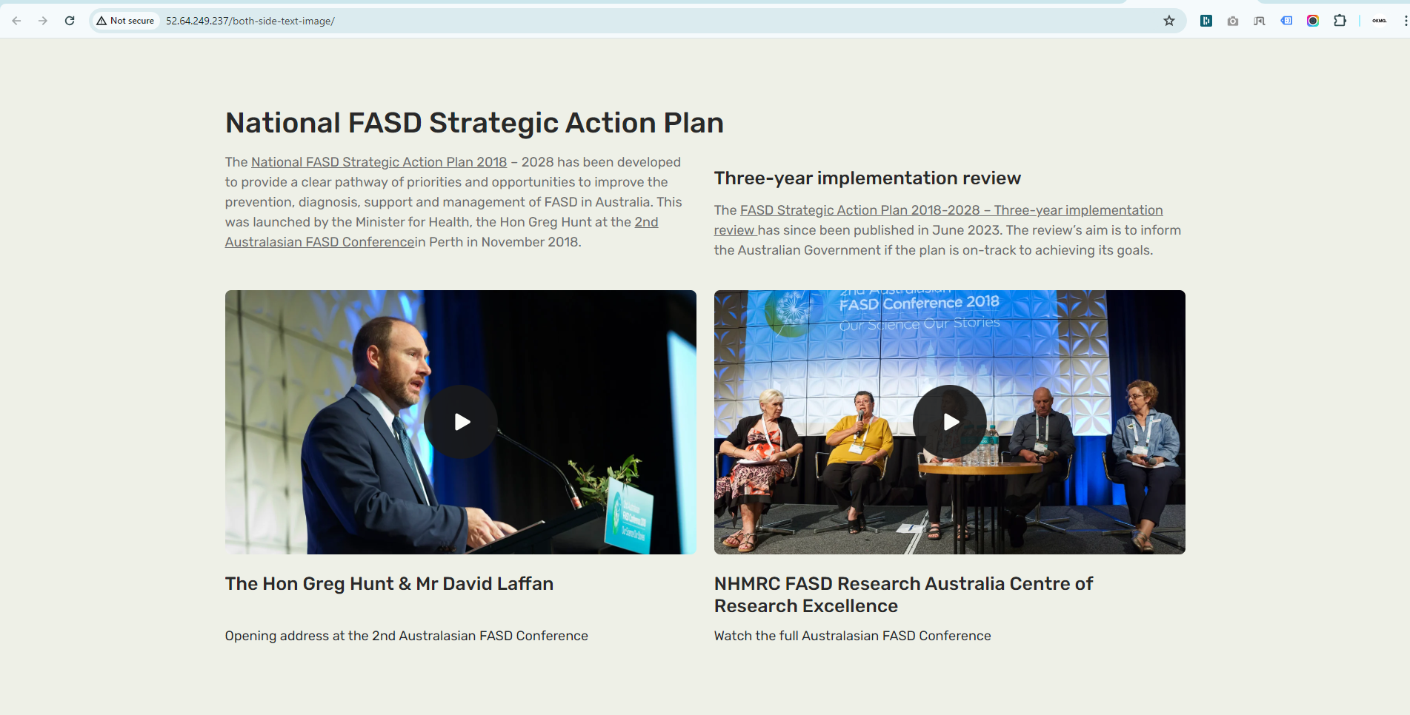

**Two Column Layout With Repeater**

**How to create a Two Column Layout section with a repeater**

There are three types of layouts to create a **Two Column Layout section with a repeater** section on a page.

**a) Text & Visual Duo**

**b) Both Side Text**

**c) Both Side Visual**

## **'Text & Visual Duo'**

**How to create a Two Column Layout With a Repeater section with the layout option 'Text & Visual Duo'.**

**Preview (Two Column Layout section - Text & Visual Duo)**

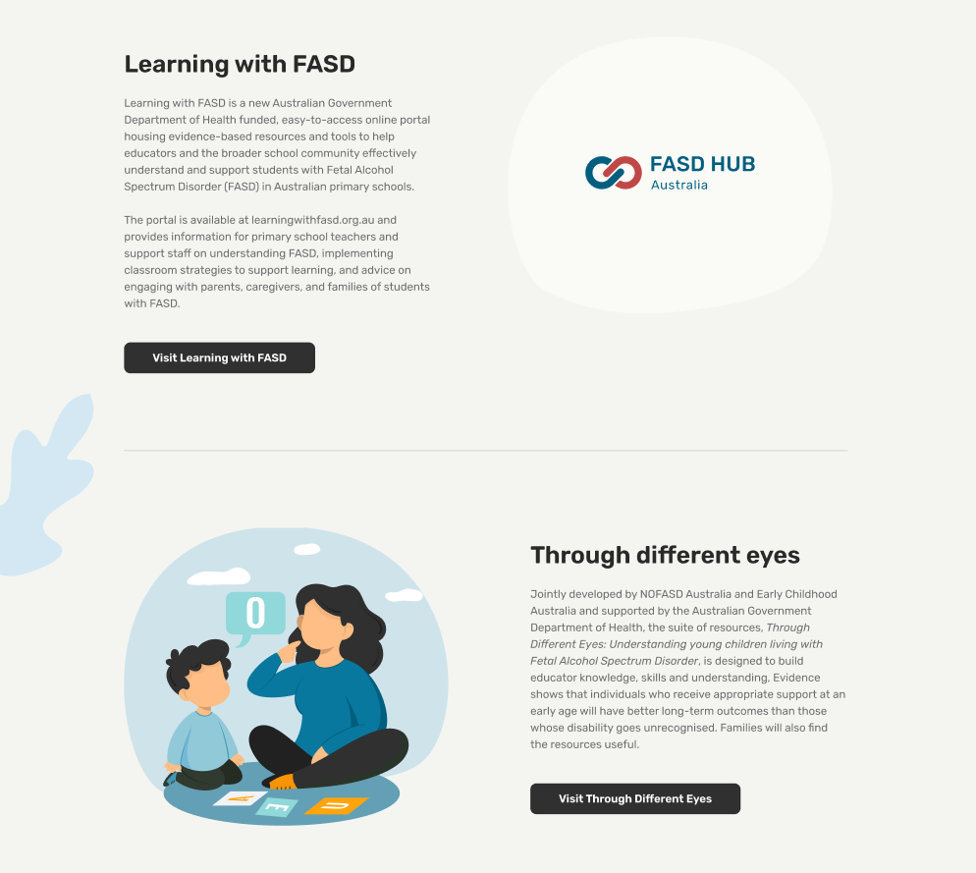

**Steps below:**

First, click on **'Add row**,' then select **Two Column Layout With Repeater** from the dropdown menu, as shown in the screenshot below.

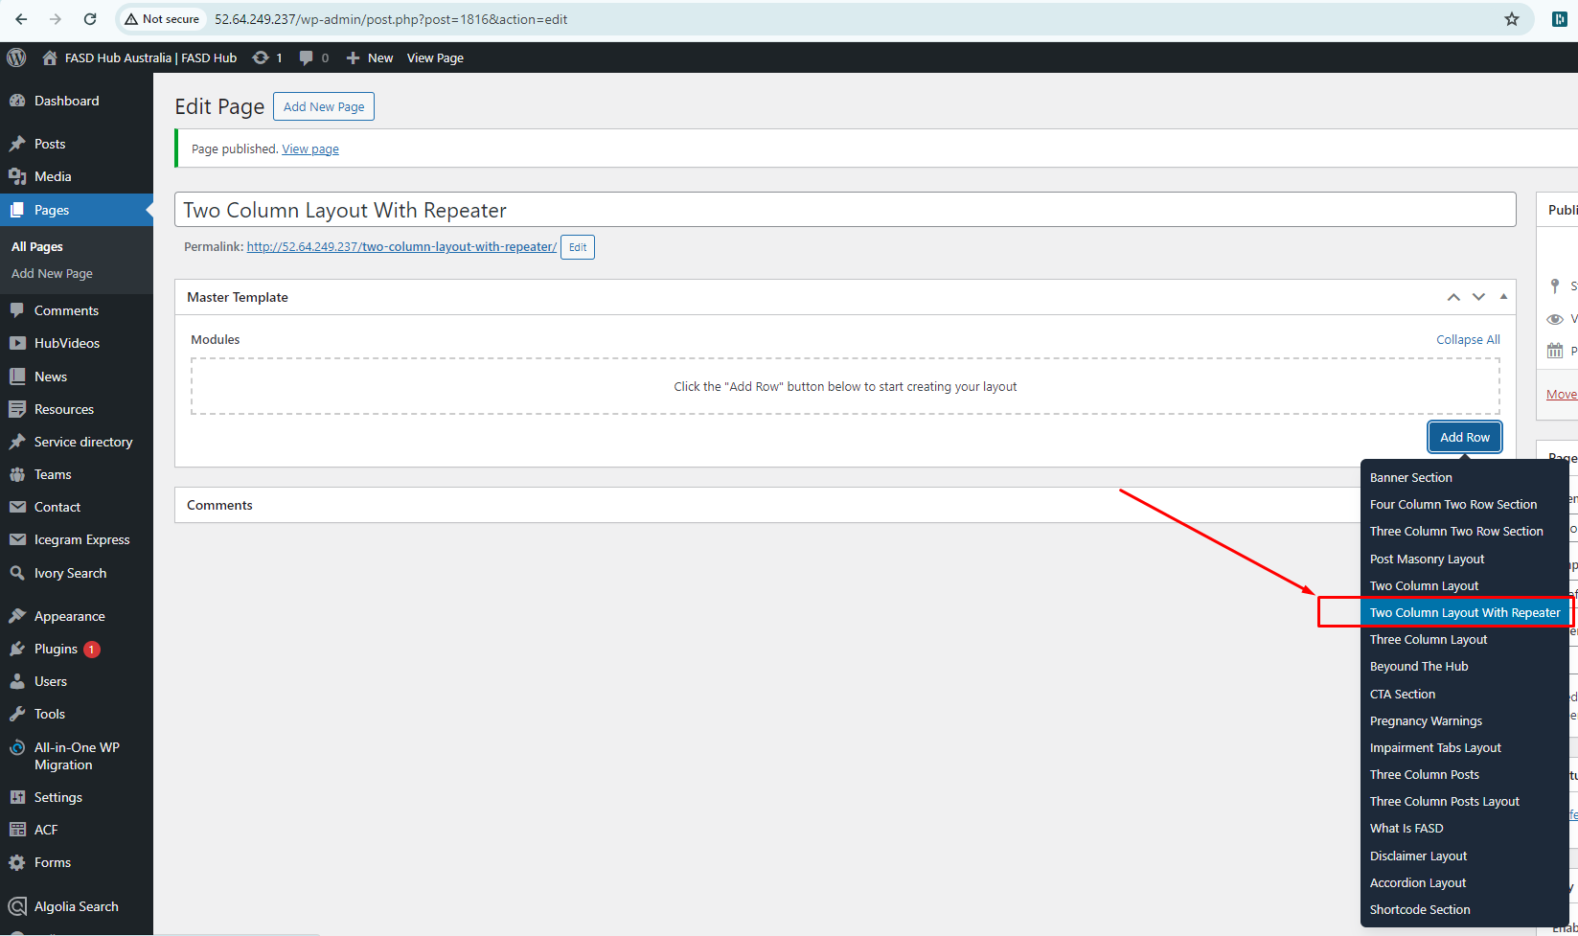

After this, you should select the ‘**Text & Visual Duo’** option from the **Type of Layout**, as shown in the screenshot below.

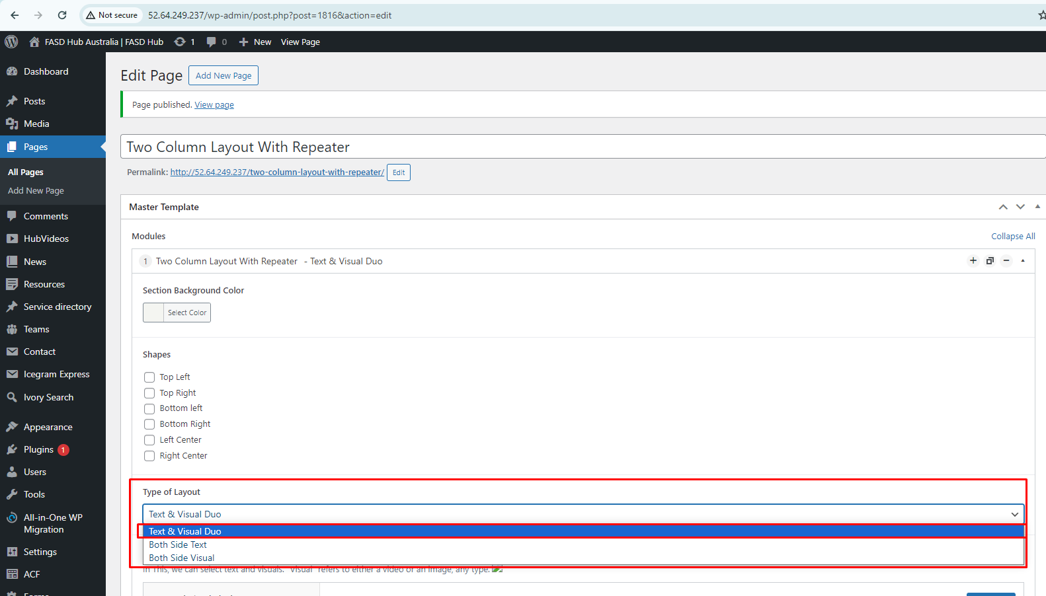

After that, click on the **'Add row'** button and add **Text And Visual blocks** for adding content, as shown in the screenshot below.

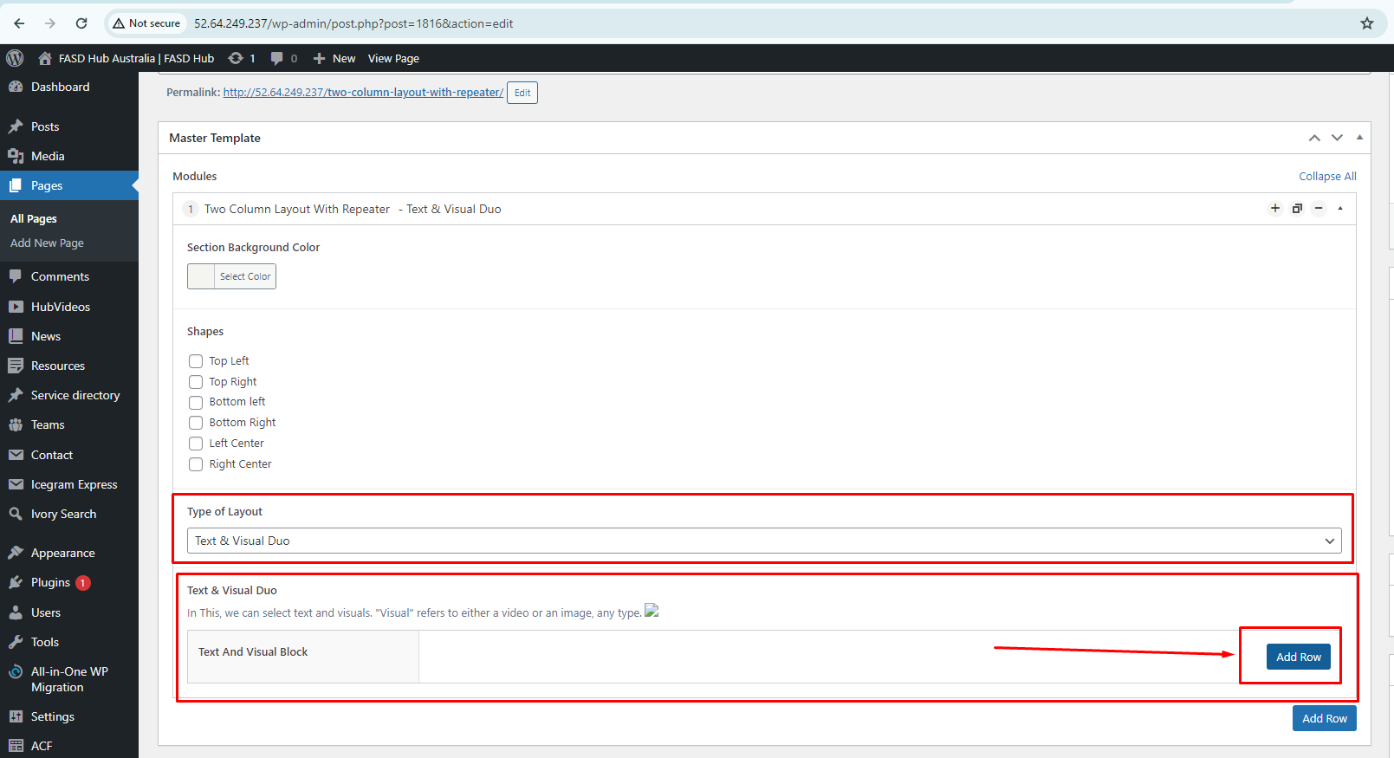

Here, you will have two options: one for **video** and the other for **image**. You can create two types of layouts using these options: '**Image with Text**' and **'Video with Text**'. If you choose to add a **video**, you will see the option for the **featured image**, where you need to set the **thumbnail**, as shown in the screenshot below.

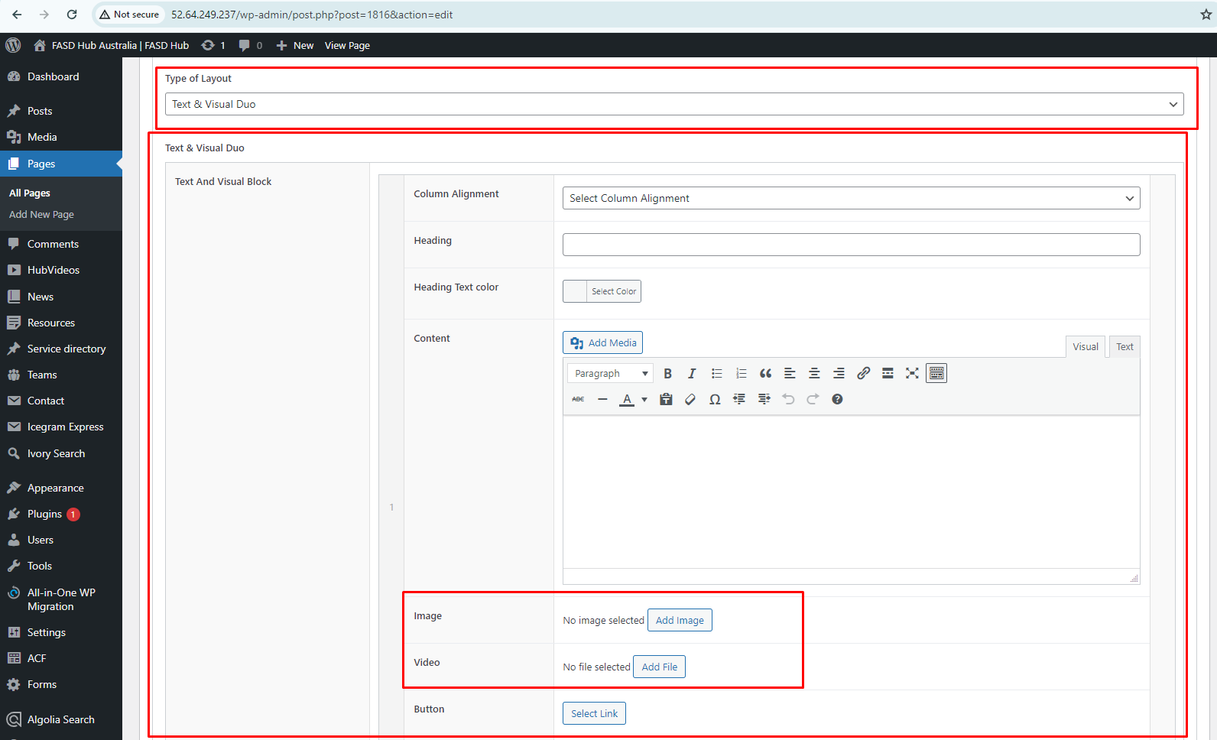

If you want to add this Text and Visual Block repeatedly, you can do so by clicking the **'Add row'** button.

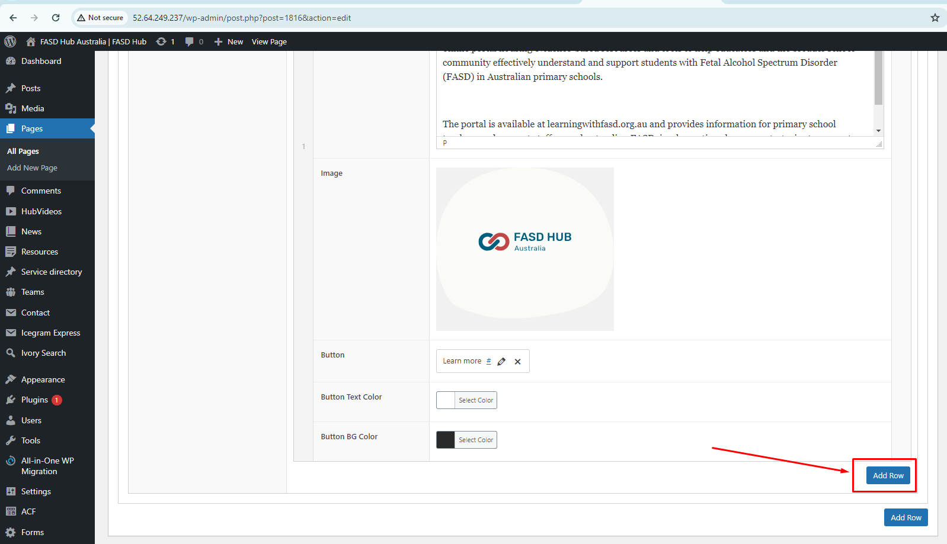

After adding content to these field boxes, save your changes and check your page, as shown in the screenshot below.

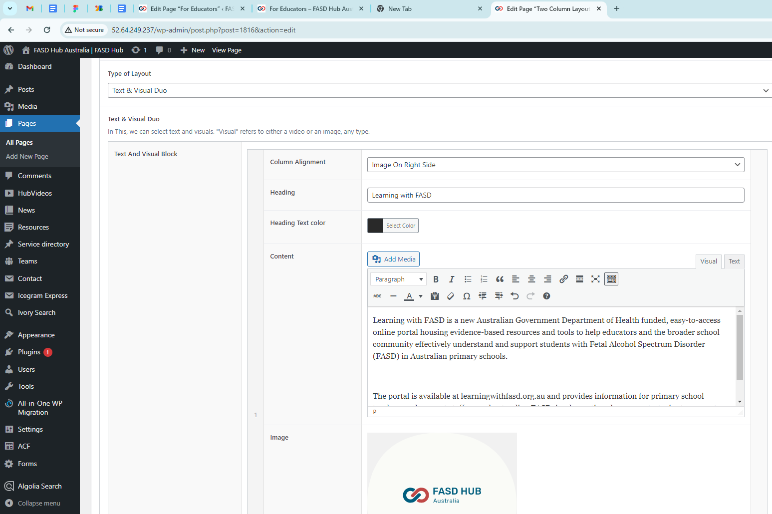

Finally, we have achieved the output of the **Two Column Layout With Repeater** for the **Text & Visual Duo** section on the front end, as shown in the screenshot below.

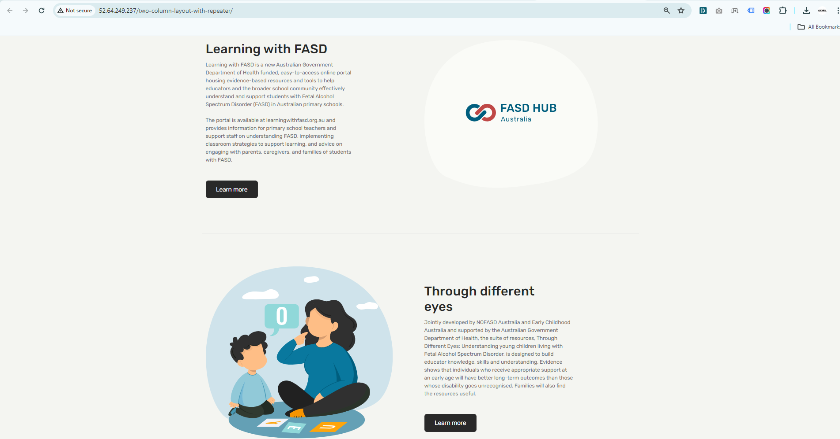

## **‘Both Side Text'**

**How to create a Two Column Layout With a Repeater section with the layout option 'Both Side Text'.**

**Preview (Two Column Layout section - Both Side Text)**

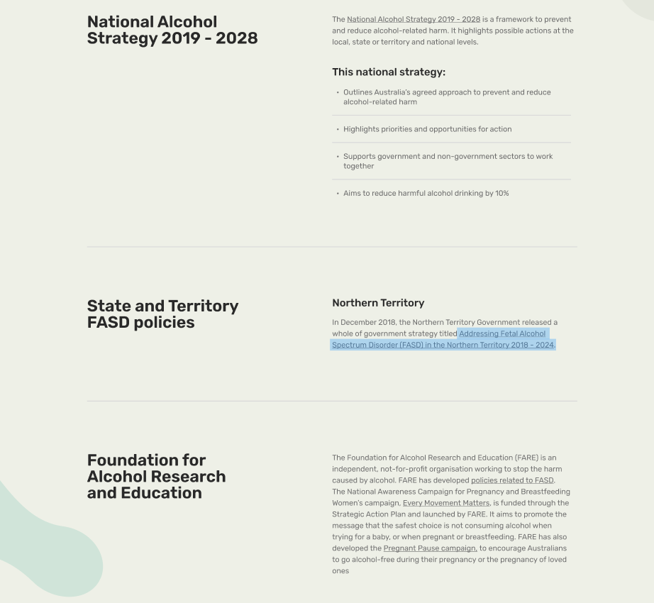

**Steps below:**

First, click on **'Add row**,' then select **Two Column Layout With Repeater** from the dropdown menu, as shown in the screenshot below.

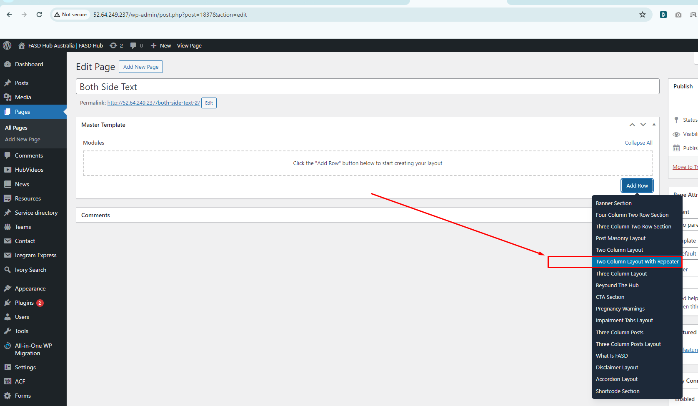

After this, you should select the ‘**Both Side Text’** option from the **Type of Layout**, as shown in the screenshot below.

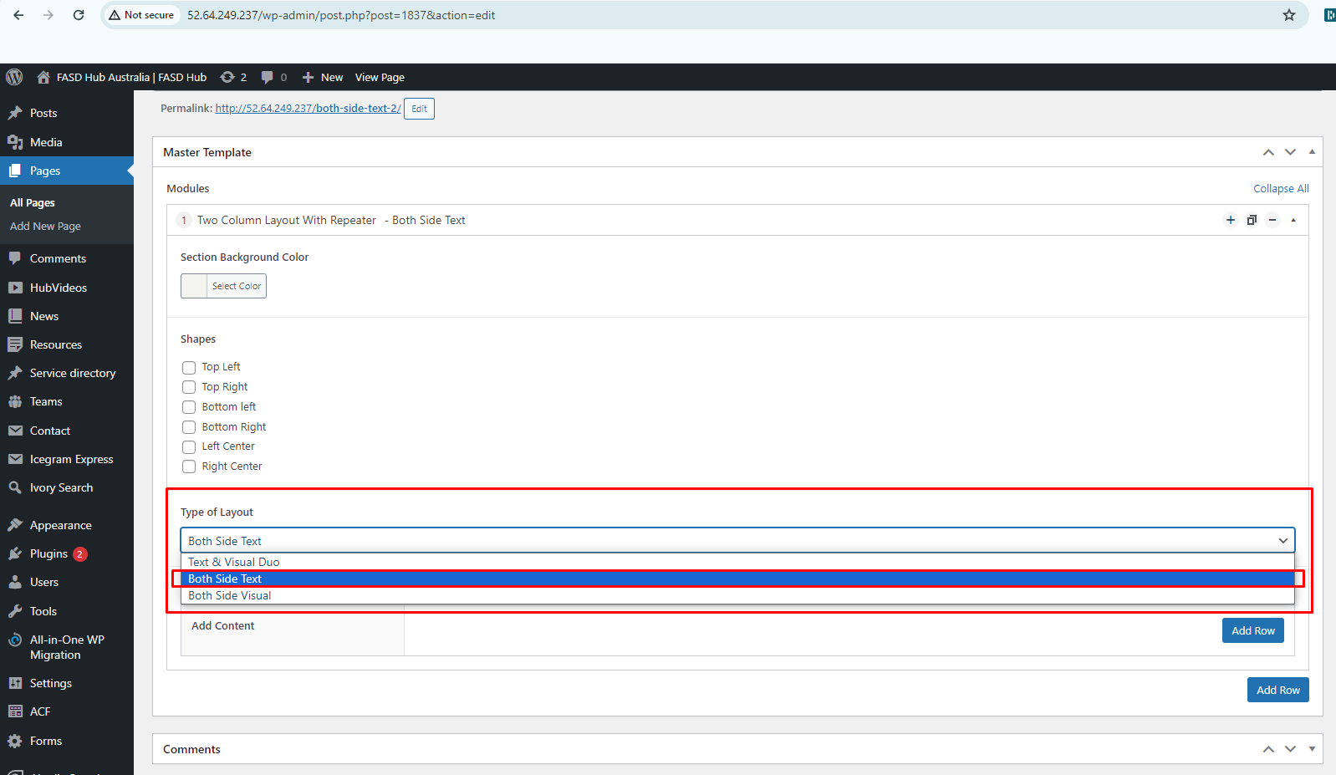

After that, click on the **'Add row'** button and add **Add Content blocks** for adding content, as shown in the screenshot below.

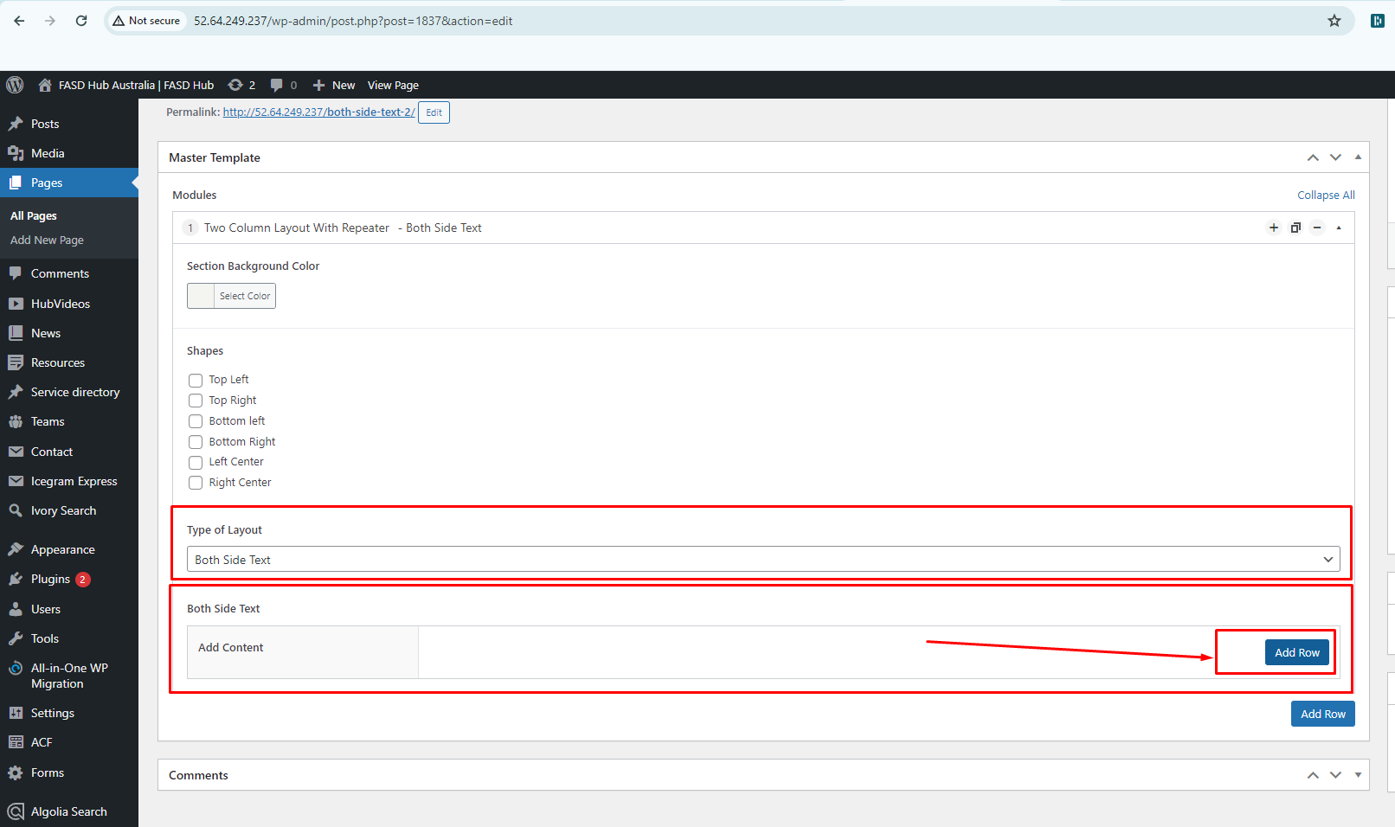

If you want to add this **Add Content** blocks repeatedly, you can do so by clicking the **'Add row'** button.

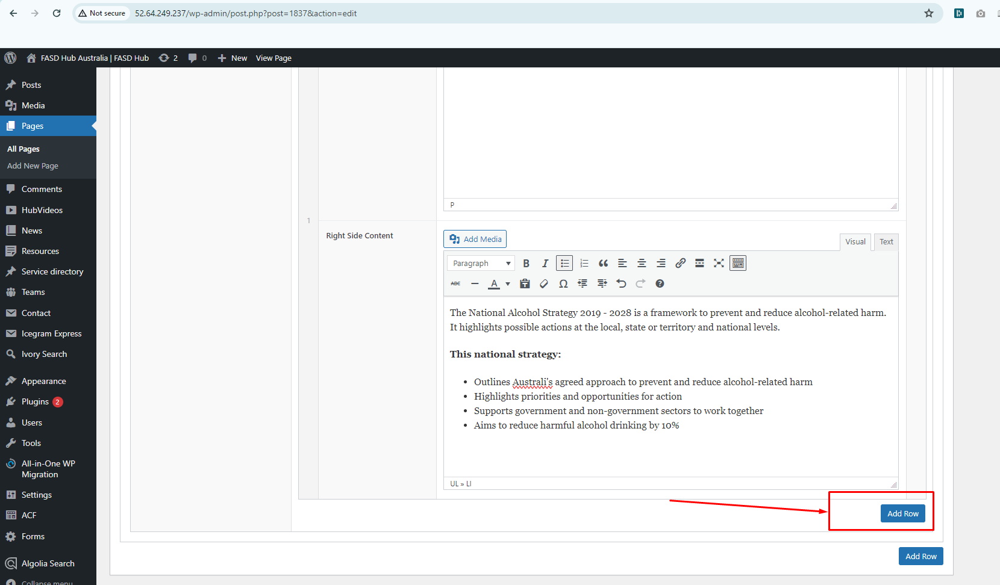

After adding content to these field boxes, save your changes and check your page, as shown in the screenshot below.

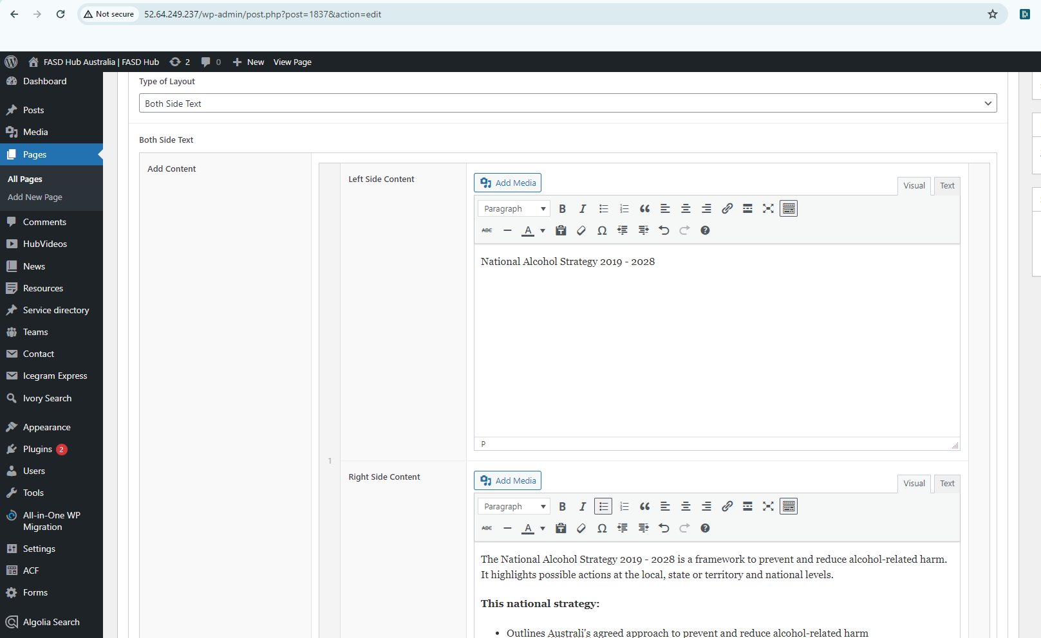

Finally, we have achieved the output of the **Two Column Layout With a Repeater** for the **Both Side Text** section on the front end, as shown in the screenshot below.

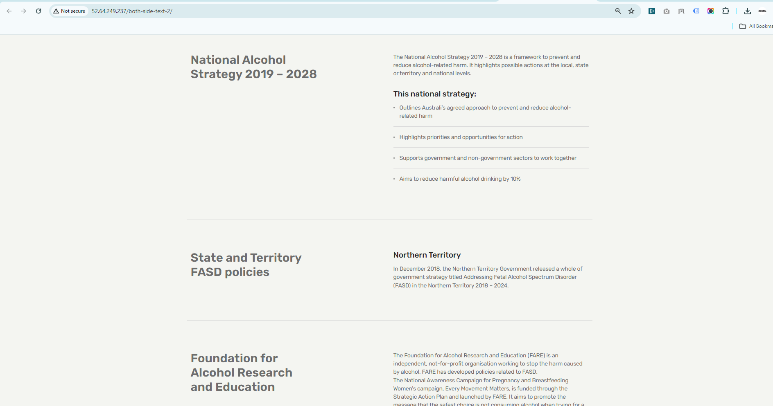

## **‘Both Side Visual’**

**How to create a Two Column Layout With a Repeater section with the layout option 'Both Side Visual.**

**Preview (Two Column Layout section - Both Side Visual)**

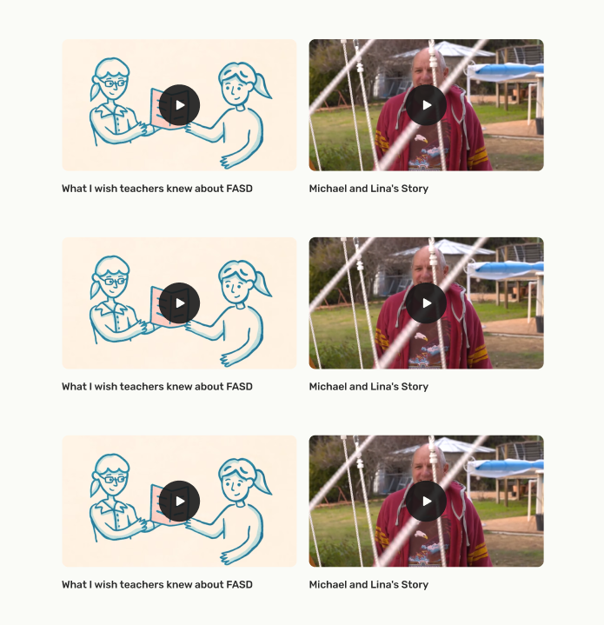

**Steps below:**

First, click on **'Add row**,' then select **Two Column Layout With Repeater** from the dropdown menu, as shown in the screenshot below.

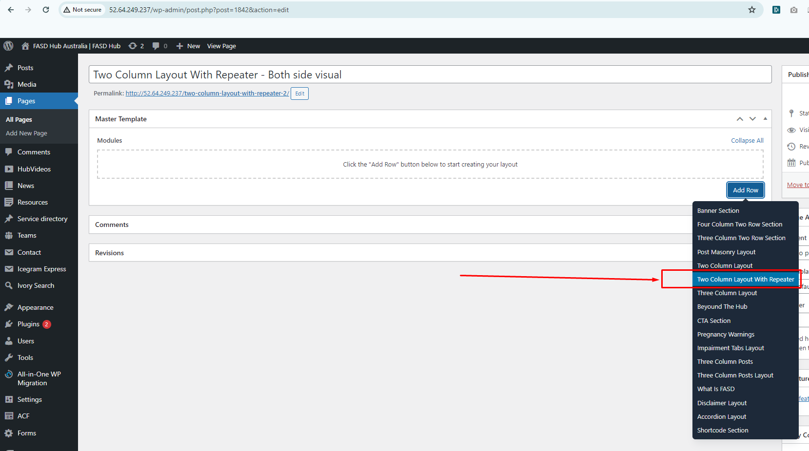

After this, you should select the ‘**Both Side Visual’** option from the **Type of Layout**, as shown in the screenshot below.

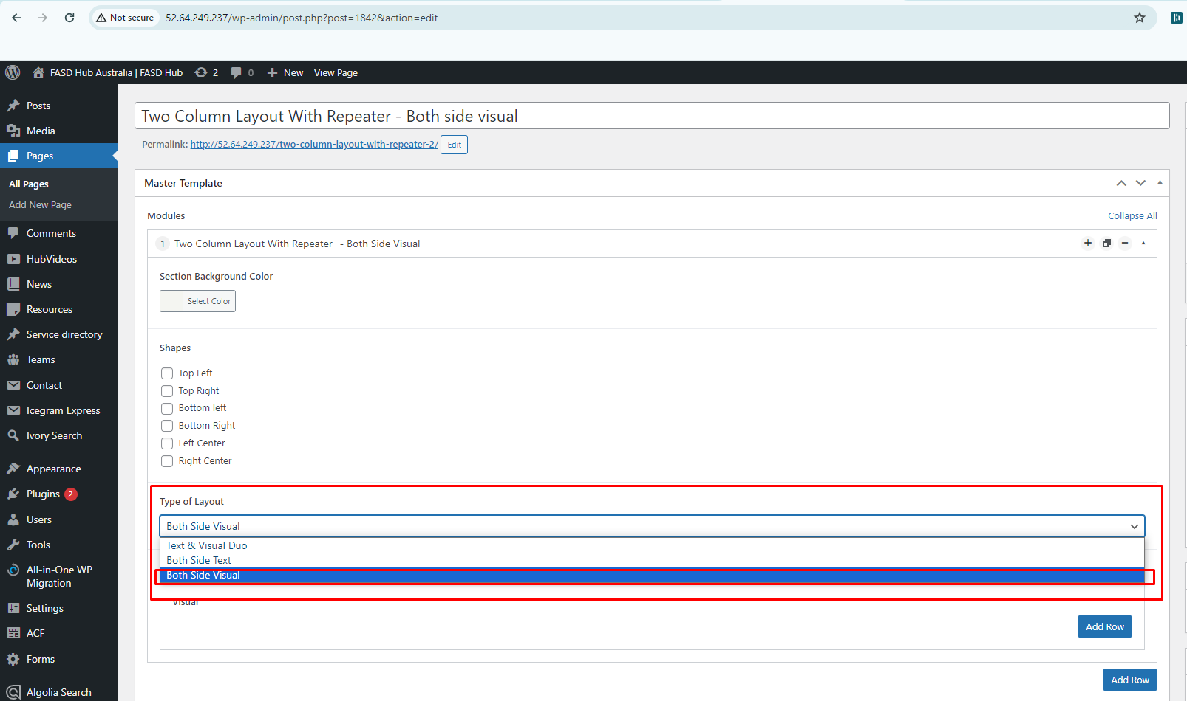

After that, click on the **'Add row'** button and add **Visual content blocks** for adding content, as shown in the screenshot below.

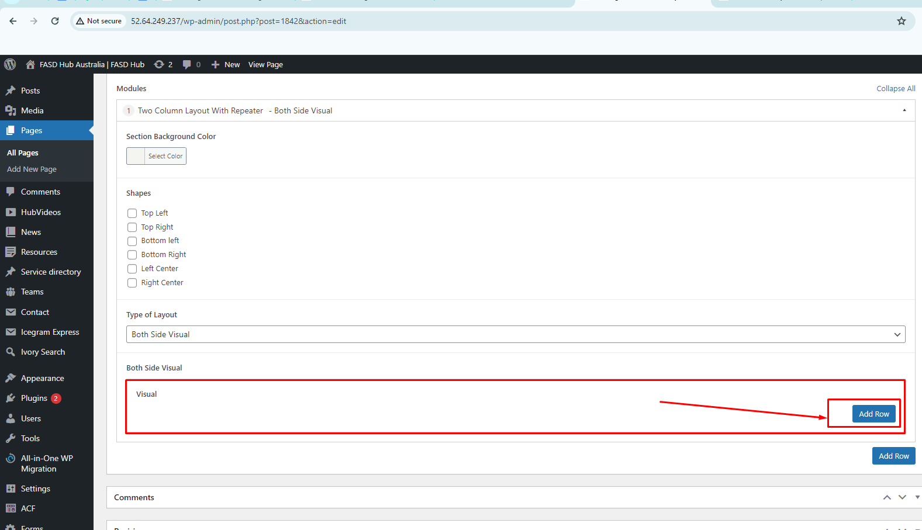

If you want to add these **Visual content blocks** repeatedly, you can do so by clicking the **'Add row'** button.

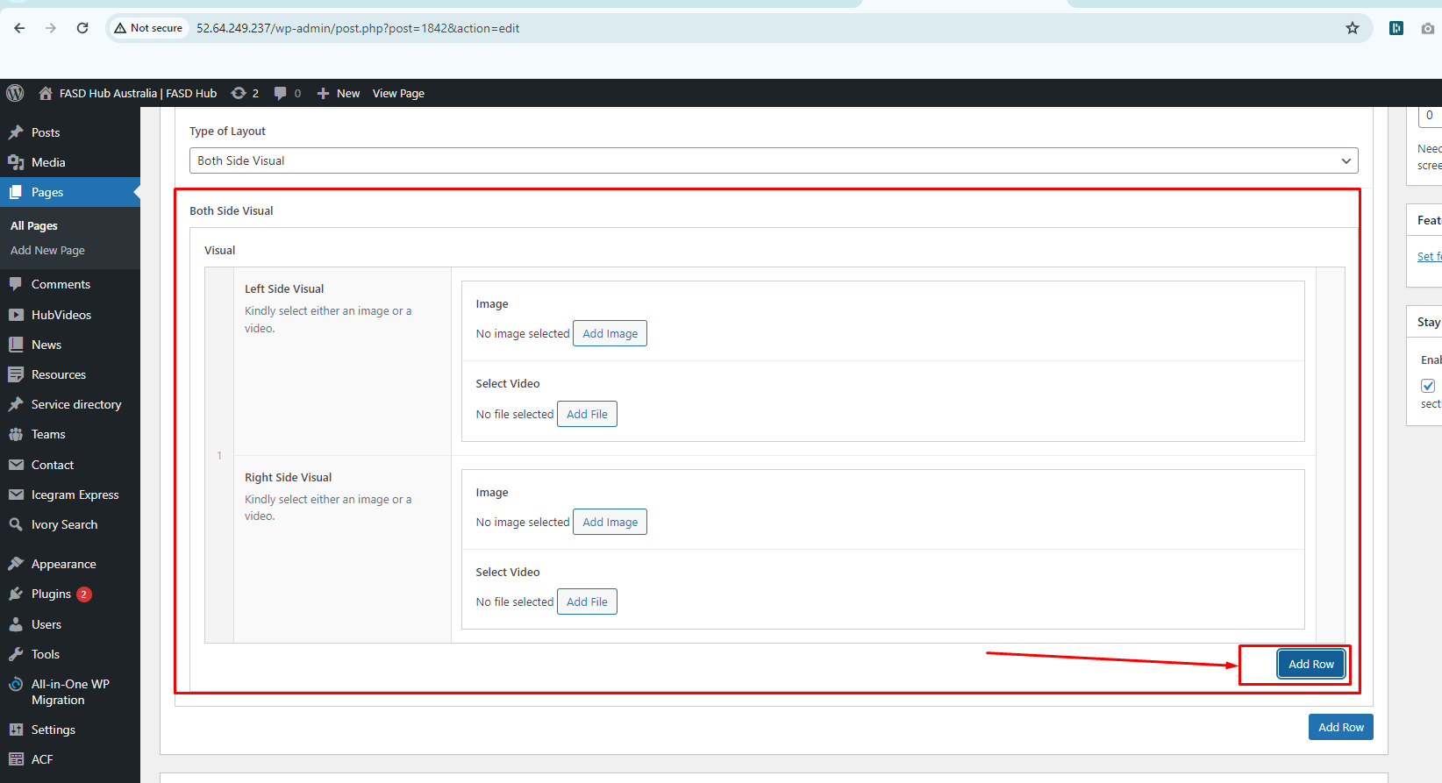

Here, you will have two options: one for **video** and the other for **image**. You can create two types of layouts using these options: '**Image** and **'Video**. If you choose to add a **video**, you will see the option for the **featured image**, where you need to set the **thumbnail**, as shown in the screenshot below.

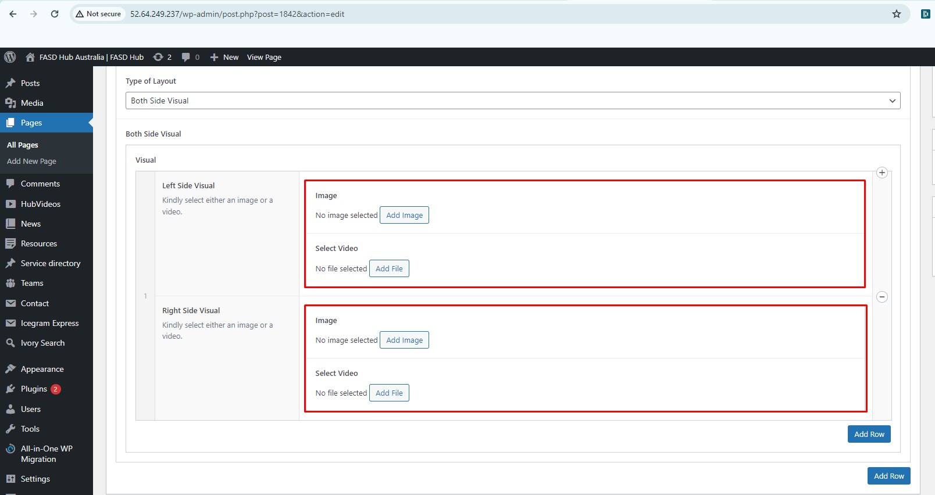

After adding content to these field boxes, save your changes and check your page, as shown in the screenshot below.

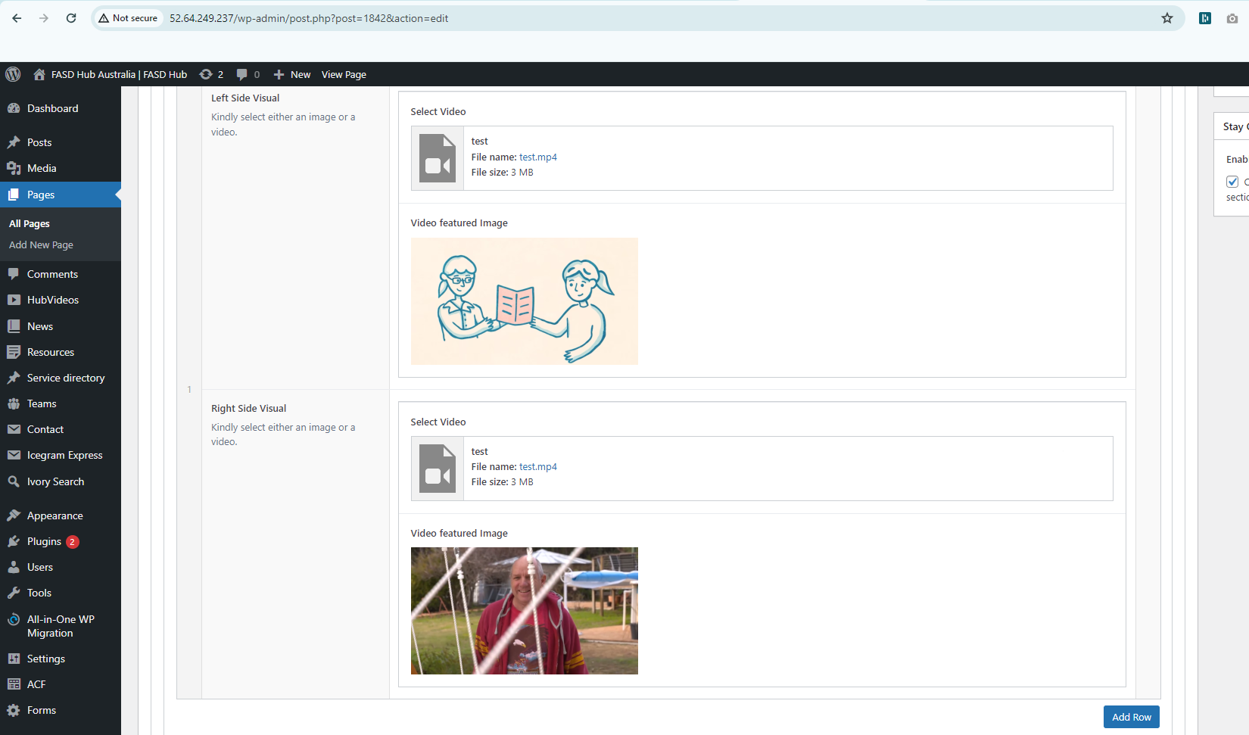

Finally, we have achieved the output of the **Two Column Layout With a Repeater** for the **Both Side Visual** section on the front end, as shown in the screenshot below.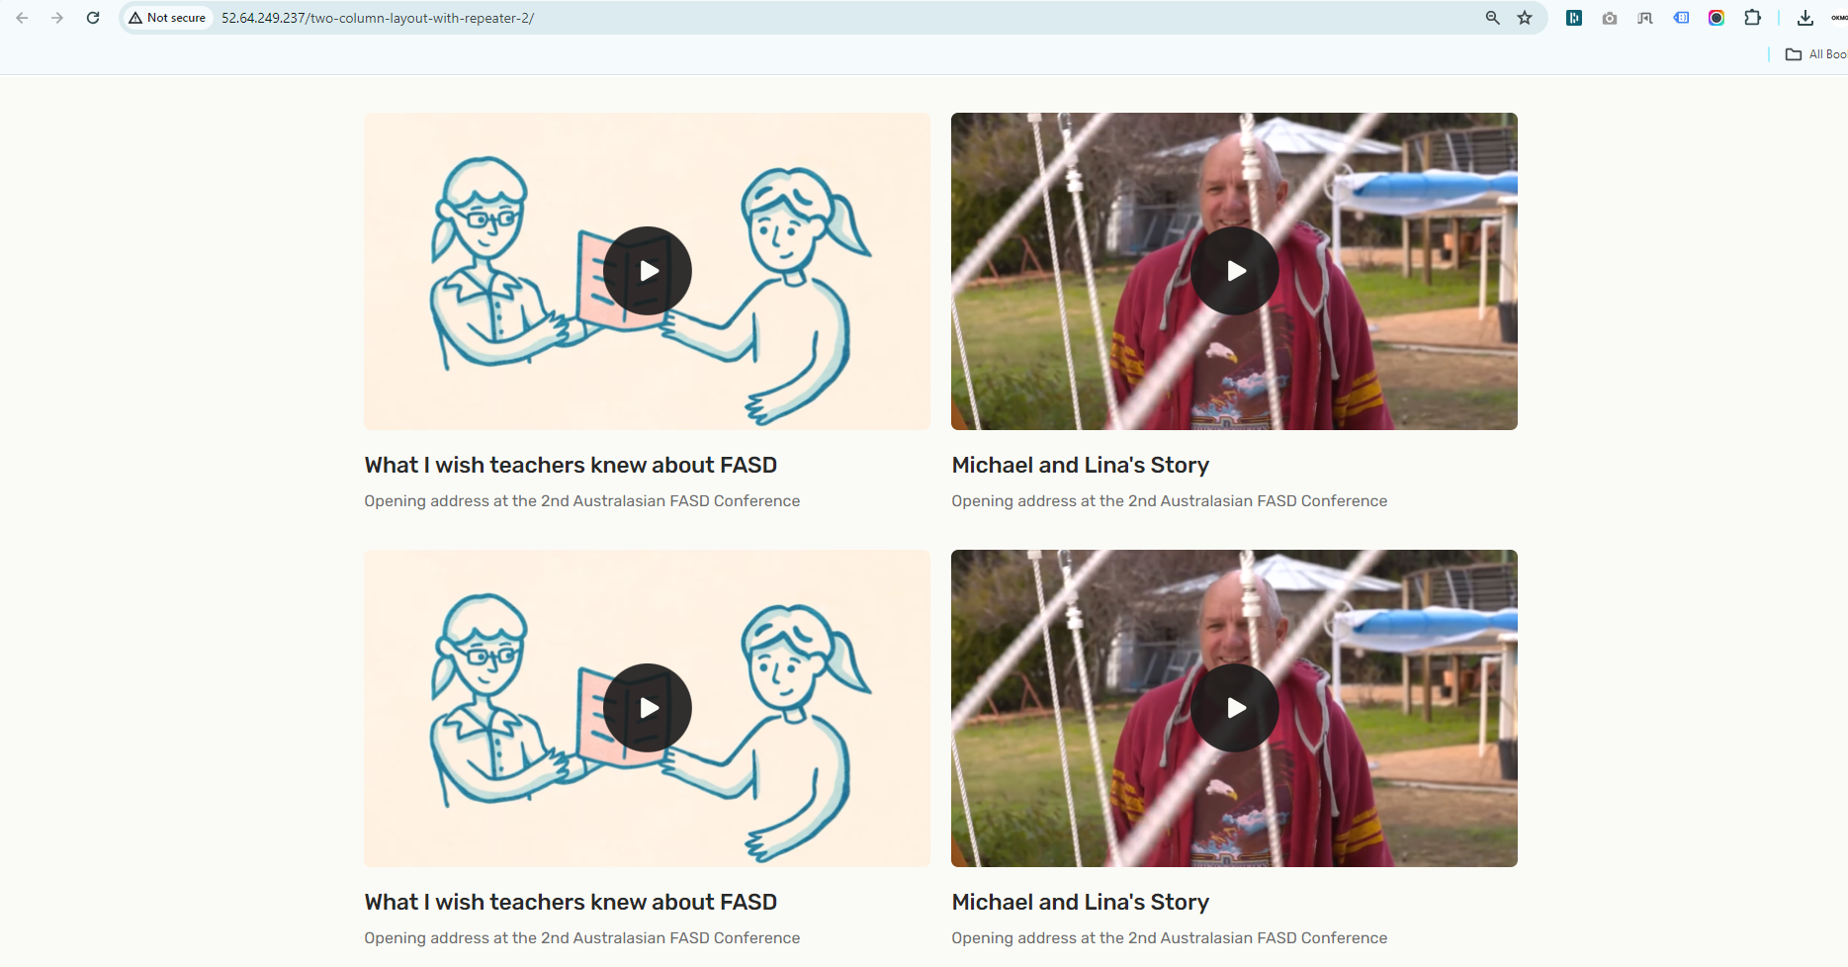

**Three Column Layout**

**How to create a Three Column Layout section**

**Preview (Three Column Layout )**

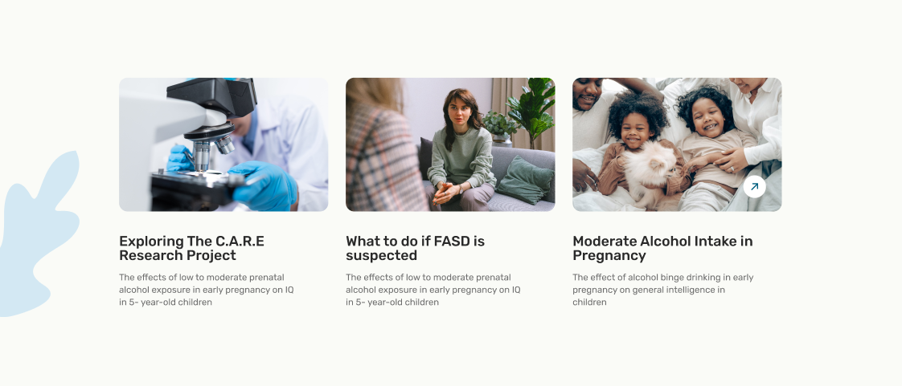

**Steps below:**

First, click on **'Add row**,' then select **'Three column layout'** from the dropdown menu, as shown in the screenshot below.

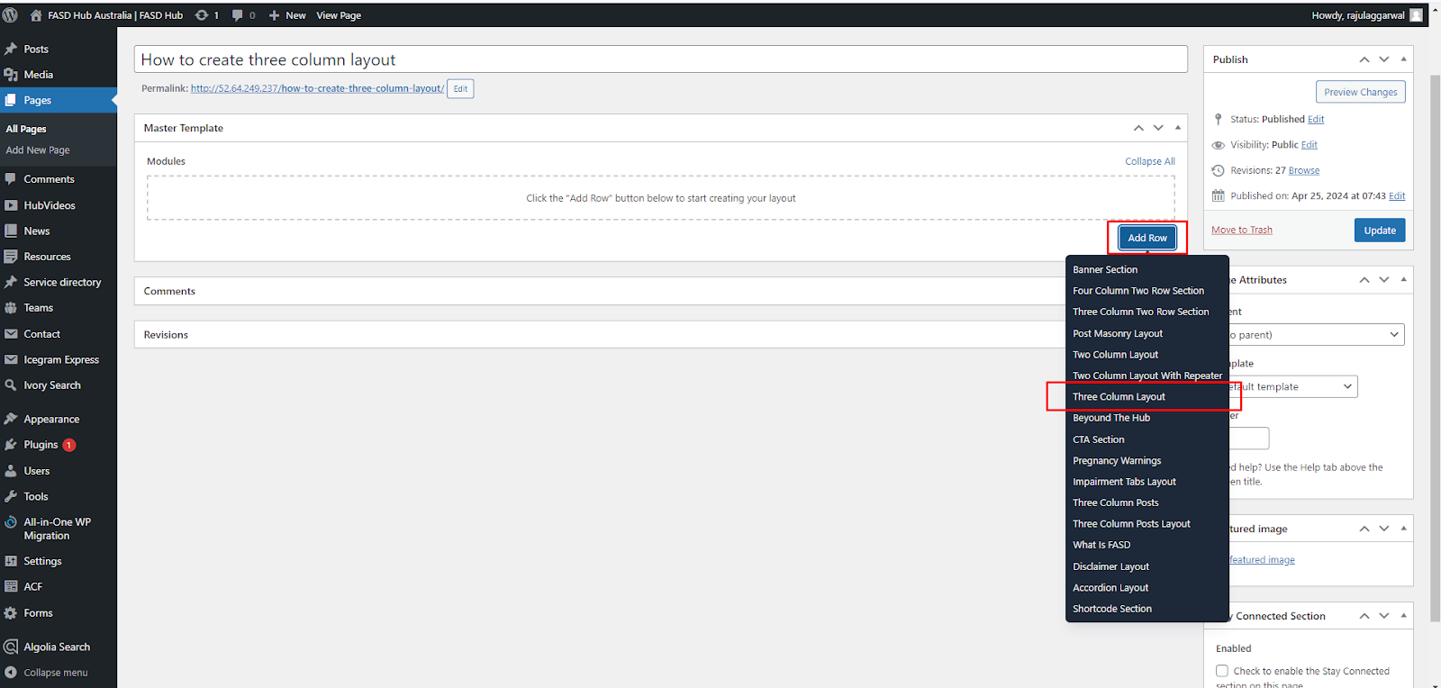

After that, click on the **'Add row'** button and add **Content blocks** for adding content, as shown in the screenshot below.

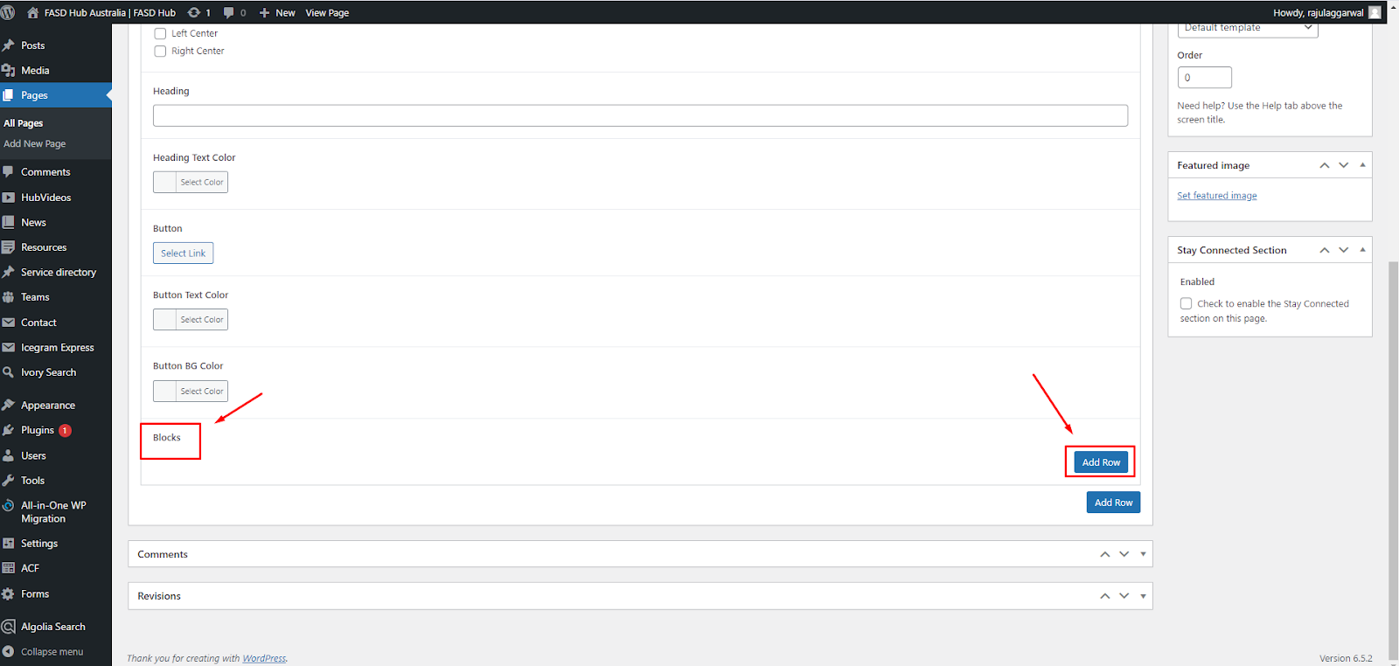

Here, you will have two options: one for **video** and the other for **image**. You can create two types of layouts using these options: '**Image** and **'Video**. If you choose to add a **video**, you will see the option for the **featured image**, where you need to set the **thumbnail**, as shown in the screenshot below.

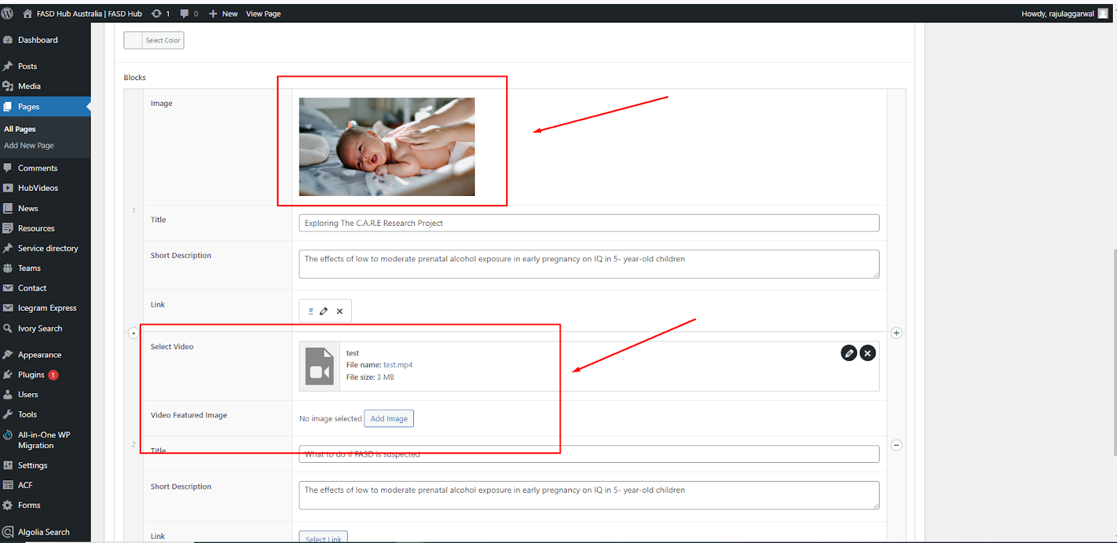

After adding content to these field boxes, save your changes and check your page, as shown in the screenshot below.

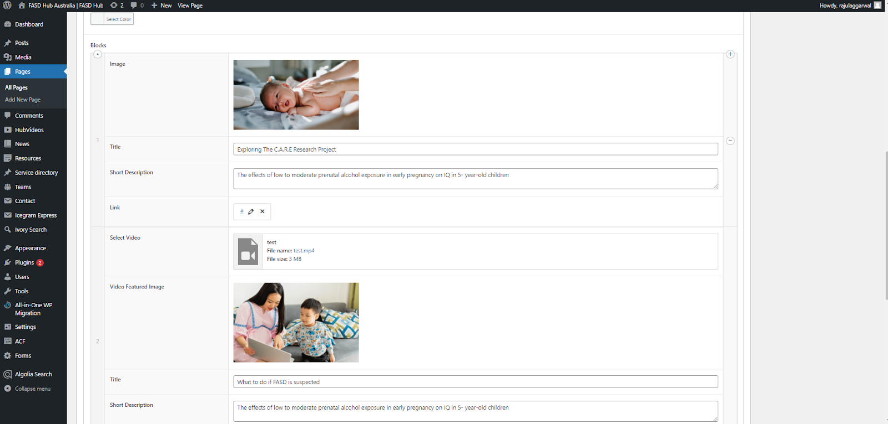

Finally, we have achieved the output of the **Three Column Layout** section on the front end, as shown in the screenshot below.

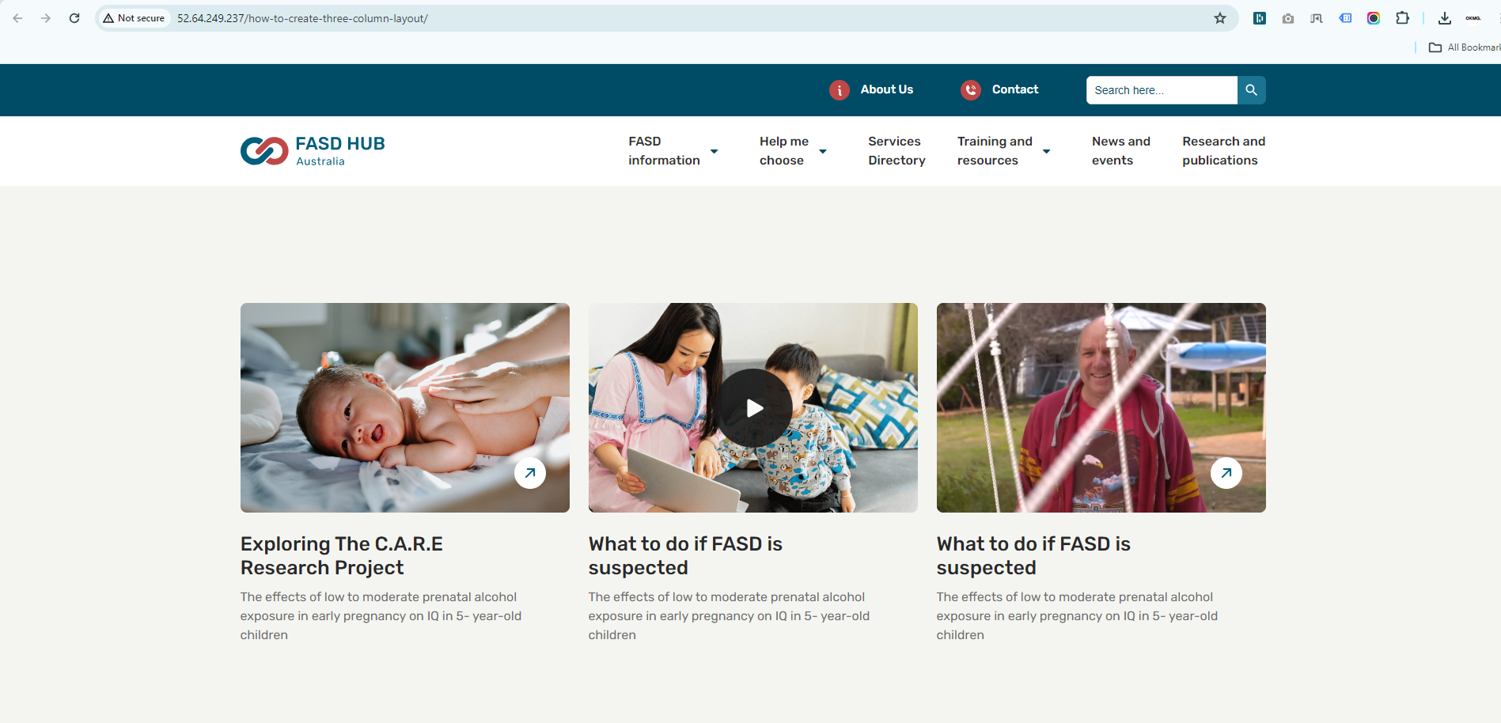

**Beyond the Hub**

**How to create a Beyond the Hub section.**

**Preview (Beyond the hub)**

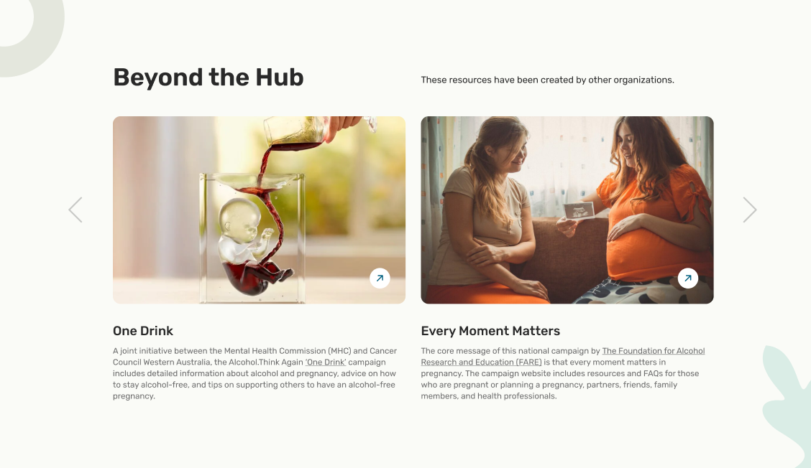

**Steps below:**

First, click on **'Add row**,' then select **'Beyond the Hub'** from the dropdown menu, as shown in the screenshot below.

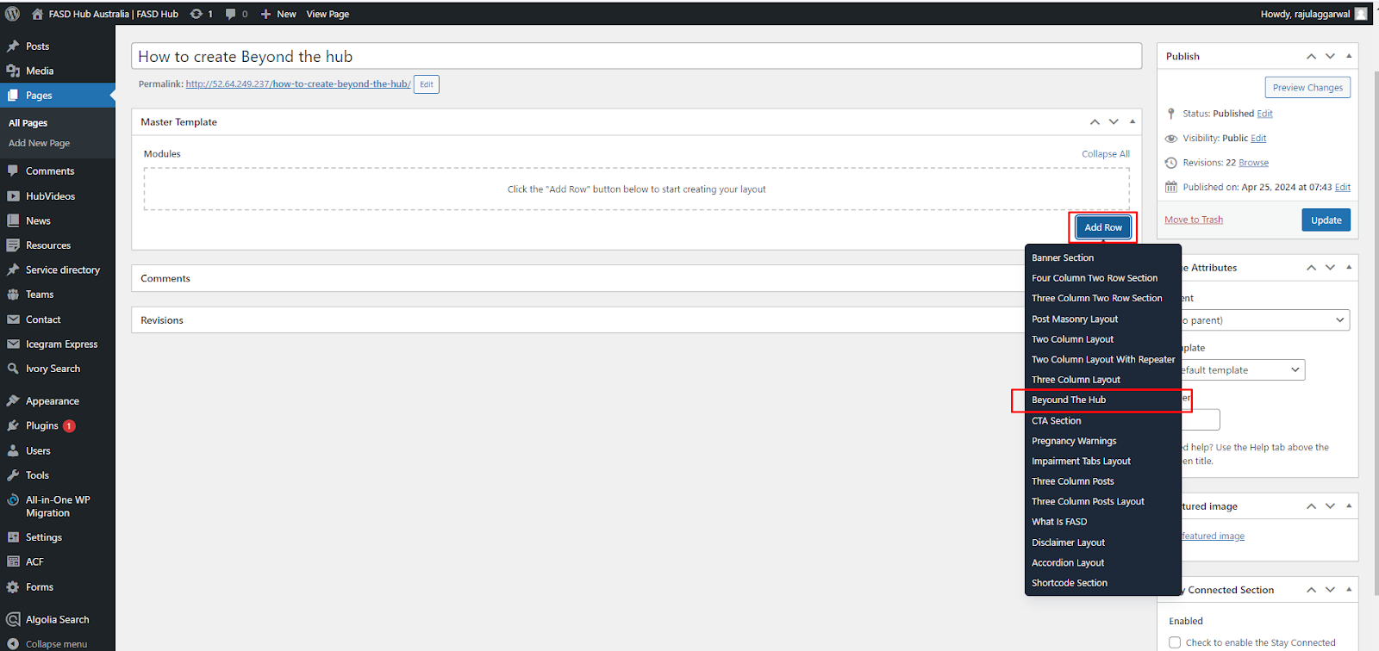

After that, the module related to **beyond the hub** will be added, and you will find options related to this, as shown in the screenshot below.

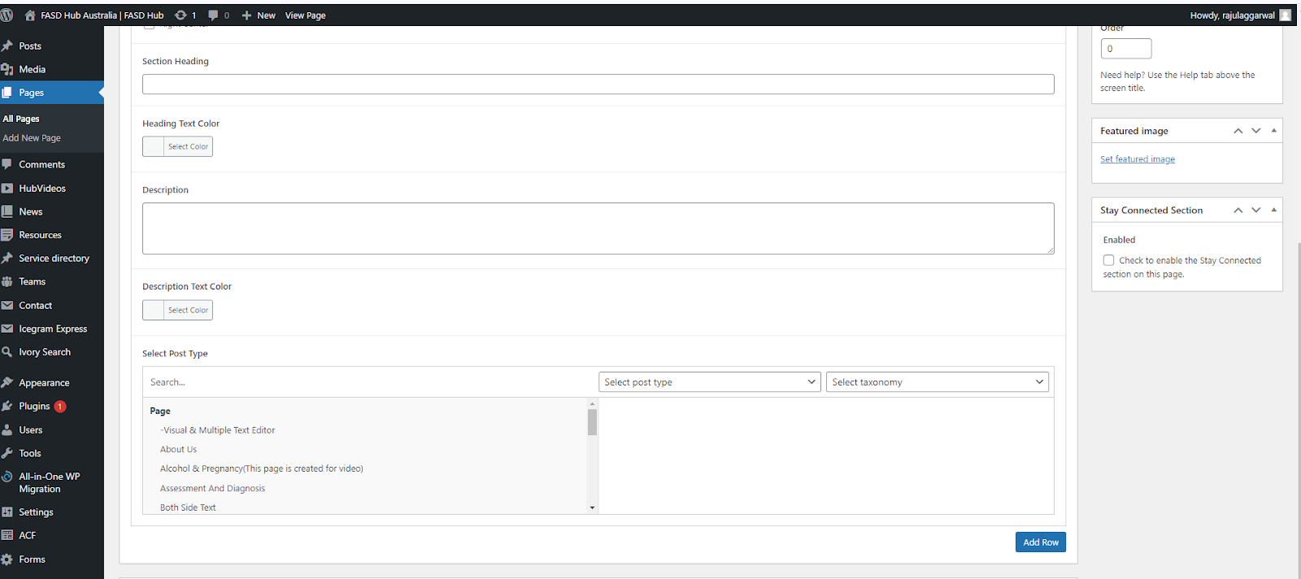

After filling in the section **heading** and **description**, you have to select the **post type** and **taxonomy** that you want. On the left side, you have to select the **post** of your desire that you want to display on the front end.

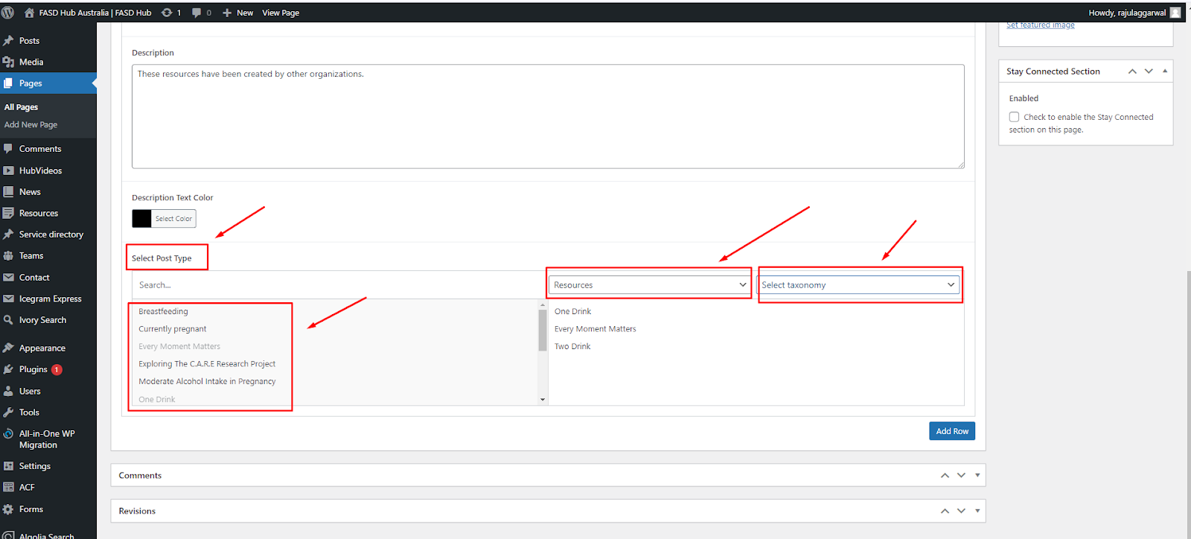

You can add multiple posts here, which will display as a slider on the front end, as shown in the screenshot below.

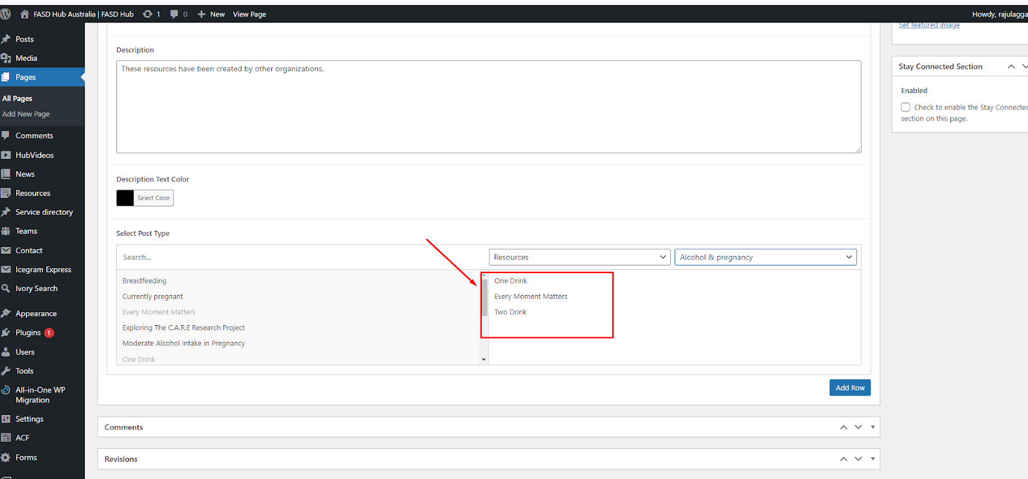

After adding content to these field boxes, save your changes and check your page, as shown in the screenshot below.   
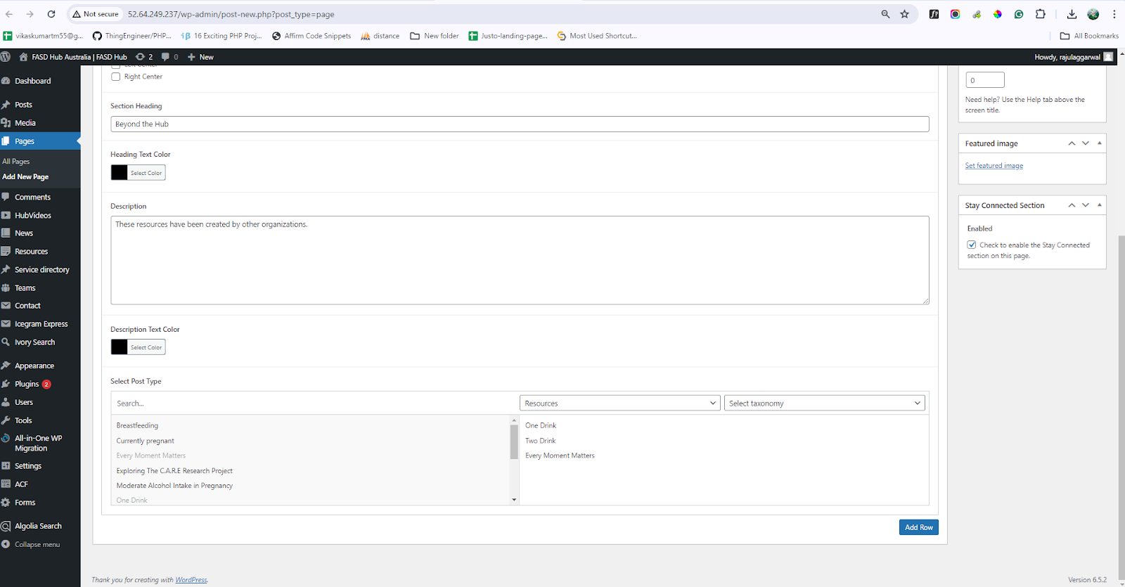

Finally, we have achieved the output of the **Beyond the Hub section** on the front end, as shown in the screenshot below.

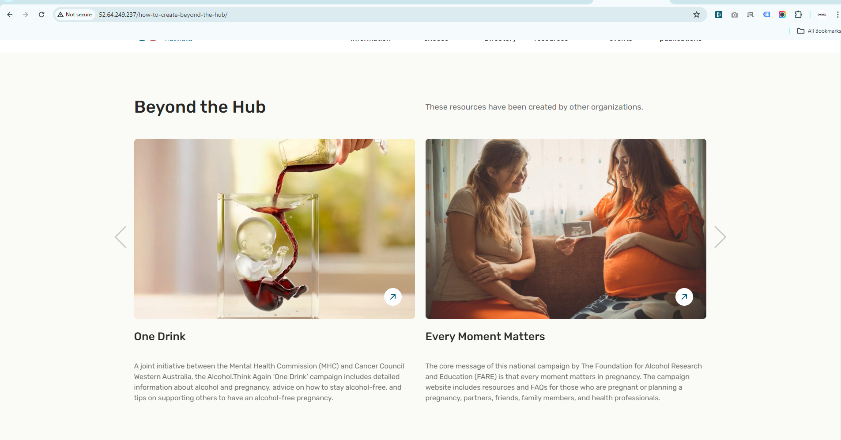

**CTA Section**

**How to create a CTA section.**

**Preview (CTA section)**



**Steps below:**

First, click on **'Add row**,' then select **'CTA Section'** from the dropdown menu, as shown in the screenshot below.

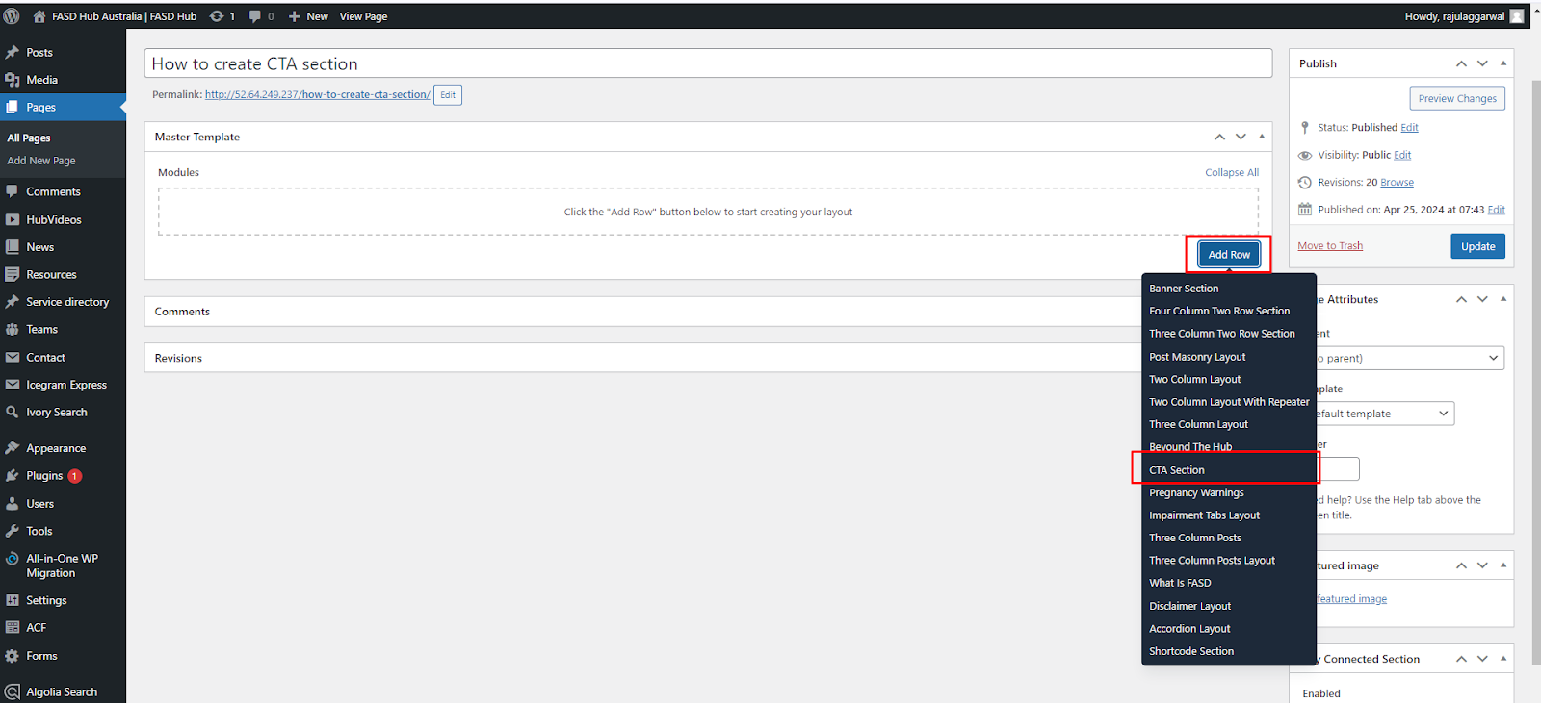

After that, the module related to the CTA section will be added, and you will find options related to this, such as heading, description, and button, as shown in the screenshot below.

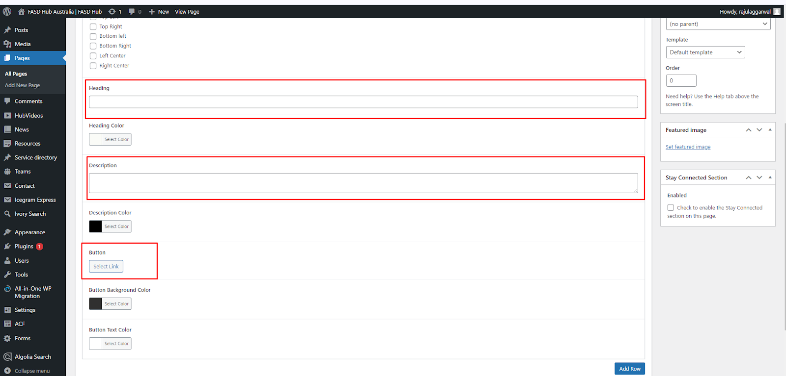

After adding content to these field boxes, save your changes and check your page, as shown in the screenshot below.

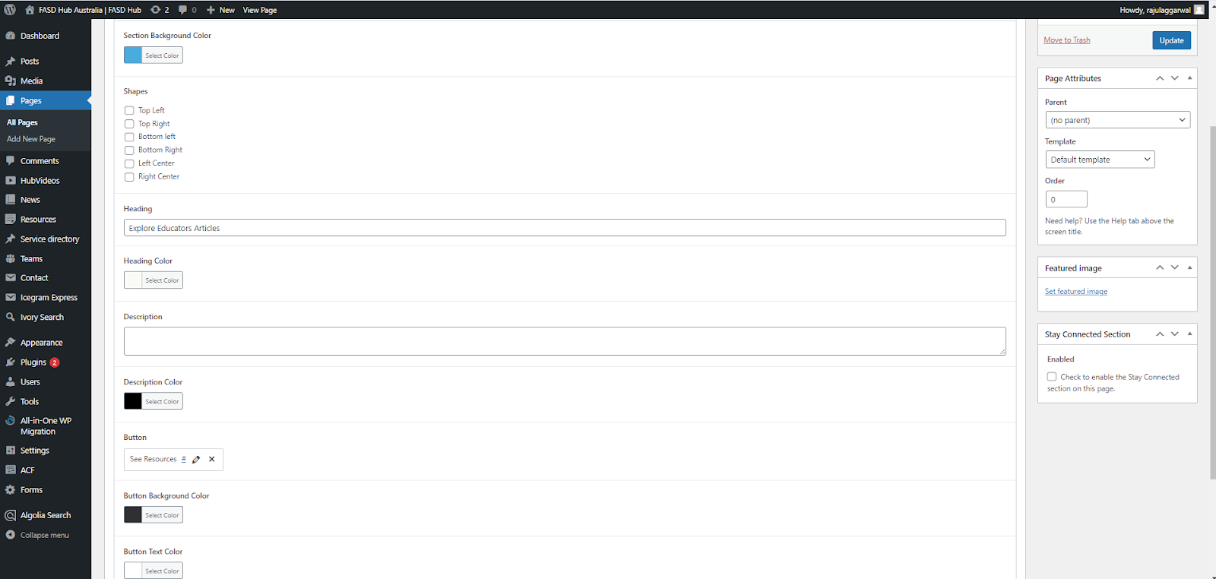

Finally, we have achieved the output of the **CTA Section** on the front end, as shown in the screenshot below.  
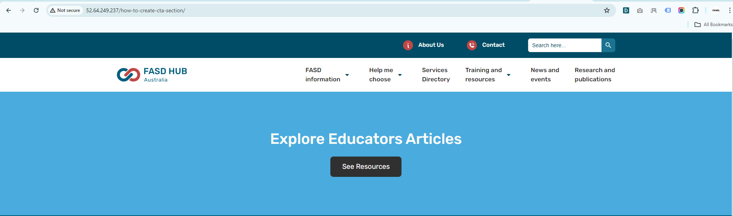

**Pregnancy Warning**

**How to create a Pregnancy warning section.**

**Preview (Pregnancy warning)**

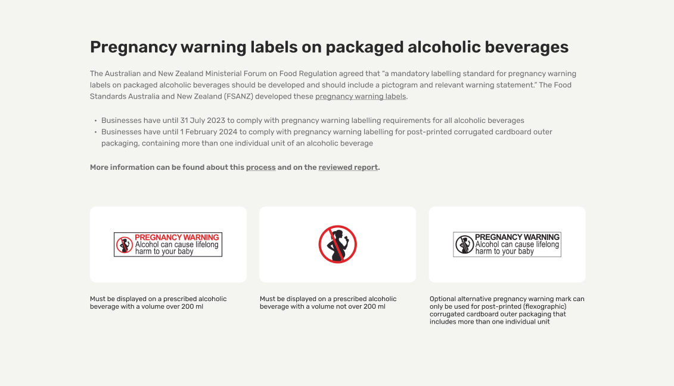

**Steps below:**

First, click on **'Add row**,' then select **'Pregnancy warning'** from the dropdown menu, as shown in the screenshot below.

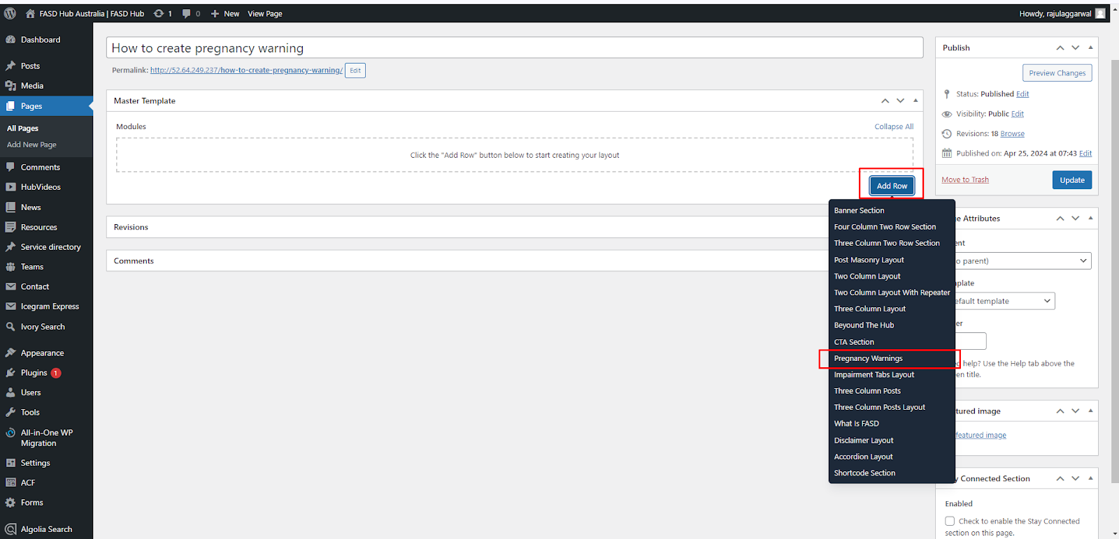

After that, click on the **'Add row**' button and add **Content blocks** for adding content, as shown in the screenshot below.

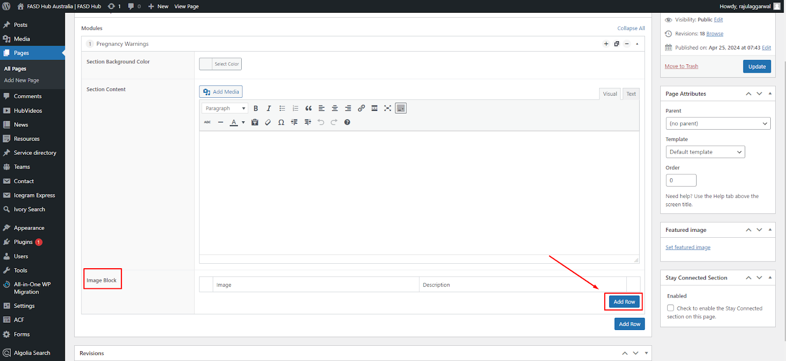

After adding content to these field boxes, save your changes and check your page, as shown in the screenshot below.

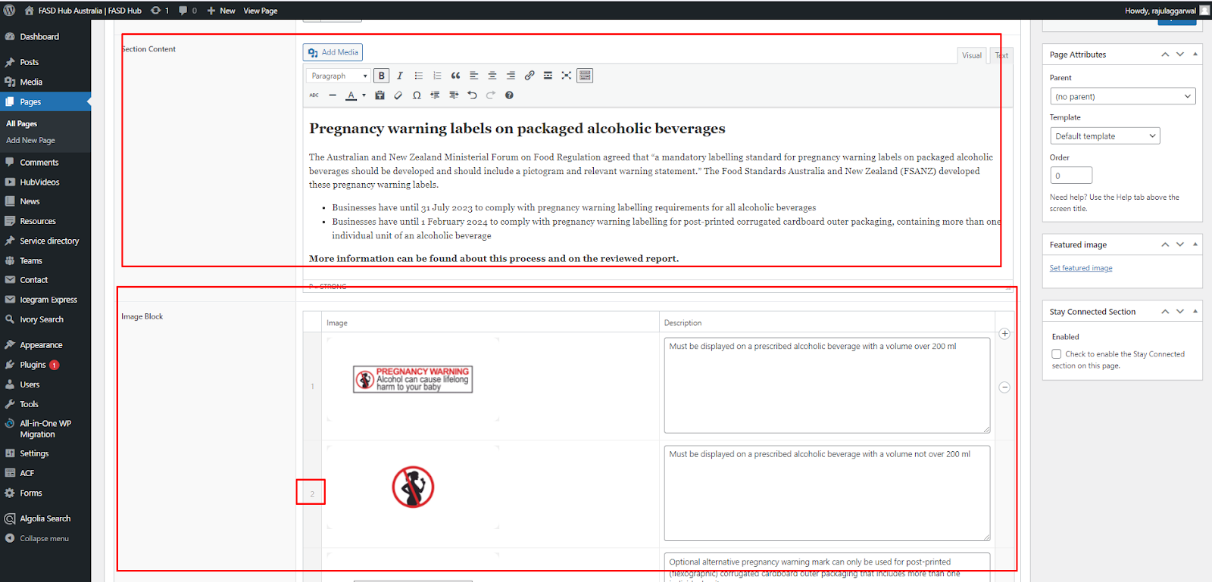

Finally, we have achieved the output of the **pregnancy warning** sectionon the front end, as shown in the screenshot below.

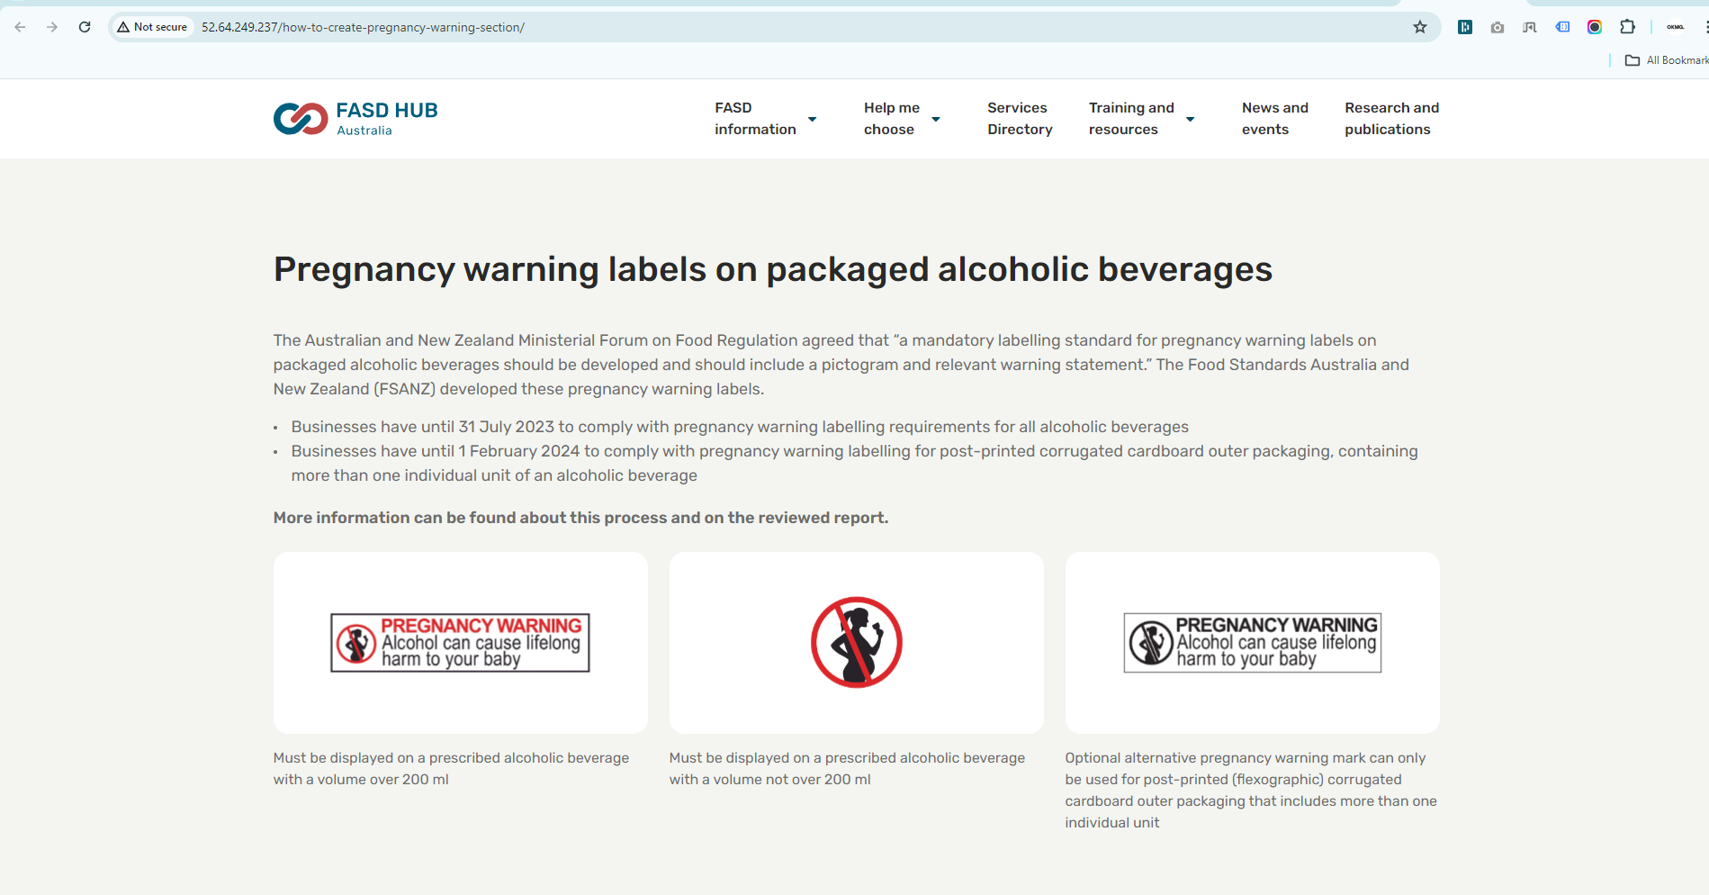

**Impairment Tabs layout**

**How to create an impairment tabs layout section.**

**Preview (Impairment tabs layout)**

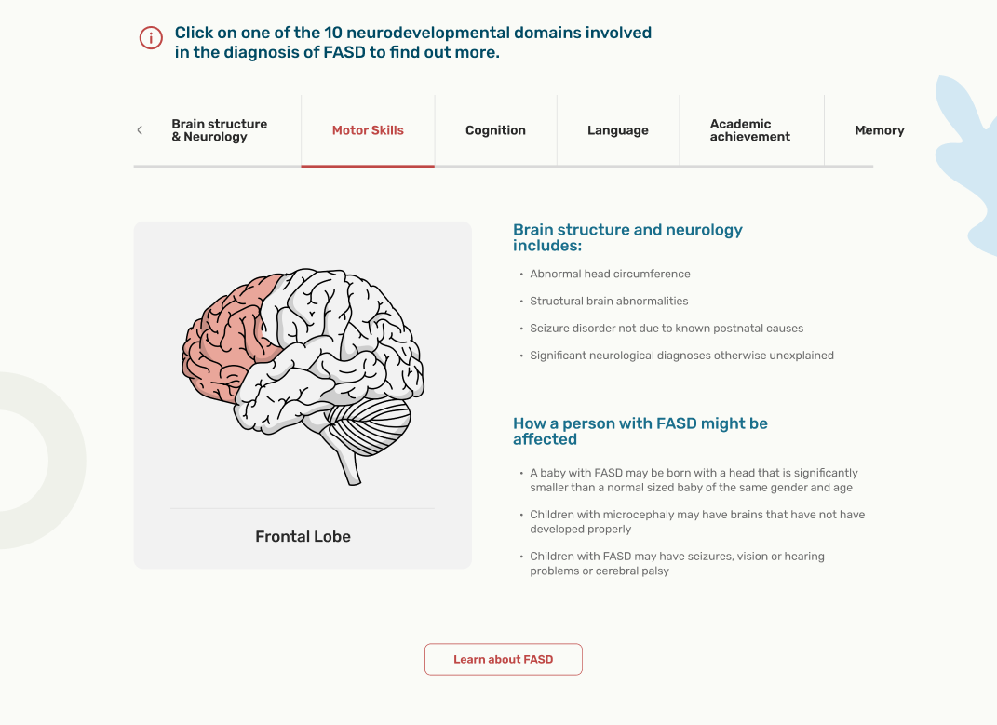

**Steps below:**

First, click on **'Add row**,' then select **'Impairment tabs layout'** from the dropdown menu, as shown in the screenshot below.

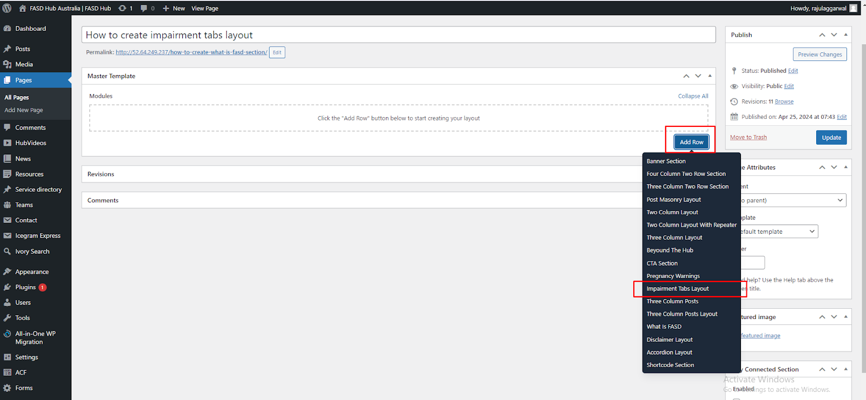

After that, the module related to the **impairment tabs layout** will be added, and you will find options related to this such as section heading and button, as shown in the screenshot below.

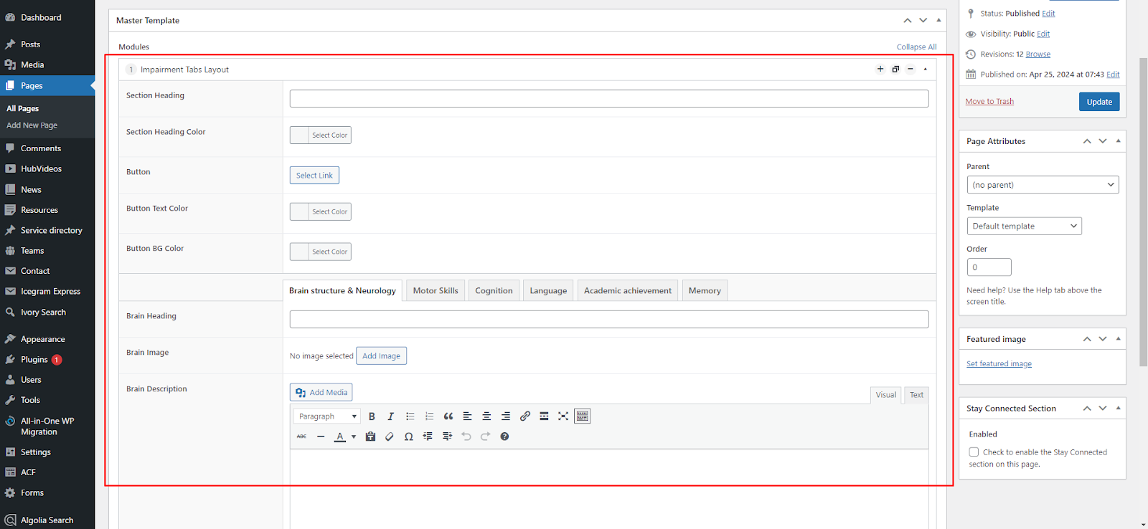

Here, you will find many tabs, within which you can add **tab headings**, **content,** and **images** related to that tab, as shown in the screenshot below.

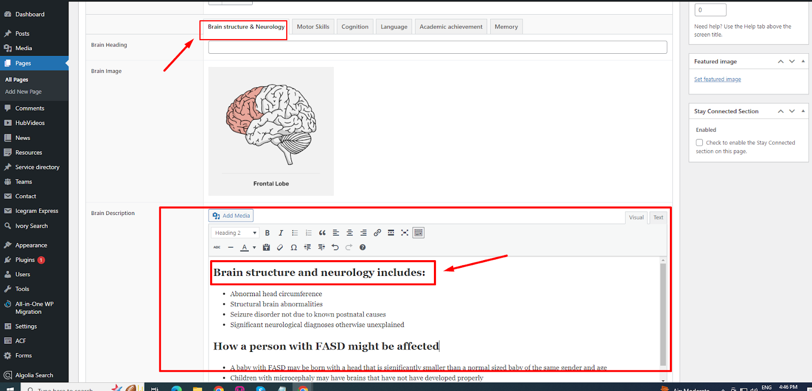

After adding content to these field boxes, save your changes and check your page, as shown in the screenshot below.

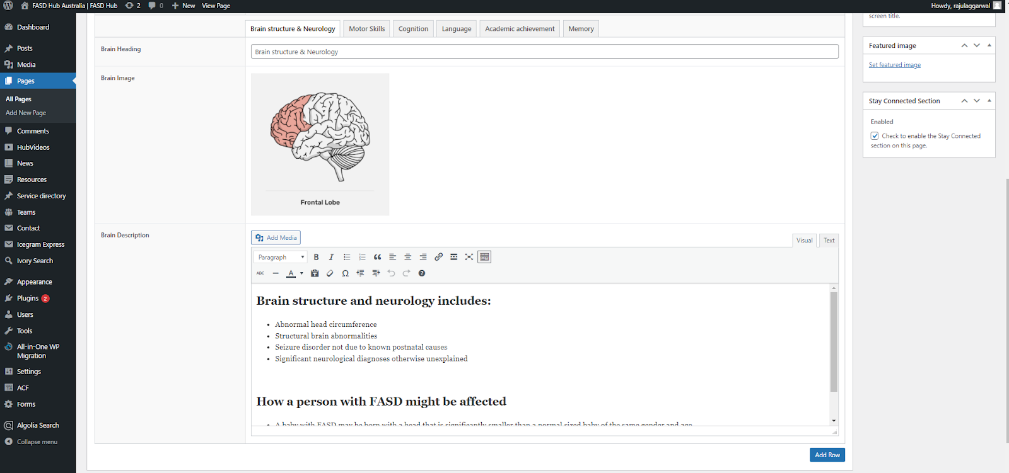

Finally, we have achieved the output of the **Impairment tabs layout** sectionon the front end, as shown in the screenshot below.

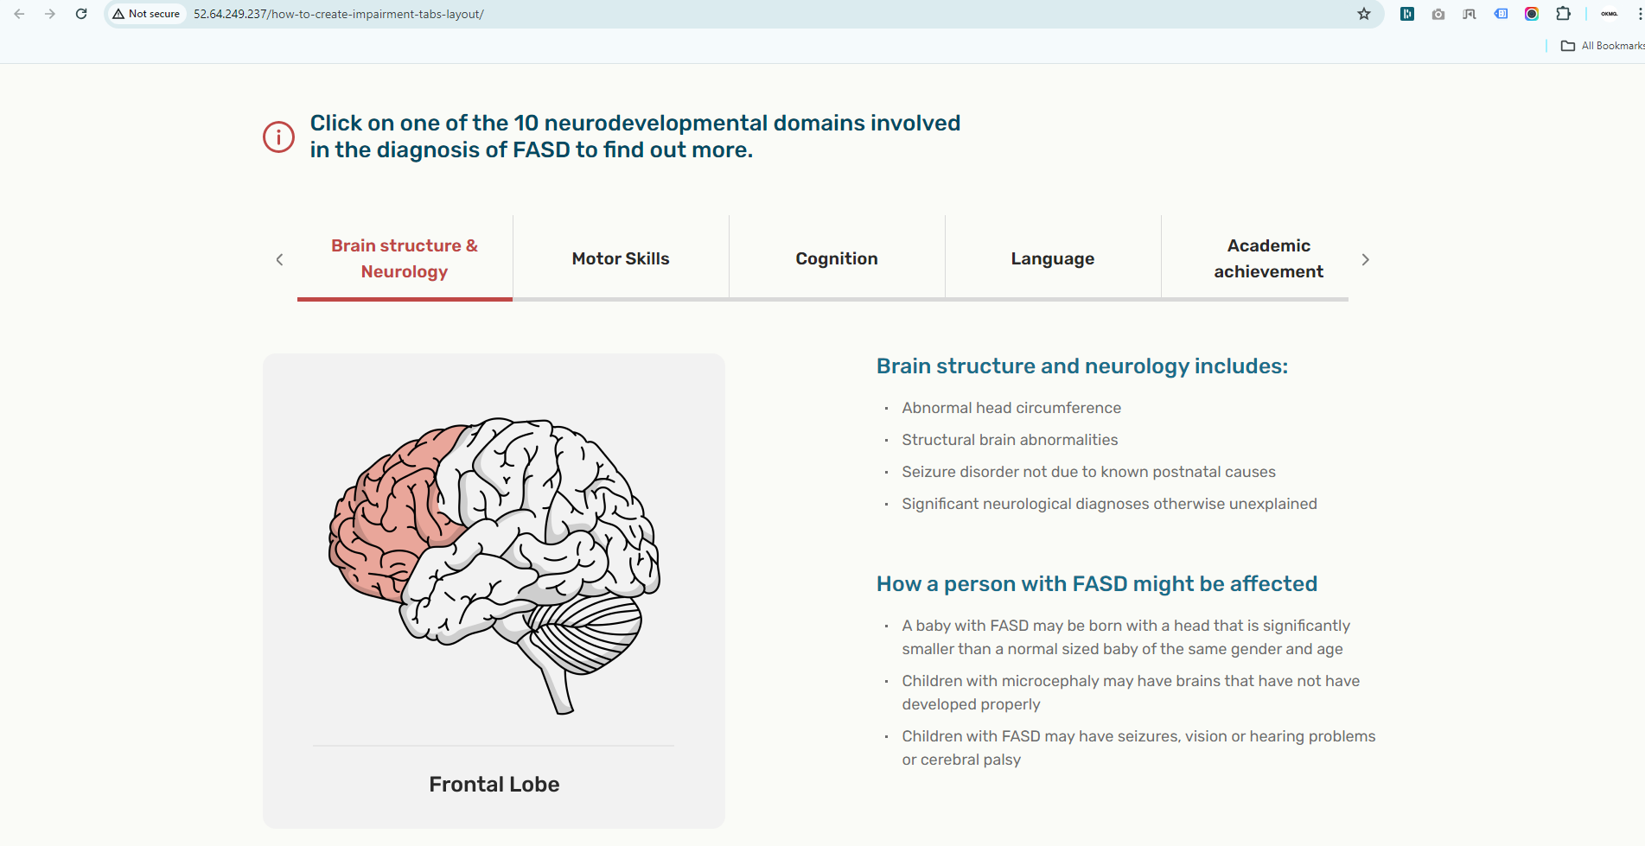

**Three-Column Post Layout**

**How to create a Three Column Post layout section.**

**Preview (Three column post layout)**

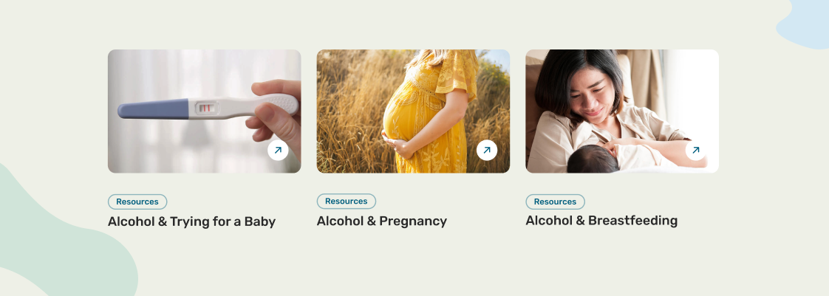

**Steps below:**

First, click on **'Add row**,' then select **'Three column post layout'** from the dropdown menu, as shown in the screenshot below.

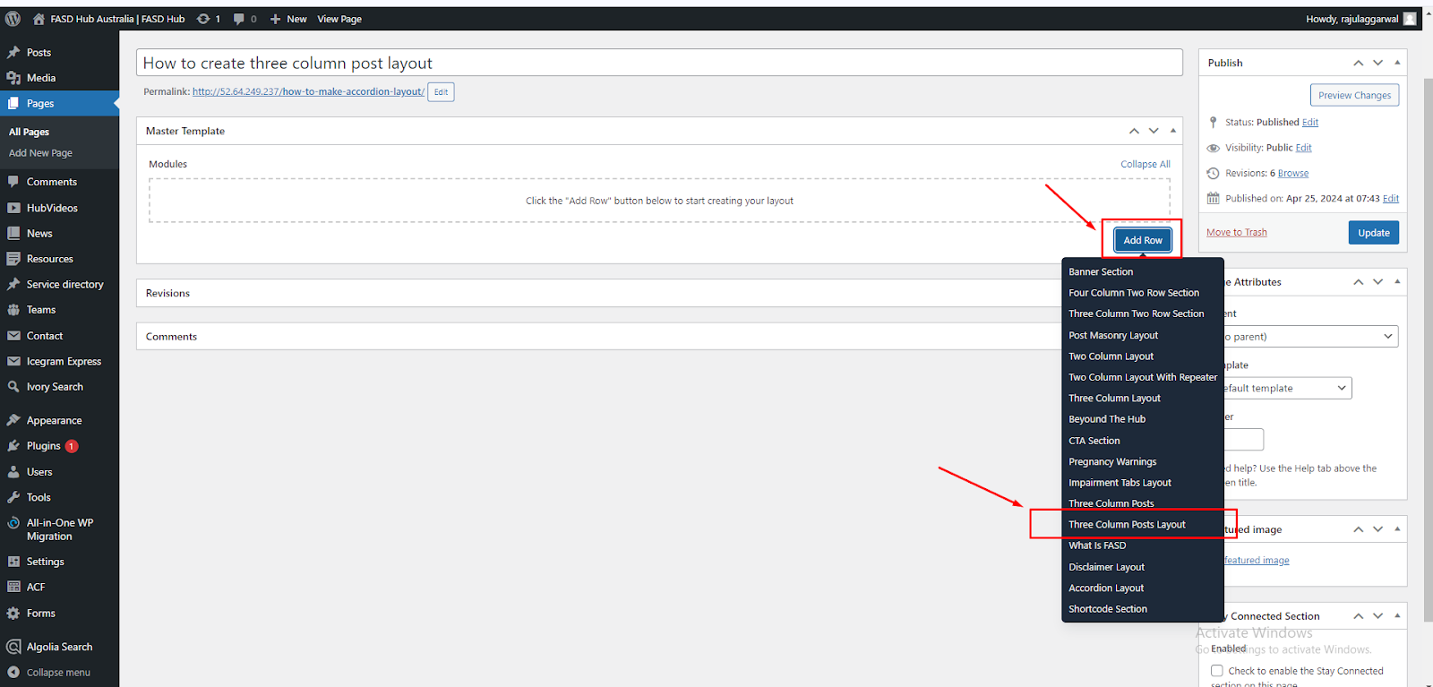

After that, the module related to the **three-column post layout** section will be added, and you will find options related to this, as shown in the screenshot below.

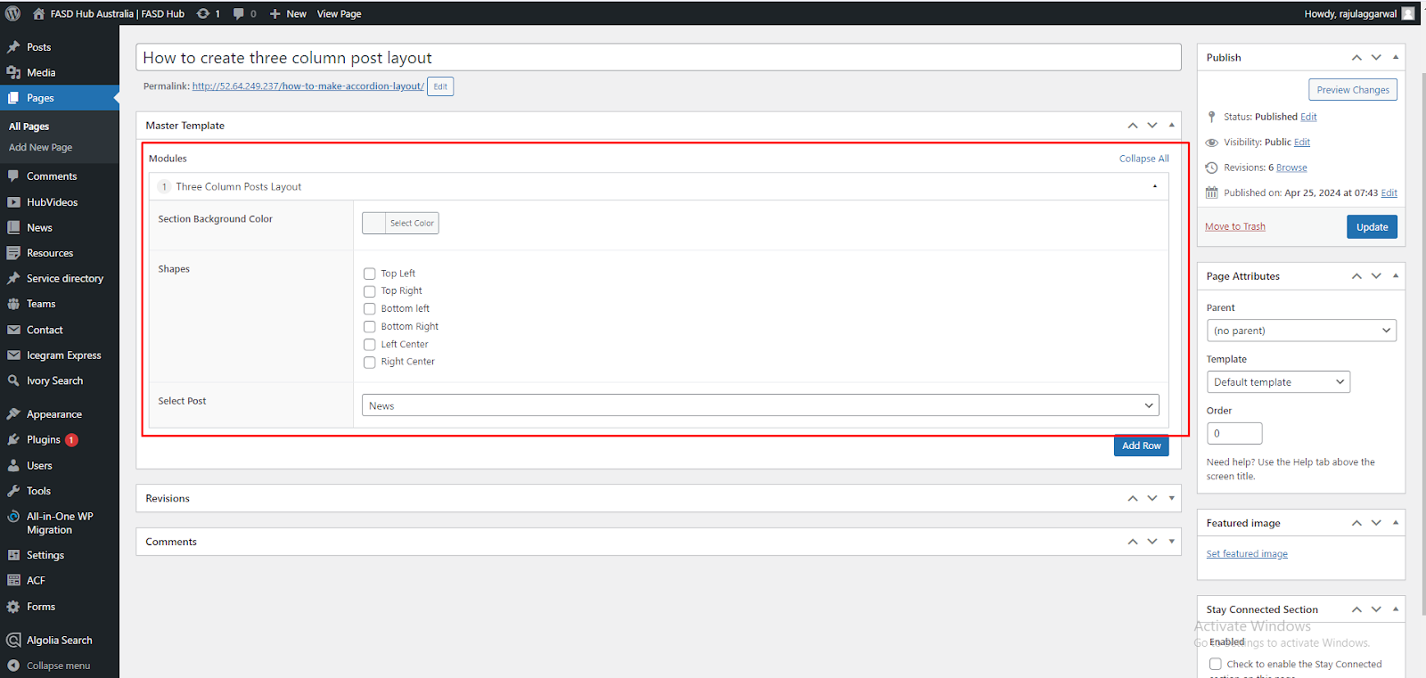

Now, you will see the option for selecting the post type. You can select the post type you want here such as **news** or **resource**, as shown in the screenshot below.

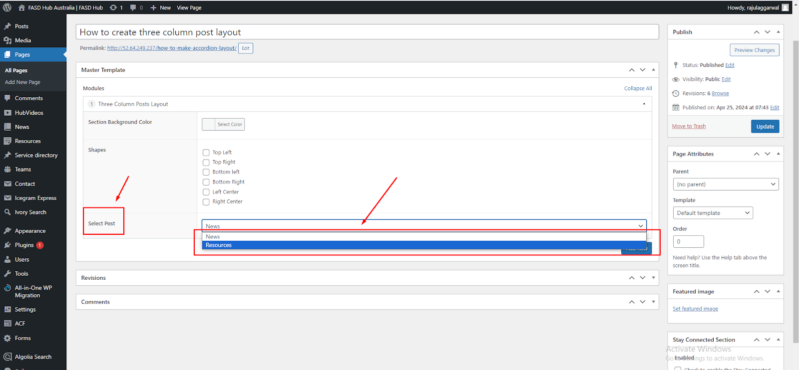

After adding content to these field boxes, save your changes and check your page, as shown in the screenshot below.

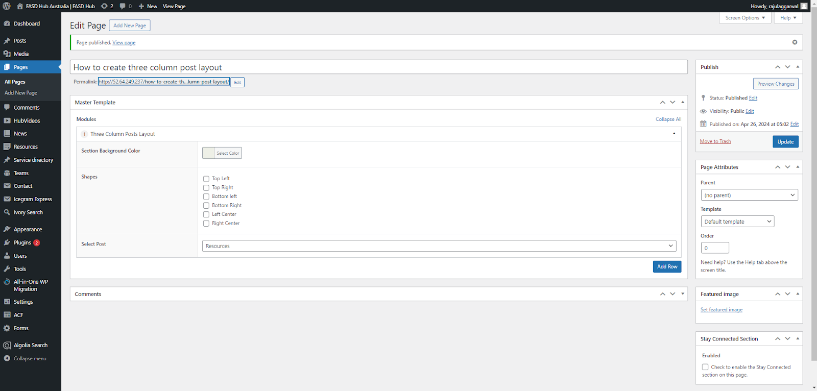

Finally, we have achieved the output of the **Three-column post layout** section on the front end, as shown in the screenshot below.

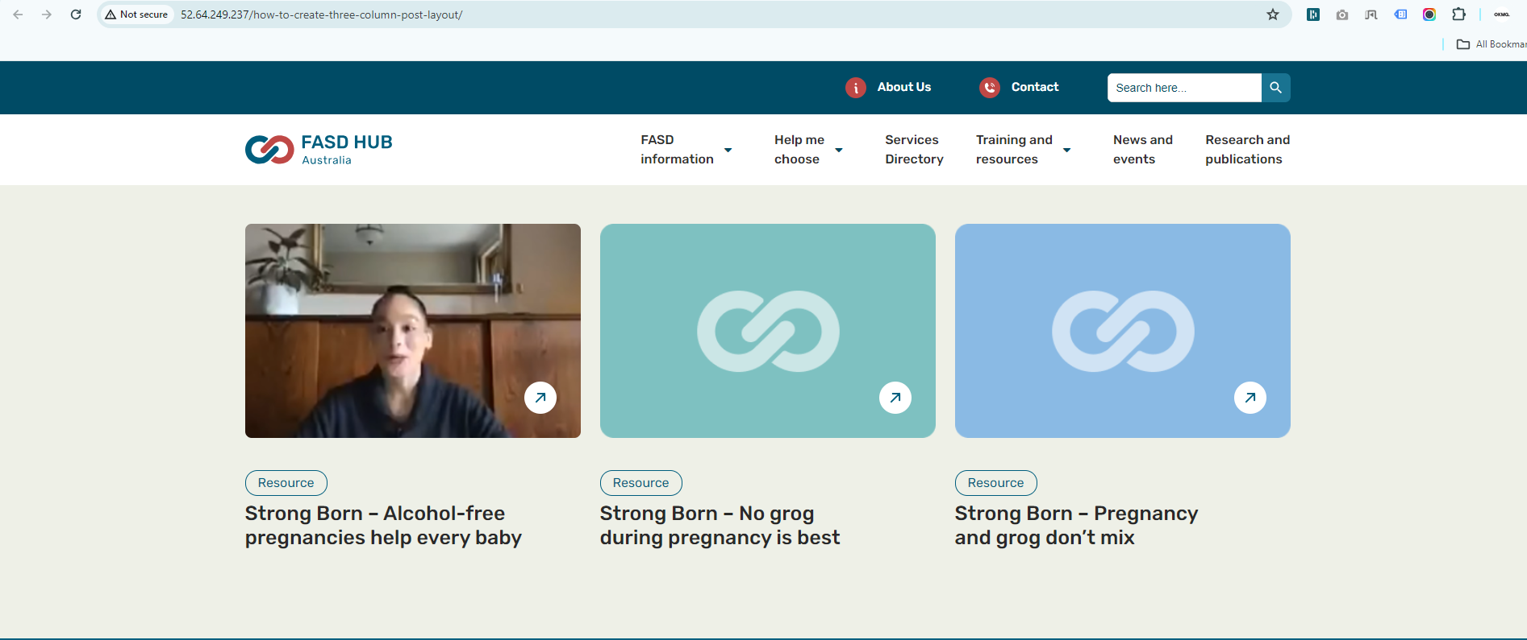

**What is FASD**

**How to create a What Is FASD section.**

**Preview (What is FASD)**

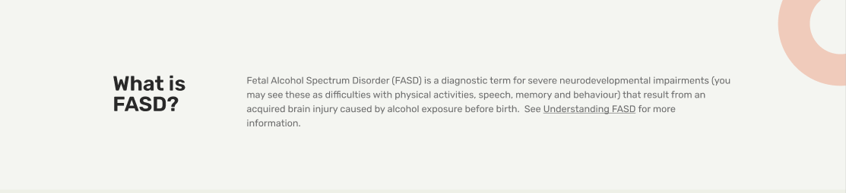

**Steps below:**

First, click on **'Add row**,' then select **'What is FASD'** from the dropdown menu, as shown in the screenshot below.

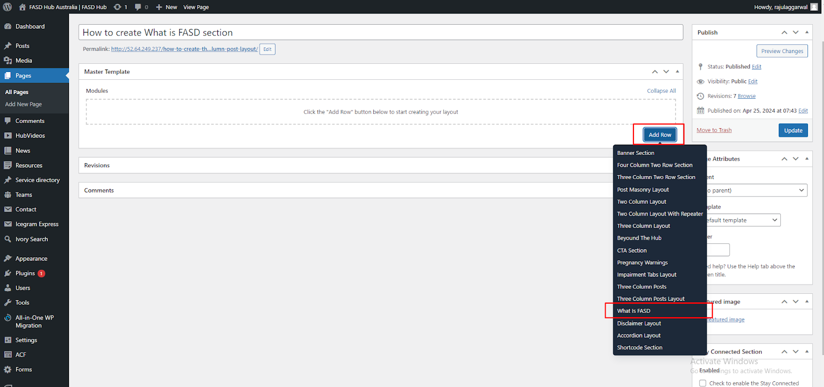

After that, click on the **'Add row**' button and add **Content blocks** for adding content, as shown in the screenshot below.

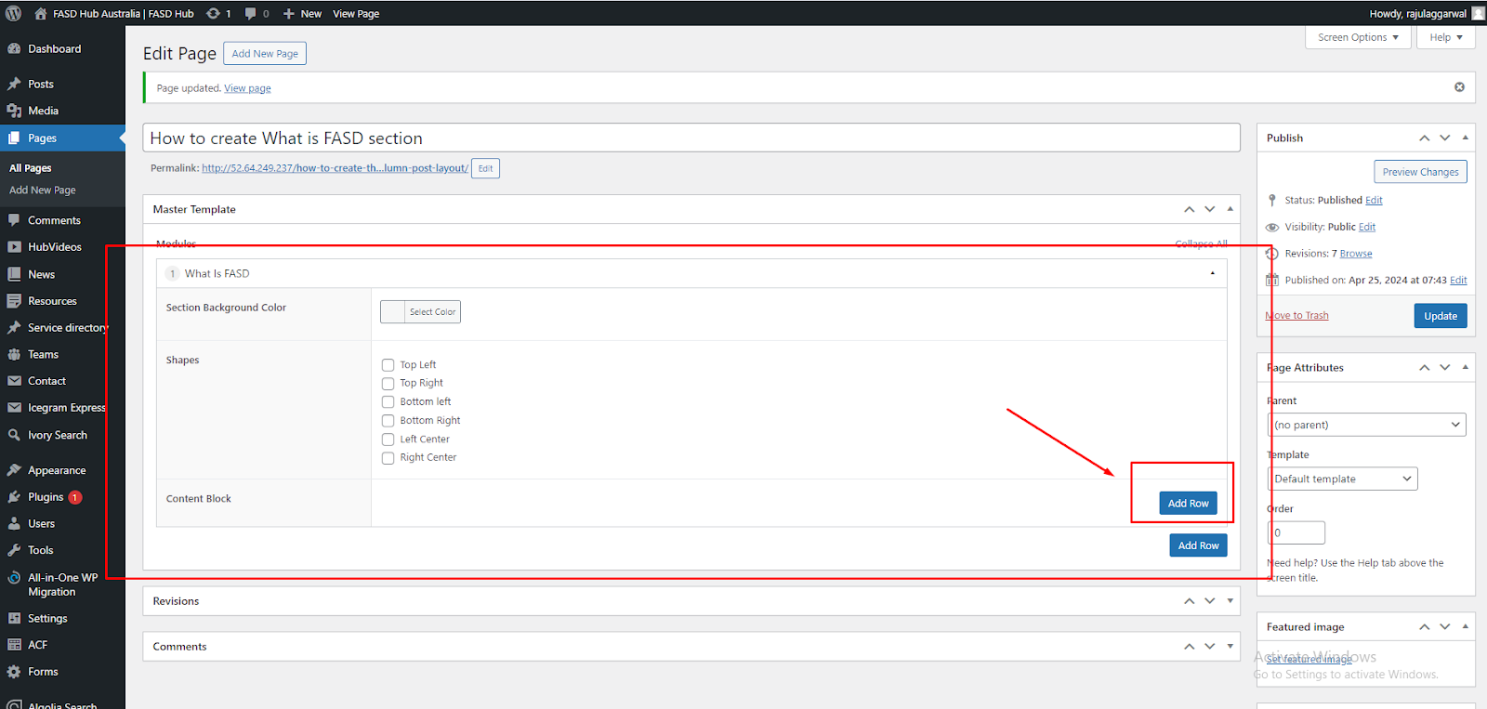

Add heading in the **Left side Content** editor in the **heading (h1 - h3)** tag and description in the **Right side Content** editor, as shown in the screenshot below.

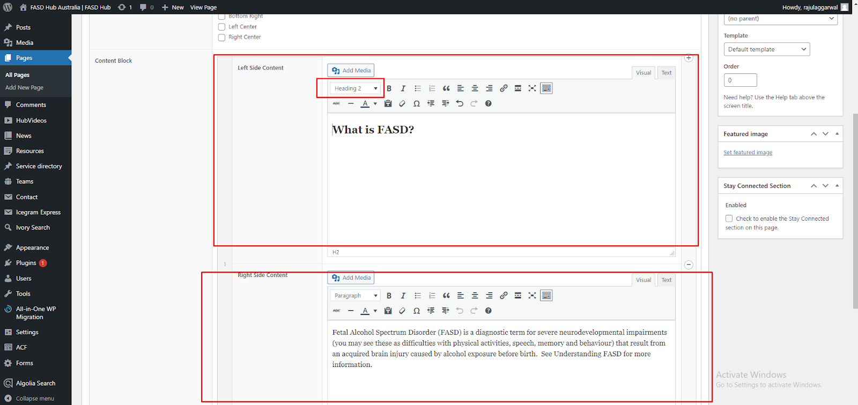

After adding content to these field boxes, save your changes and check your page, as shown in the screenshot below.

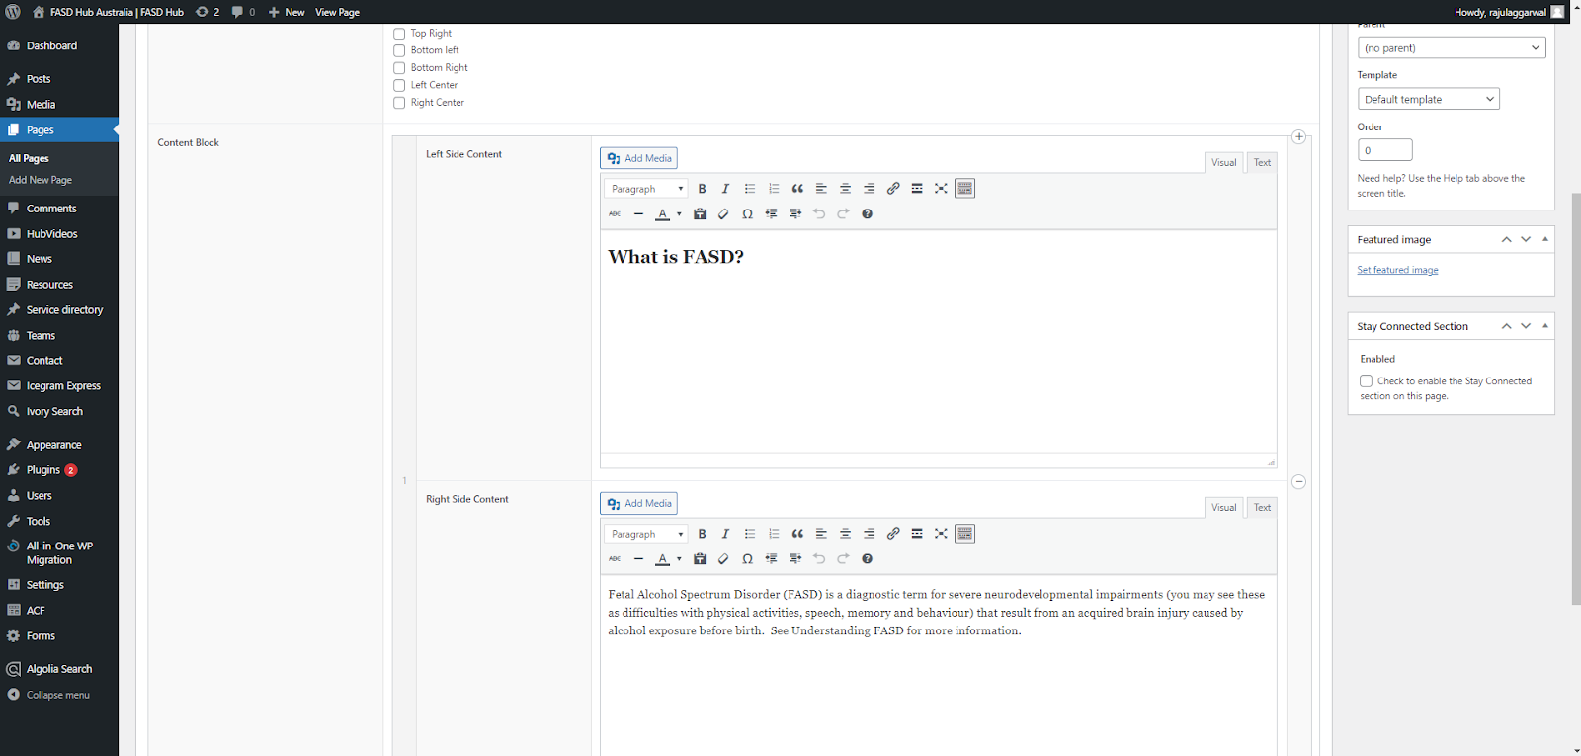

Finally, we have achieved the output of **what is FASD** on the front end, as shown in the screenshot below

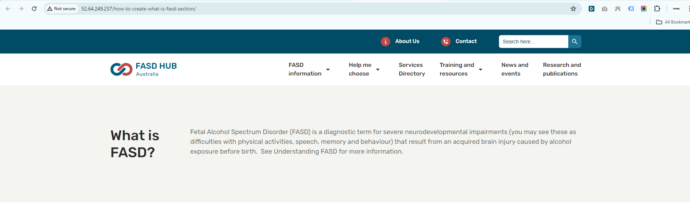

**Disclaimer Layout**

**How to create a Disclaimer Layout section.**

**Preview (Disclaimer Layout)**

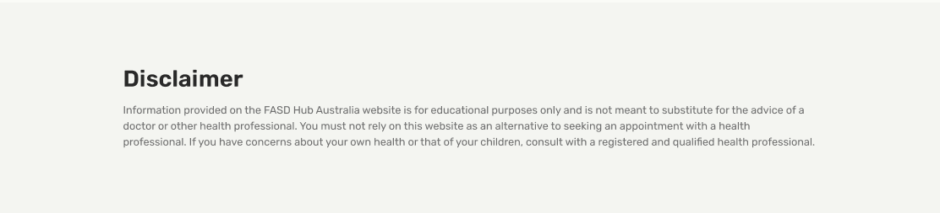

**Steps below:**

First, click on **'Add row**,' then select **'Disclaimer Layout'** from the dropdown menu, as shown in the screenshot below.

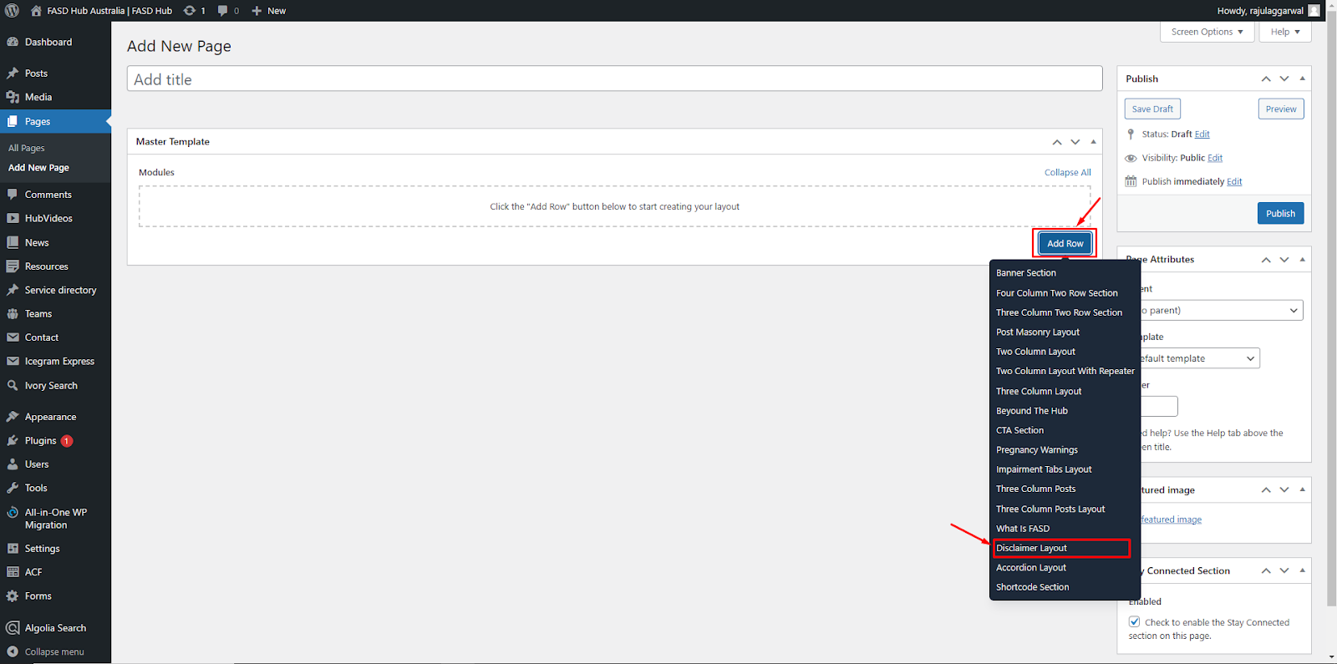

After that, the module related to the **disclaimer layout** section will be added, and you will find options related to the disclaimer layout, as shown in the screenshot below.

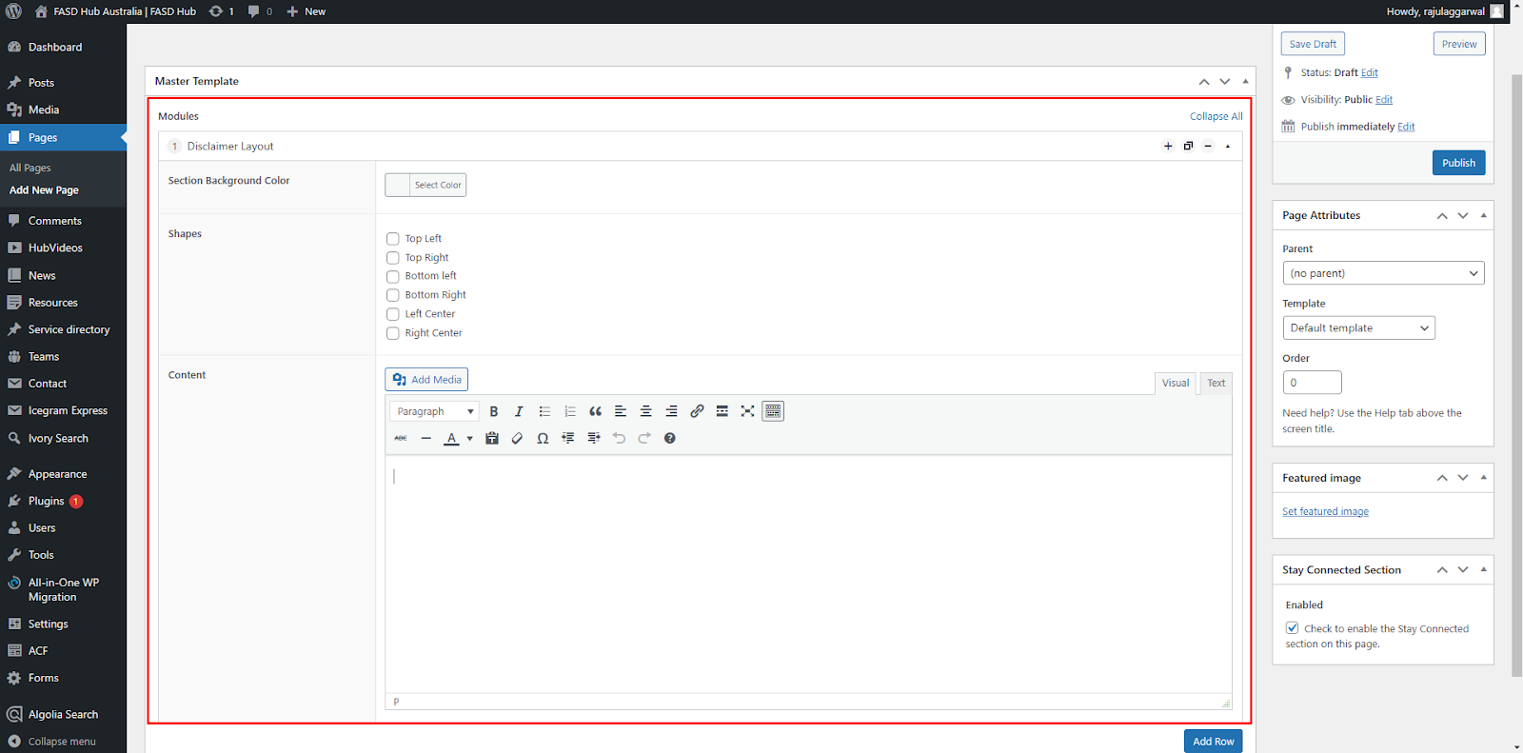

Now, you will see the option to add content, as shown in the screenshot below.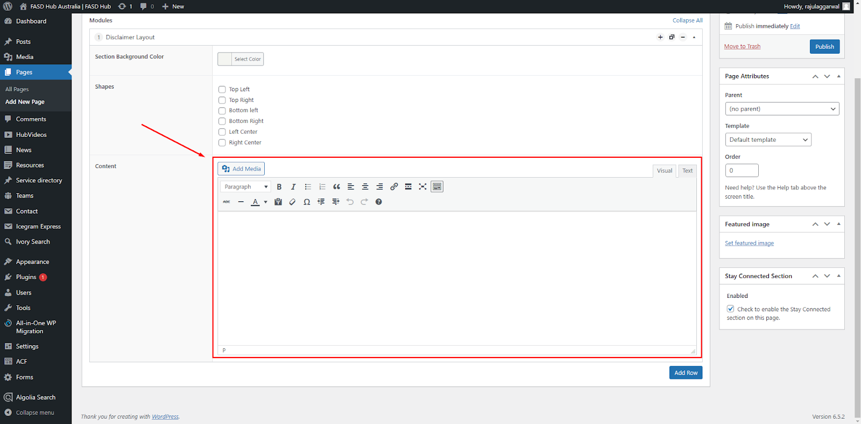

From this option, you can add both a **heading** and **description** in the text editor, as shown in the screenshot below.

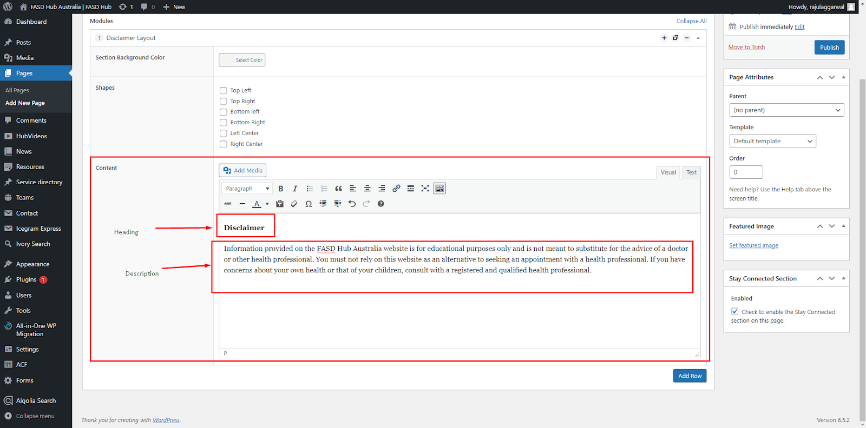

After adding content to these field boxes, save your changes and check your page, as shown in the screenshot below.

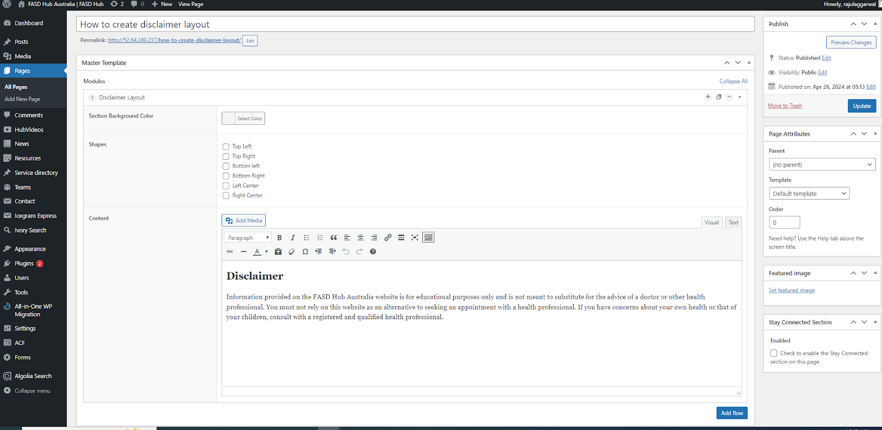

Finally, we have achieved the output of the **disclaimer layout** section on the front end, as shown in the screenshot below.

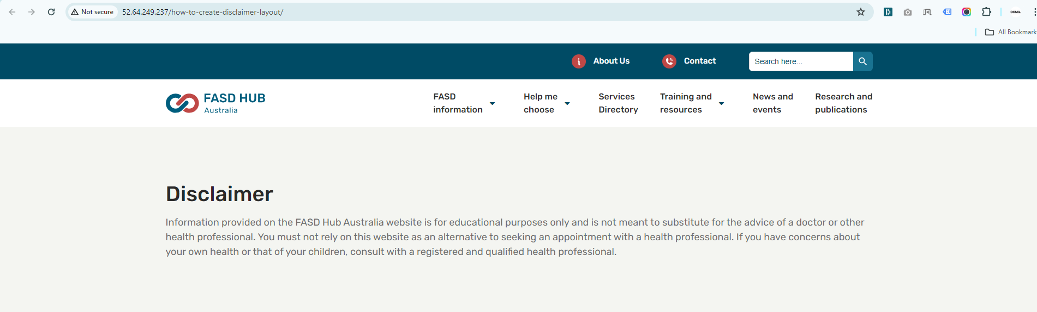

**Accordion layout**

**How to create an Accordion layout section.**

**Preview (Accordion layout)**

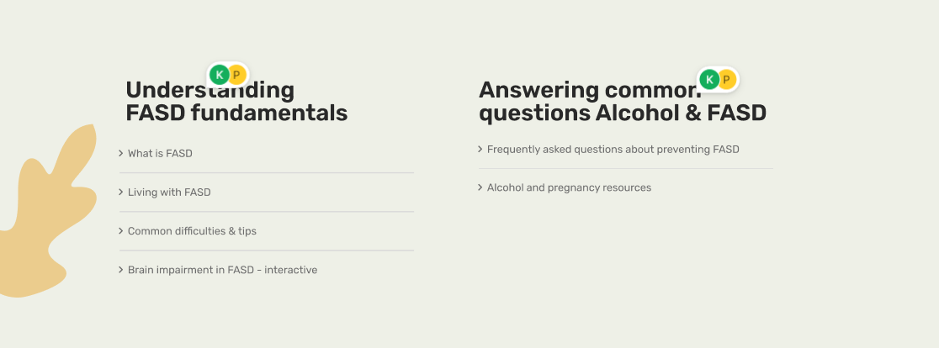

**Steps below:**

First, click on **'Add row**,' then select **'Accordion layout'** from the dropdown menu, as shown in the screenshot below.

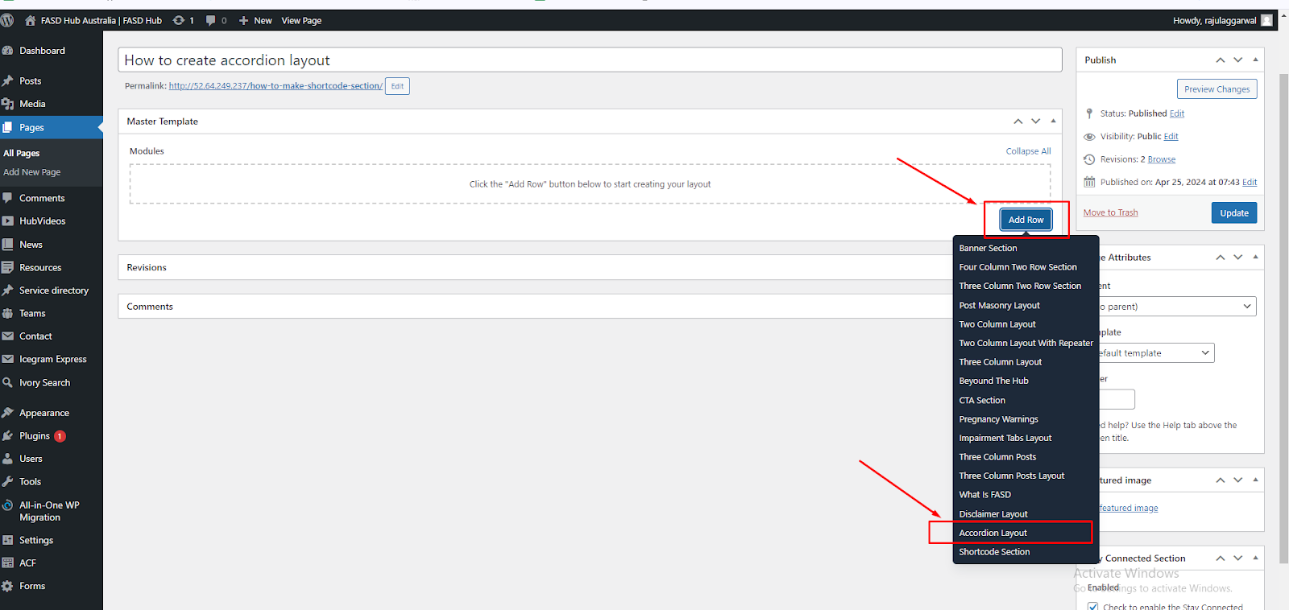

After that, the module related to the **accordion layout** section will be added, and you will find options related to this, as shown in the screenshot below.

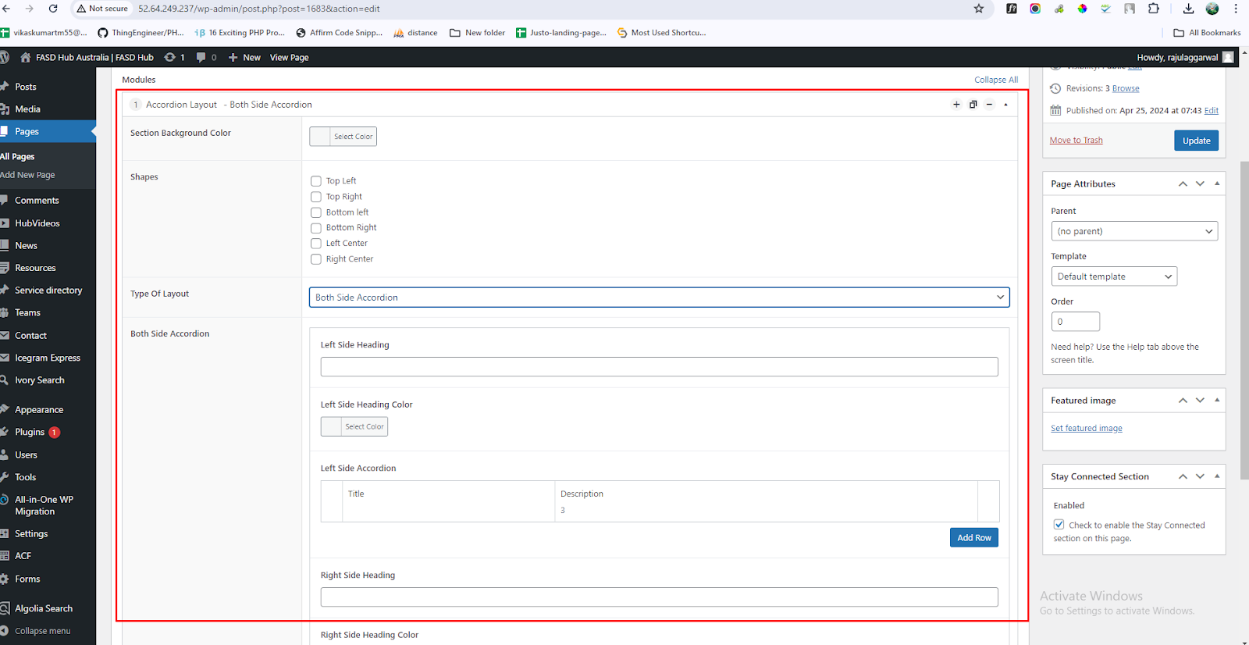

Now you will see the option for adding information regarding **accordion** such as **heading** and **description**, as shown in the screenshot below.

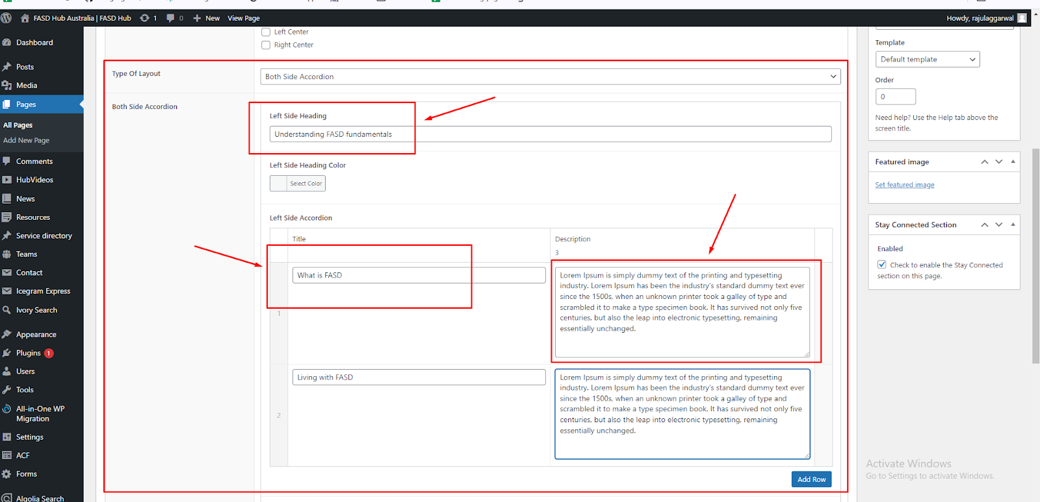

You can add as many **accordions** as you want by clicking "**Add Row**," as shown in the screenshot below.

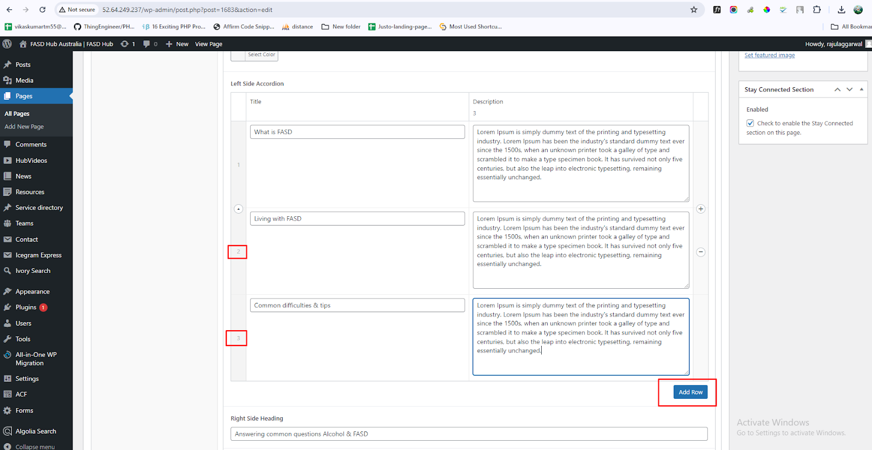

After adding content to these field boxes, save your changes and check your page, as shown in the screenshot below.

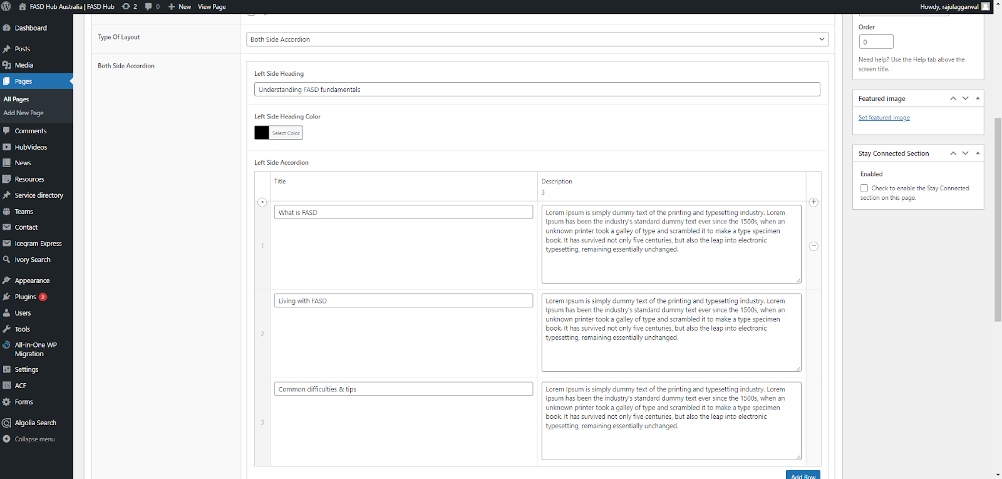

Finally, we have achieved the output of the **Accordion Layout** section on the front end, as shown in the screenshot below.

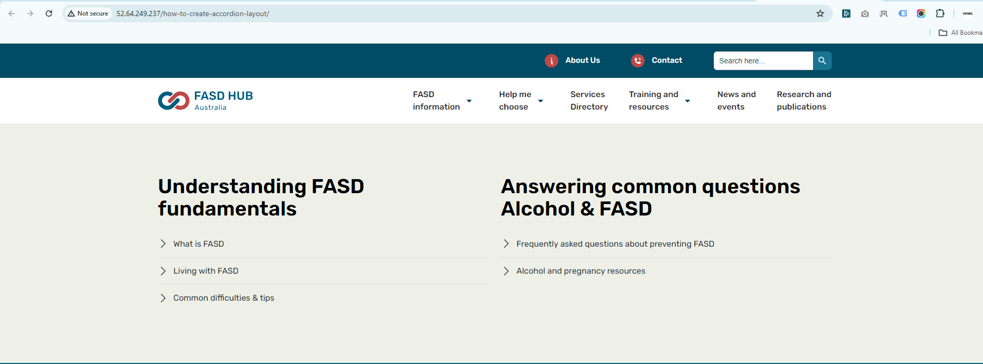

**Shortcode Section**

**How to create a shortcode section.**

**Preview (Shortcode Section)**

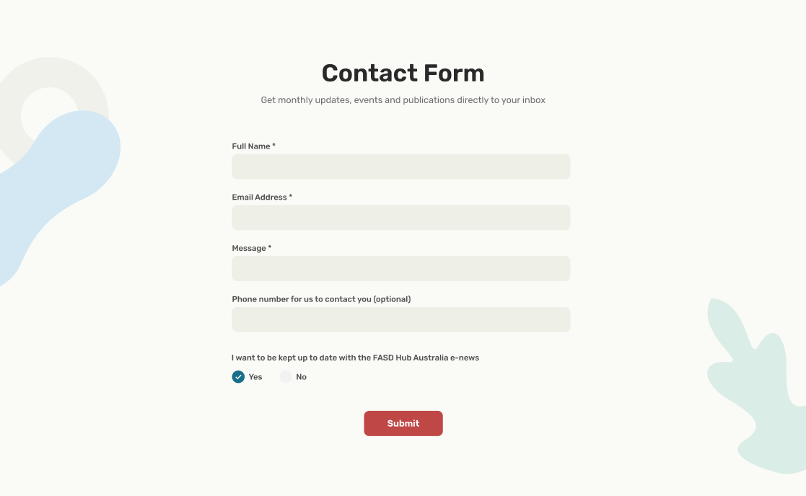

**Steps below:**

First, click on **'Add row**,' then select **'Shortcode Section'** from the dropdown menu, as shown in the screenshot below.

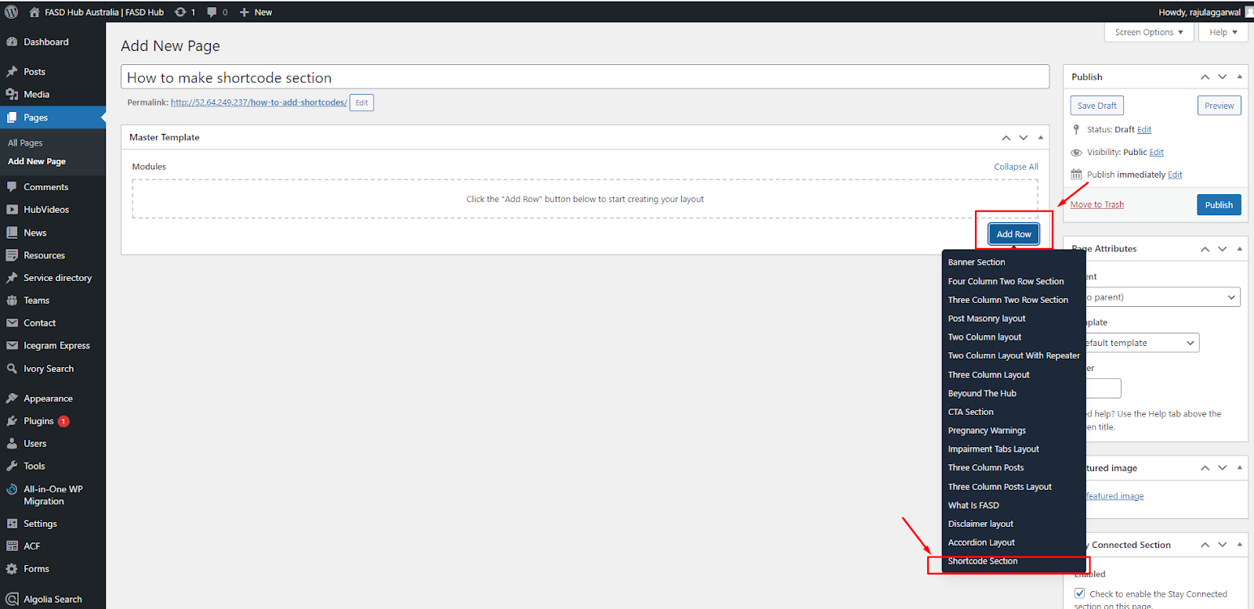

After that, the module related to the **shortcode section** will be added, and you will find options related to the **shortcode** section, as shown in the screenshot below.

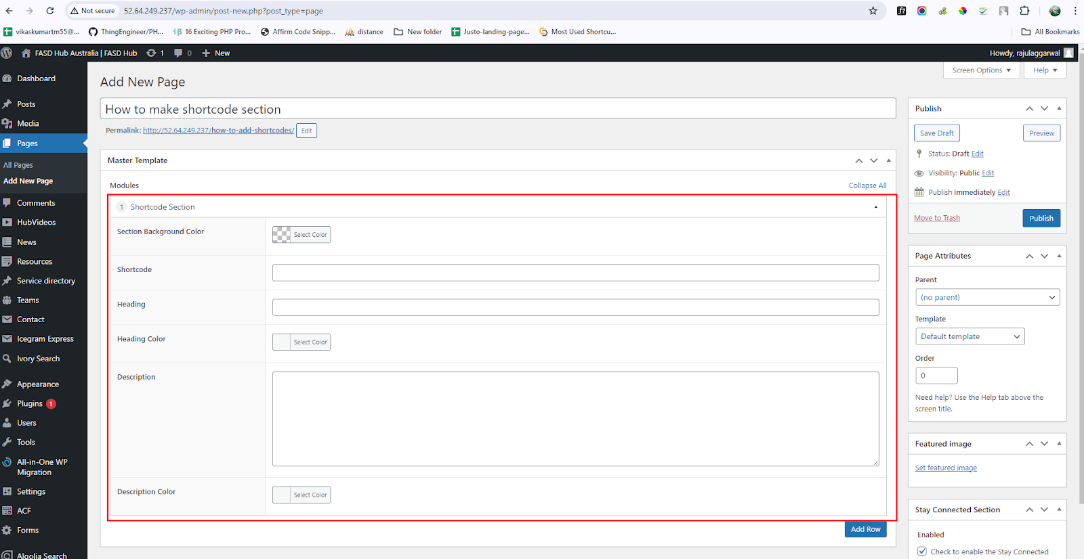

Now you will see the option for **Shortcode** here, as shown in the screenshot below.

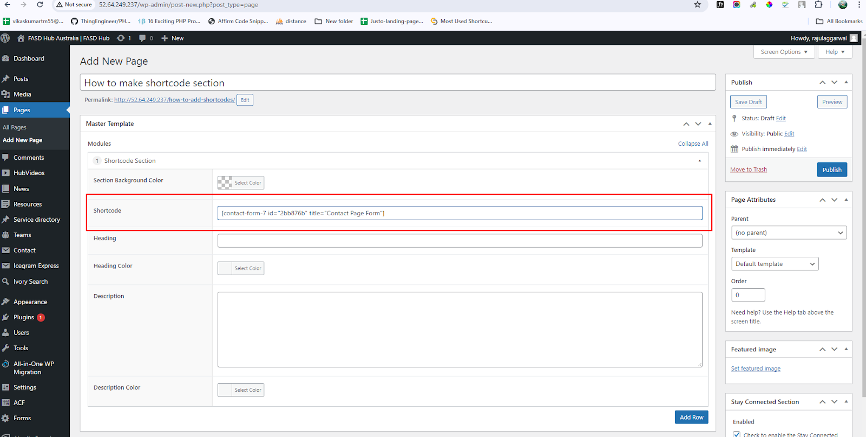

For the **contact form** shortcode, you have to go to the **Admin dashboard > Contact**. Now, you have to copy the **shortcode** for the **contact form**, as shown in the screenshot below.

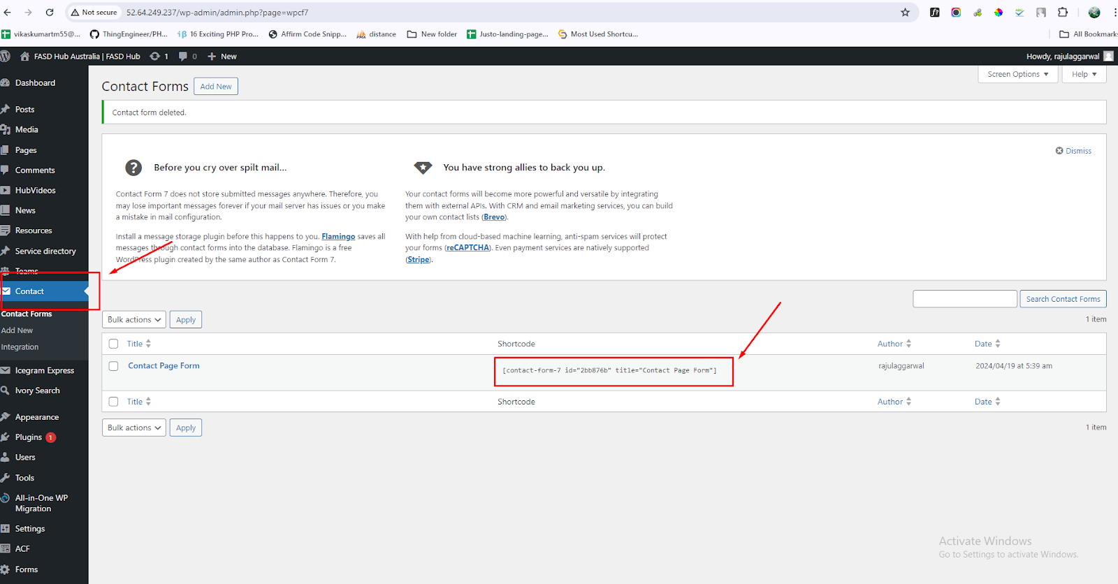

Now, you have to paste the **shortcode** here, which you copied from there, as shown in the screenshot below.

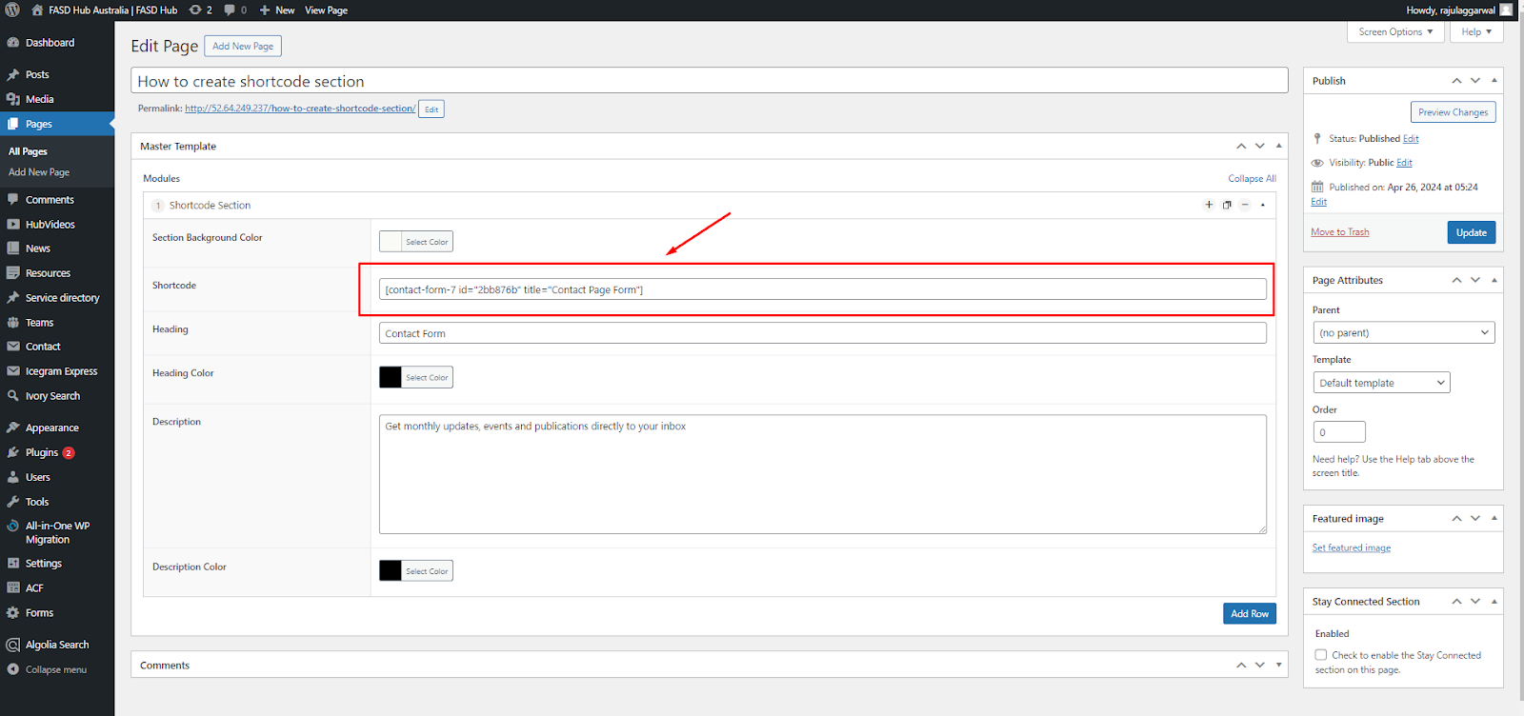

Below the shortcode, you have to add a **heading** and **description** for shortcode, as shown in the screenshot below

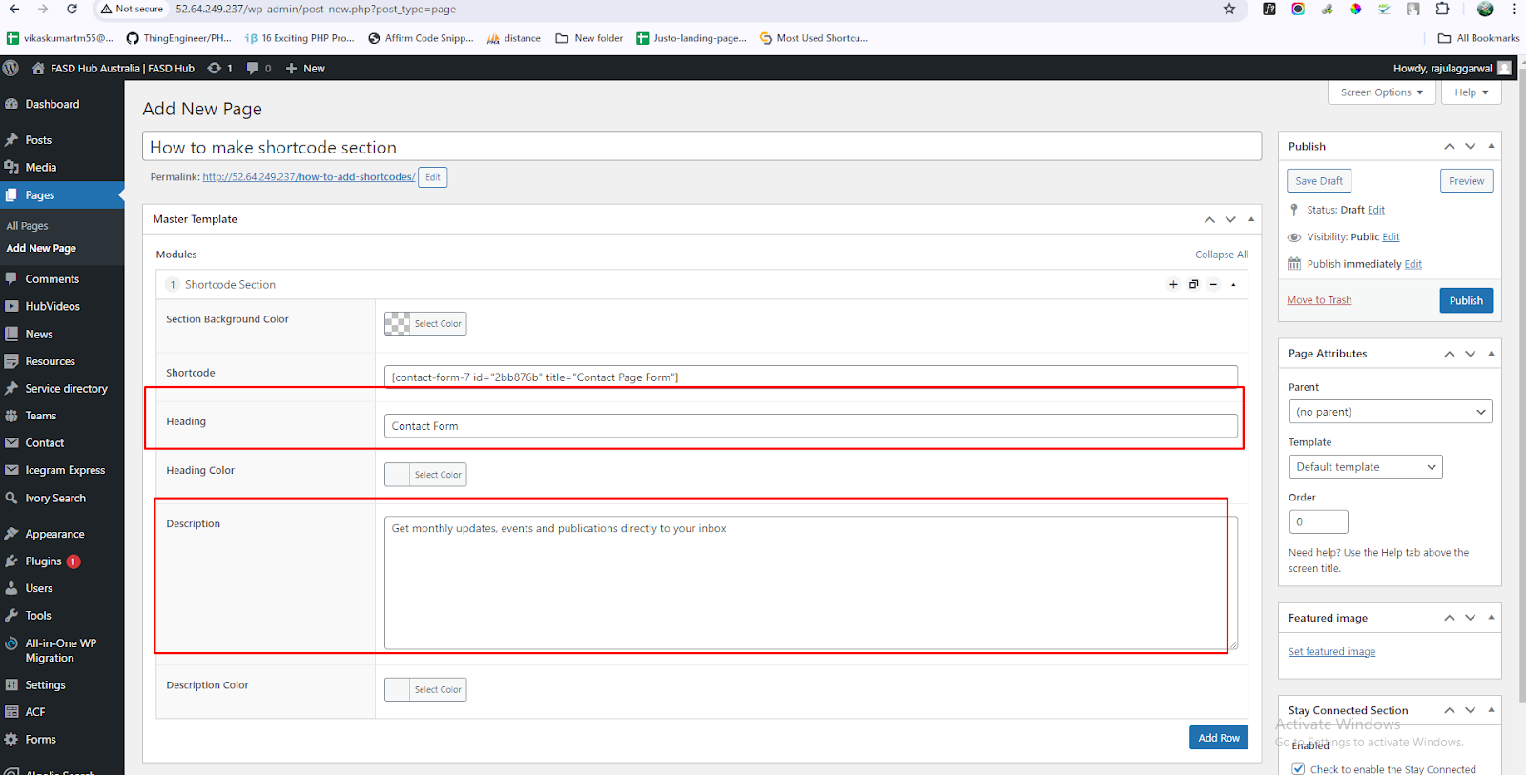.

After adding content to these field boxes, save your changes and check your page, as shown in the screenshot below.   
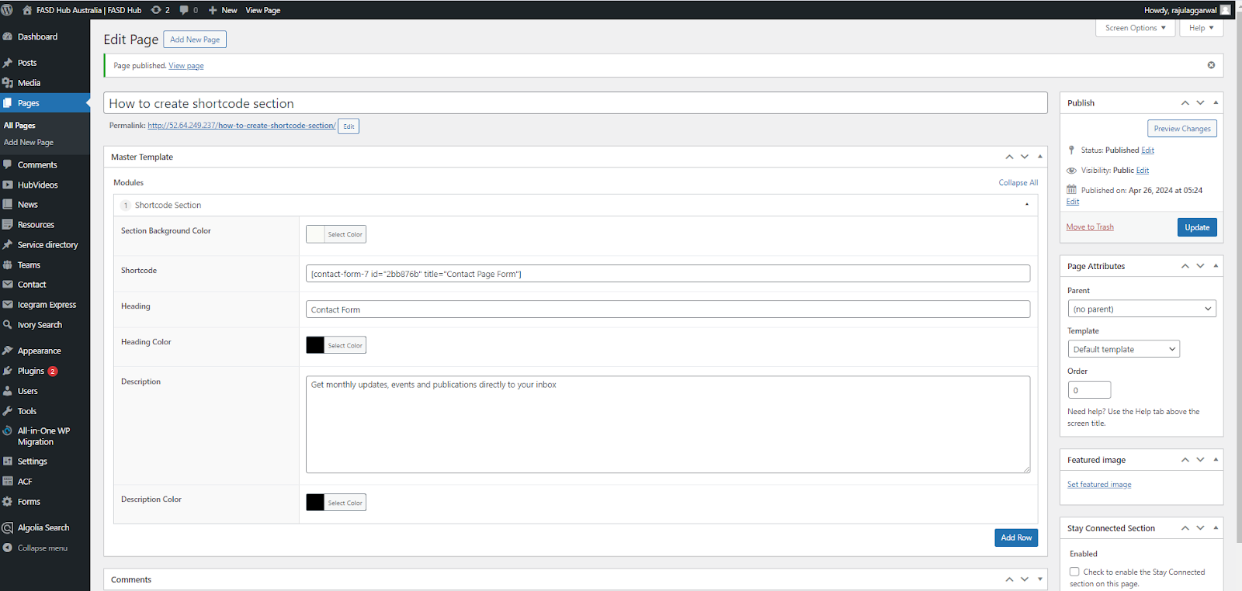

Finally, we have achieved the output of the **shortcode section** on the front end, as shown in the screenshot below.

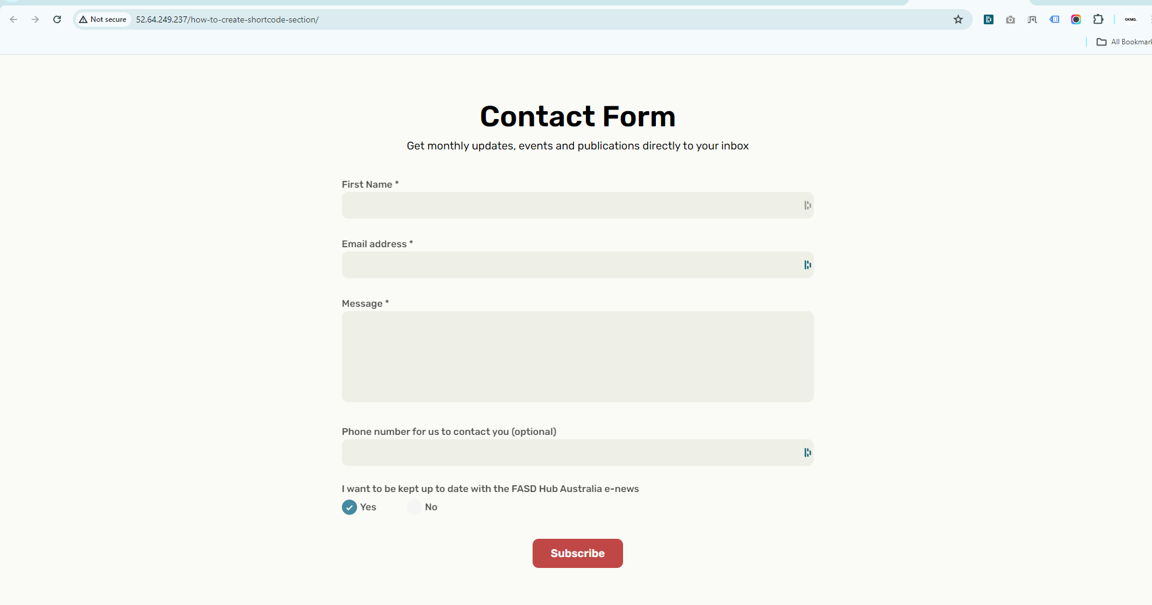

**Shortcode Section**

**How to create a shortcode section.**

**Preview (Shortcode Section)**